Elmley Castle C of E First School SEND Information Report

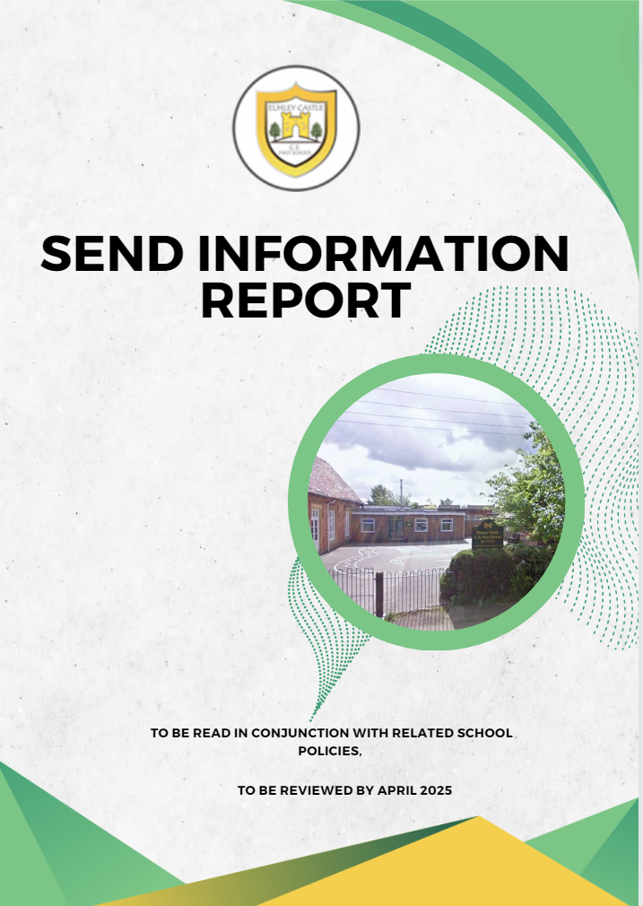

“A little piece of Heaven on Earth.”

**What Elmley Castle C of E First School Offers pupils with Disability, learning/Special Educational Needs or (SEND)**

Elmley Castle C of E First School values the contribution that every child can make and is supported by the Local Authority to ensure that all pupils, regardless of their specific needs, make the best possible progress. The school seeks to raise the achievement, remove barriers to learning and increase physical and curricular access to all. All children and young people with Special Educational Needs or Disabilities (SEND) are valued, respected and considered equal members of the school. As such, provision for pupils with SEND is a matter for the school as a whole. All teachers are teachers of pupils with SEND. The Governing Body, Headteacher, SENDCo and all other members of staff are responsible for teaching children with SEND. This School’s Information Report is in line with The SEND Code of Practice 2014, Worcestershire’s Local Offer and the school’s SEND Policy which can be accessed via the website or by contacting the school office.

**Identifying the Special Educational Needs and Disabilities of pupils**

Where pupils’ progress is significantly slower than that of their peers, or fails to match their previous rate of progress, despite high quality teaching targeted at specific areas of difficulty, it may be that the child has SEND. Information will be gathered, including seeking the views of parents and the pupil, as well as from teachers and assessments.

There can be a many reasons for learners ‘falling behind.’ These may include absences, attending lots of different schools, difficulties with speaking English, or worries that distract them from learning. The schools understand that children who experience these barriers to learning are vulnerable, however this does not mean that all vulnerable learners have SEND. Only those with a learning difficulty that requires special educational provision will be identified as having SEND.

At different times in their school life, a child or young person may have a Special Educational Need or Disability. The Code of Practice 2014 defines SEND as follows:

“A child or young person has SEND if they have a learning difficulty or disability which calls for special education provision to be made for him or her. A child of compulsory school age or a young person has a learning difficulty or disability if he or she:

1. has a significantly greater difficulty in learning than the majority of others the same age, or
2. has a disability which prevents or hinders him or her from making use of facilities of a kind generally provided for others of the same age in mainstream schools or mainstream post-16 institutions.

Special educational provision is educational or training provision that is additional to, or different from, that made generally for other children or young people of the same age by mainstream schools.

The SEND Code of Practice 2014 identifies four key areas of SEND which are:

* Communication and interaction, for example, autistic spectrum disorder, Asperger’s Syndrome, speech and language difficulties.
* Cognition and learning, for example, dyslexia, dyspraxia, dyscalculia.
* Social, emotional and mental health difficulties, for example, attention deficit hyperactivity disorder (ADHD).
* Sensory and/or physical needs, for example, visual impairments, hearing impairments, processing difficulties, epilepsy.

**Who are the best people to talk to in this school about my child’s needs with Special Educational Needs and/or Disability (SEND)**

**Special Educational Needs and Disability Coordinator (SENDCo)**

The Elmley Castle C of E First School SENDCo has responsibility for the overall management of SEND in the school. They are responsible for:

* Co-ordinating all the support for children with SEND and developing the school’s SEND Policy to make sure the needs of these children are being met.
* Ensuring that parents of children with SEND are involved in supporting their child’s learning, are kept informed about the support their child is getting and are involved in reviewing how things are going.
* Liaising with outside agencies who may come and support your child’s learning (e.g. Speech and Language).
* Updating the schools SEND register and making sure there are records of your child’s progress and learning needs.
* Providing support for other staff in the school so they can help children with SEND in the school to achieve the best progress possible.
* Working with class teachers, parents, children and other professionals to write Educational Health Care Plan (EHC Plans).

**Class Teacher**

The Class Teacher is responsible for:

* Keeping appropriate records on your child and their progress, which can be used to identify areas of support.
* Working with the SENDCo and identifying, planning and delivering any additional help your child may need.
* Responsible for ensuring their class provision map is kept up to date
* Working with the SENDCo to share and review assessment and progress information - Informing you of progress at Parents’ Evenings.
* Ensuring that all additional adults working with your child in school are helped to deliver the planned work for your child, so they can achieve the best possible progress.
* Work with outside agencies who may offer advice and help to support your child - Ensure they follow the school’s SEND policy.
* Working closely with any teaching partners (TP) or specialist staff to plan and assess the impact of support and interventions and how they can be linked to classroom teaching
* Have half termly discussions with the SENDCo to assess the progress made in interventions to determine their effectiveness and whether to maintain the current approach or adopt a new one.
* Attend IPM (Individual provision map) review meetings and follow up actions

**Headteacher**

The Headteacher is responsible for:

* Work with the SENDCo and SEND governor to determine the strategic development of the SEND policy and provision in the school
* Have overall responsibility for the provision and progress of learners with SEND and/or a disability
* The day to day management of all aspects of the school, including the support for children with SEND - Ensuring that the needs of SEND are met.
* Keeping the Governing Body up to date about any issues in the school relating to SEND.
* Working with the school Finance Officer and Governor to plan and spend money for children with SEND effectively, monitoring the impact of such spending.

**SEND Governor**

The SEN Governor is Emma Robinson. They will be kept informed of SEND in the school by the SENDCo, Headteacher and the SENDCo’s annual report and ensure that the necessary support is made for any child who attends school who has SEND.

**How can I let the school know I am concerned about my child’s progress in school?**

* If you have concerns about your child’s progress you should speak to your child’s teacher initially, either at a Parents’ Evening or by arranging another formal appointment.
* If you are not happy that the concerns are being managed and that your child is still not making progress you should speak to the SENDCo or Headteacher.
* If you are still not happy then you can speak to the SEND Governor.
* Formal complaints should go through the School Complaints Policy which can be found on the school website or by contacting the school office.

**What support will my child receive?**

**Class Teacher input:** Teachers endeavour to provide first quality teaching to cater for all needs within their class.

* The class teacher will have the highest possible expectations for your child and all pupils in their class.
* Teaching will build upon what your child already knows, can do and can understand.
* Different techniques and ways of teaching are utilised to fully involve children in their learning in class (e.g. more practical learning).
* Specific strategies are in place to support your child to learn – these may have been suggested by the SENDCo or outside agencies.
* Your child’s teacher will have carefully checked your child’s progress and will have decided how to meet gaps in learning to help them make the best progress possible.

**Specific Group work with a smaller group of children**

* These groups are called intervention groups or social groups.
* They can be run in the classroom setting or outside of the classroom.
* They can be run by a teacher or teaching partner.
* Your child will engage in the group session with specific targets to help them make more progress. - Sometimes an external professional will guide or run these groups.

**Specified Individual support**

* + This can be provided in a classroom setting or outside of the classroom.
  + Children with a Statement of Special Educational Needs or an Education, Health and Care Plan (EHCP) are supported based on their needs. Your child may also need specialist support in school from a professional outside the school - e.g. Advisory Teaching Service, Educational Psychologist. Once an EHC Plan is in place it would outline the type of support required and how the school will deliver this support.

**How is extra support allocated?**

* The school budget, received from Worcestershire Local Authority, includes money for supporting children with SEND. Money is also received from other local authorities if a child is supported by them.
* The Headteacher decides on the budget for SEND in consultation with the School Finance Manager and the Governors.
* Funding is used for employing TP’s to work with children with EHC Plans, target individual groups and SEND training for staff if required.
* Other resources are purchased for use with individuals or groups where appropriate.
* All resources/training and support are reviewed regularly and changes made as needed.

**How are the teachers in school helped to work with children with an SEND and what training do they receive?**

* The SENDCo’s job is to support the class teacher in planning for children with SEND
* Whole school training is given to staff as and when appropriate
* Staff who need additional training are either sent on training courses, or are provided with in house training when needed.
* The SENDCo attends the local SENDCo network meeting alongside other SENDCos within the Bredon Moles Cluster Group.
* The Learning Support Team are involved in training and advice for TP’s and staff as well as NHS health specialists such as Speech and Language Therapy.
* Regular meetings with class teacher and SENDCo to discuss pupils in class with a particular focus on those on IPM’s or EHCP’s.
* Services who visit the school to help with support/advice and training:
* NHS school nurse
* Speech and language therapists
* Educational psychologists
* Learning support services
* Perryfields PRU
* Bengeworth Academy
* Complex communication needs team
* Glovierspiece Care Farm
* Therapy dog

**How will teaching be adapted for my child with SEND?**

All pupils have the right to a broad, balanced and relevant curriculum. All pupils with SEND are taught with their peers in mainstream classes by the class teacher, and study the curriculum appropriate for their needs. All teaching and support staff are aware of the Early Years Foundation Stage Statements and the National Curriculum Statements and in their planning and teaching they strive to:

* Provide suitable learning challenges
* Meet the pupils diverse learning needs
* Remove the barriers to learning and assessment

Teachers match the learning objectives to the needs and abilities of the pupils. They use a range of strategies to develop the pupils’ knowledge, understanding and skills. Where appropriate, materials are modified or support is provided to enable pupils with SEND to access the learning or the assessment process.

Specific resources and strategies may be used to support your child individually and in groups.

The school acknowledges that its practices make a difference and because of this the school and teachers regularly review issues related to pupils with SEND and classroom organisation, teaching styles and methods, materials and tasks to determine how these can be improved.

# Identifying pupils with Special Educational Needs and assessing their needs

We will assess each pupil’s current skills and levels of attainment on entry, which will build on previous settings and Key Stages, where appropriate. Class teachers will make regular assessments of progress for all pupils and identify those whose progress:

* Is significantly slower than that of their peers starting from the same baseline.
* Fails to match or better the child’s previous rate of progress.
* Fails to close the attainment gap between the child and their peers.
* Widens the attainment gap.

This may include progress in areas other than attainment, for example, social needs.

Slow progress and low attainment will not automatically mean a pupil is recorded as having SEN.

When deciding whether special educational provision is required, we will start with the desired outcomes, including the expected progress and attainment, and the views and the wishes of the pupil and their parents. We will use this to determine the support that is needed and whether we can provide it by adapting our core offer, or whether something different or additional is needed.

If a learner is identified as having SEND, we will provide support that is ‘additional to’ or ‘varies from’ the differentiated approaches and learning arrangements normally provided as part of high-quality classroom teaching.

The SEN Support given to a pupil will be delivered through a graduated approach outlined below.

We share our practice with other schools in our cluster, which can include provision maps and assessment tools. In this way we learn from each other, develop a wider understanding of different SEND, and share training opportunities to improve the support we offer our learners.

When providing support that is ‘additional to’ or ‘varies from’, we engage in the graduated response which is a four-stage process: Assess, Plan, Do and Review in a cyclical process.

The Graduated Response

**Assess**: this involves taking into consideration all of the information from discussions with parents or carers, the child, the class teacher, formative and summative assessments and outside agencies when applicable.

**Plan**: this stage identifies the barriers to learning, intended outcomes, and details what additional support will be provided to help overcome these barriers. Decisions will be recorded and will form the basis for review meetings held as part of Parent/Teacher Consultations and Child/ Staff discussions.

**Do**: providing the support- extra assistance for learning or learning aids- as set out in the IPM (or Child’s provision)

**Review**: measuring the impact of support provided and considering whether changes to that support need to be made. All of those involved - learner, their parents or carer, Teacher and SENDCo - contribute to this review. This stage then informs the next cycle, if necessary. This may also input from outside agencies e.g. Learning Support Team. Liasons with Teachers and Teaching partners (TP’s) to discuss progress of learners are ongoing in addition to termly Pupil Progress Meetings with the Senior Leadership Team (SLT).

This additional support, ‘intervention’ will be tailored to meet the child’s needs, and will target the area of difficulty. This support maybe provided in class or in another area of the school as part of a group of learners with similar needs or on a 1:1 basis. These ‘interventions’ may be run by a Teacher or TP.

While the majority of learners with SEND will have their needs met in this way, a tiny proportion will meet the criteria to apply for an Educational and Health Care Needs Assessment (EHCNA). Through this, the Local Authority will determine whether to make provision in accordance with and Educational and Health Care Plan (EHCP).

The class or subject teacher will work with the SENCO to carry out a clear analysis of the pupil’s needs. This will draw on:

* The teacher’s assessment and experience of the pupil.
* Their previous progress and attainment and behaviour.
* Other teachers’ assessments, where relevant.
* The individual’s development in comparison to their peers and national data.
* The views and experience of parents.
* The pupil’s own views.
* Advice from external support services, if relevant.

The assessment will be reviewed regularly.

All teachers and support staff who work with the pupil will be made aware of their needs, the outcomes sought, the support provided, and any teaching strategies or approaches that are required. We will regularly review the effectiveness of the support and interventions and their impact on the pupil’s progress.

**How will the school measure the progress of your child in school**?

The school is committed to continually monitoring the progress of all the children in the school. This takes place in a number of ways:

* Progress is continually monitored by the class teacher with termly formal assessments carried out.
* Data and levels from these assessments are recorded in line with Early Years Foundation Stage and National Curriculum requirements. Children who may not be meeting National Curriculum requirements may be assessed against a more sensitive levelling approach called P Scales.
* At the end of the Key Stage 1 (Year 2), children are formally assessed using Standard Attainment Tests (SATs). These are required by the Government and results published nationally. In addition, children in Year 1 will also complete a Phonics Screening Check.
* Any additional support will be evaluated at the end of every term to ensure the support is effective and whether it needs to be continued, increased or stopped.
* The progress of children on a Statement/EHC Plan is formally reviewed at an Annual Review meeting with all adults involved invited to attend.
* The SENDCo monitors the progress of all SEND children by collecting data at the end of every half term.
* The effectiveness of interventions are monitored by the class teacher half termly and discuss results with SENDCo
* The Headteacher sits with every class teacher 3 times a year to assess the progress of every pupil which informs our interventions and support in class.

**How will we support your child as they move between classes or to another school?**

We recognise that transition of any sort can be a difficult time for you and your child and will take steps to ensure that this process is as smooth as possible.

* For children entering the school from another setting we will work with the previous SENDCo to ensure we have information about the best way to meet the needs of your child. We will also invite you and your child to visit the school so we can discuss the best ways to meet their needs.
* When moving classes within the school, information will be passed to the new class teacher in advance and your child will have opportunities to visit the new class and meet the new teacher. Strategies and ideas that have been working well will be shared.
* When moving to a new school we will contact the SENDCo to ensure they know about any special arrangements and will ensure that all records are passed on.
* When moving to middle school, we will arrange to meet the school’s SENDCo to talk about ways to ensure the transition is smooth. There may be a specific meeting to prepare you and your child for this move and it may be appropriate to have additional visits to their new school.
* Within our setting we have a moving up day. In addition to this, we provide additional opportunities for our learners with additional needs to interact with their future class teacher/teaching partner.

**How can we support you as a parent of a child with SEND?**

We will have an early discussion with the pupil and their parents when identifying whether they need special educational provision. These conversations will make sure that:

* Everyone develops a good understanding of the pupil’s areas of strength and difficulty.
* We take into account the parents’ concerns.
* Everyone understands the agreed outcomes sought for the child.
* Everyone is clear on what the next steps are.
* Holding IPM review meetings where we look at every child’s IPM with the parents/carers. This helps everyone stay informed with the needs of the individual and how we can all play a part in ensuring they achieve their personal best.

Notes of these early discussions will be added to the pupil’s record and given to their parents.

We will formally notify parents when it is decided that a pupil will receive SEN support.

* The class teacher is regularly available to discuss your child’s progress or any other concerns you may have. They will share information about what is working well and will listen to what may be working at home so similar strategies can be used.
* Support staff working with your child regularly (1-1 daily support) will liaise with you as and when appropriate.
* The SENDCo or Headteacher are available to meet with parents to discuss any concerns they may have.
* If outside agencies have visited your child, the school will feed information back to you and share any support or strategies that can be used. Where possible a report will also be supplied
* EHC Plans will be reviewed and planned with you.
* Classroom learning will be adjusted to meet the needs of your child and where changes are significant you will be informed. Help will also be given on how to adapt homework and home learning.
* When it is deemed appropriate and helpful, a home/school communication book will be set up to communicate daily information.

**SEND Support through adaptations to the physical environment**

We will aim to meet the needs of all our learners by making any adaptions needed dependant on the learners we have within our setting. We strive to be inclusive to enable all learners whatever their need to succeed. This will be achieved by:

* A designated sensory room
* Being mindful of classroom layout for instance a space to roam without distracting peers
* Workstations both inside and outside of the classroom
* Opportunities to learn outside with external working areas
* Whole school led approach on displays – Zones of regulation
* Where appropriate pupils that require a quieter area when sitting suitable assessments
* Adapting timetable for instance early or late entry into school/dining hall
* Busy boxes
* Calm zones in classrooms

**Adapted delivery of information to pupils of information that is readily available to those without disabilities**

* Whole school approach to sign language
* Now and next where applicable
* Development of those with speech and language needs through regular visits from SALT – following their guidance; whole school intervention for speech and language
* Use of widgit
* Social stories
* Printed off sheets
* Text is SANS serif where possible across the school
* Whole school approach on displays being more accessible to all learners
* Continuous professional development on how to work with learners with SEN

**Preparing for Next Steps**

Transition is a part of life for all learners, whether that involves moving to a new class or moving to a new school. We recognise that transition is an important time for all children, but especially so for a child with SEND. Consequently, we work closely with parents, children, staff and other providers to ensure these transitions run as smoothly as possible.

Planning for transitions between all involved will take place at the appropriate time and information will be shared with the SENDCo at their next school. This information will outline needs and support that has proven effective. Where possible children will visit their new provider and, in some cases, liaisons between staff and additional visits for the child can be arranged.

Prior to coming into our school setting, we will be holding welcome parent meetings which is an opportunity for us as a school to get to know the needs of parents and future pupils. We try to create as smooth a transition as possible by sending a member of staff to get to know them further in their home setting; create opportunities to both get to know the family and the individuals needs but also give the child time in our setting through stay and plays and book and biscuit sessions.

If you have any concerns regarding your child’s progress or well‐being, then please speak to either your child’s class teacher or Mr Jamie Jarvie (SENDCo) to discuss your concerns.

**Who can parent with pupils with SEND contact for help and advice?**

The web address for the local authority is shown below and this is a useful site to gain further information. <https://www.worcestershire.gov.uk/send-local-offer-0/early-years-birth-starting-school/send-advice-and-support-parents>

The Special Educational Needs and Disabilities Information, Advice and Support Service (SENDIAS) is at arm's length from Worcestershire's Children's Services and able to give independent and neutral advice. For more information, please visit:

<https://www.worcestershire.gov.uk/directory-record/send-information-advice-and-support-service-sendiass>

or email:

sendiass@worcestershire.gov.uk

or call: 01905 768153

**Where can I access The Local Authority’s Offer?**

Local authorities must publish a local offer, setting out in one place information about provision that is available for children and young people in their area who have special educational needs. You can find the Worcestershire Local Offer: ‘Ordinarily Available’ at:

<https://www.worcestershire.gov.uk/send-local-offer-0>