Elmley Castle C of E First School SEND Policy
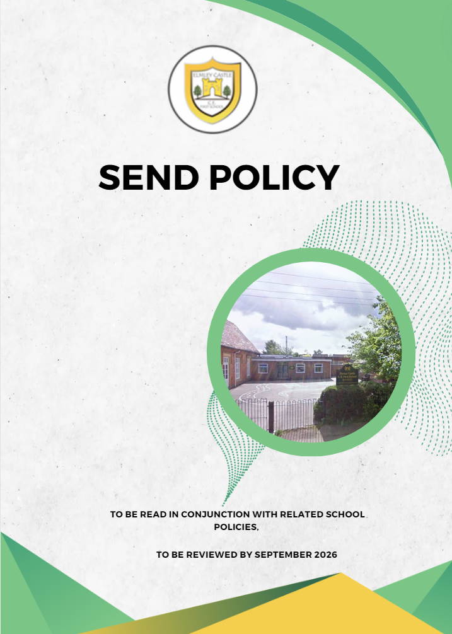

“A little piece of Heaven on Earth.”

Welcome to our SEND policy, we hope you find it informative and helpful. Elmley Castle First School is committed to providing an appropriate and high-quality education to all its pupils. We believe that all children, including those identified as having special educational needs and/or disabilities (SEND) have a common and equal entitlement to a broad and balanced academic and social curriculum, which is accessible to them, and to be fully included in all aspects of school life.
We believe that all pupils should be equally valued in school. We strive to eliminate prejudice and discrimination and to develop an environment where all our pupils can flourish and feel safe.

This policy describes the ways we meet the need of pupils who experience barriers to their learning; which may relate to sensory or physical impairment, learning difficulties or emotional or social development, or may relate to factors in their environment, including the learning environment they experience in school.

Through our school values we instill a school environment where all our pupils treat each other with respect and generosity. We encourage positive relationships and strive to be inclusive through staff role modelling positive relationships as well as rewarding pupils when demonstrating our school values. All pupils are encouraged to access wider opportunities such as school parliament, residential visits, school plays, sports teams and other responsibilities such as class librarians.

Contents
1. Aims 3
2. Legislation and guidance 3
3. Definitions 4
4. Roles and responsibilities 4
5. SEND information report 5
6. Monitoring arrangements ……….11
7. Links with other policies and documents…………………………………………………………………………………….………..12
8. Key Abbreviations ……………………………………………………….……………………………………………………………………….19
9. Identification and support from intervention to EHCP ……………………………………………………..…………………. 20

1. Aims
Our SEND policy and information report aims to:
- Set out how our school will support and make provision for pupils with Special Educational Needs and Disabilities (SEND)
- Explain the roles and responsibilities of everyone involved in providing for pupils with SEND
- To ensure the SEND and Disability Act and relevant Codes of Practice and guidance are implemented effectively across the school.
- To ensure equality of opportunity for and to eliminate prejudice and discrimination against pupils with SEND.
- To regularly and accurately monitor the progress of all pupils, to identify needs as they arise and to provide support as early as possible.
- Enable all children to have full access to all elements of the school curriculum.
- To provide specific input, matched to individual needs, in addition to differentiated classroom provision, for those pupils recorded as having SEND.
- To ensure that as far as practicably possible and in line with legislation, we meet every pupils’ needs
- In so far as is possible, to enable pupils to move on from us to the next stage of their education with the basic skills needed to support them in meeting the challenges.
- To have a close working relationship with parents/carers where possible and involve them in the planning of provision to meet their child’s additional needs, that is above what is provided under Quality First Teaching.
- To create an environment that meets the special educational needs of each child in order that they can achieve their learning potential and engage in activities alongside pupils who do not have SEND
- To raise the aspirations of and expectations for all pupils with SEND
- To ensure that all staff are well informed about their pupils’ special educational needs and disabilities

2. Legislation and guidance
This policy and information report is based on the statutory Special Educational Needs and Disability (SEND) Code of Practice and the following legislation:
- Part 3 of the Children and Families Act 2014, which sets out schools’ responsibilities for pupils with SEND and disabilities
- The Special Educational Needs and Disability Regulations 2014, which set out schools’ responsibilities for education, health and care (EHC) plans, SEND co-ordinators (SENDCos) and the SEND information report

3. Definitions
A pupil has SEND if they have a learning difficulty or disability which calls for special educational provision to be made for them.
They have a learning difficulty or disability if they have:
- A significantly greater difficulty in learning than the majority of others of the same age, or
- A disability which prevents or hinders them from making use of facilities of a kind generally provided for others of the same age in mainstream schools
Special educational provision is educational or training provision that is additional to, or different from, that made generally for other children or young people of the same age by mainstream schools.

4. Roles and responsibilities
4.1 The SENDCo (Special Educational Needs and Disability Co-ordinator)
The SENDCo is Jamie Jarvie
Contact information: 01386 710279
They will:
- Work with the Head Teacher and SEND governor to determine the strategic development of the SEND policy and provision in the school
- Have day-to-day responsibility for the operation of this SEND policy and the co-ordination of specific provision made to support individual pupils with SEND, including those who have EHCP’S (Education health care plans)
- Provide professional guidance to colleagues and work with staff, parents, and other agencies to ensure that pupils with SEND receive appropriate support and high-quality teaching
- Advise on the graduated approach to providing SEND support
- Advise on the deployment of the school’s delegated budget and other resources to meet pupils’ needs effectively
- Be the point of contact for external agencies, especially the local authority and its support services
- Liaise with potential next providers of education to ensure pupils and their parents are informed about options and a smooth transition is planned
- Work with the Head Teacher, head of school and governing board to ensure that the school meets its responsibilities under the Equality Act 2010 with regard to reasonable adjustments and access arrangements
- Ensure the school keeps the records of all pupils with SEND up to date

4.2 The SEND governor
The SEND governor is Emma Robinson
The SEND governor will:
- Help to raise awareness of SEND issues at governing board meetings
- Monitor the quality and effectiveness of SEND and disability provision within the school and update the governing board on this
- Work with the head teacher and SENDCo to determine the strategic development of the SEND policy and provision in the school
- The governing body is responsible for reporting to parents annually on the school’s policy on SEN

4.3 The senior leadership team (SLT)
The senior leadership team will:
- Work with the SENDCo and SEND governor to determine the strategic development of the SEND policy and provision in the school
- Have overall responsibility for the provision and progress of learners with SEND and/or a disability

4.4 Class teachers
Each class teacher is responsible for:
- The progress and development of every pupil in their class
- Working closely with any teaching partners (TP) or specialist staff to plan and assess the impact of support and interventions and how they can be linked to classroom teaching
- Working with the SENDCo to review each pupil’s progress through the use of their IPM’s, impact from interventions and assessments then decide on any changes to provision if appropriate
- Ensuring they follow this SEND policy
- Writing Individual Provision Map (IPM’s) with the support and guidance of the SENDCo
- Attend IPM (Individual provision map) review meetings and follow up actions

5. SEND information report
5.1 The kinds of SEND that are provided for
Our school currently provides additional and/or different provision for a range of needs, including:
- Communication and interaction, for example, autistic spectrum disorder, Asperger’s Syndrome, speech and language difficulties
- Cognition and learning, for example, dyslexia and dyspraxia
- Social, emotional and mental health difficulties, for example, attention deficit hyperactivity disorder (ADHD)
- Sensory and/or physical needs, for example, visual impairments, hearing impairments, processing difficulties, epilepsy, downs syndrome and diabetes.
- Moderate/severe/profound and multiple learning difficulties
- Global delay

5.2 Identifying pupils with SEND and assessing their needs
We will assess each pupil’s current skills and levels of attainment on entry. Class teachers will make regular assessments of progress by:
- The analysis of data using the schools internal tracking system, summative assessments and information from previous education providers.
- Tracking individual pupil progress over time through summative data and their IPM’s
- Liaison with feeder schools on transfer
- Information from other services
Class teachers will make regular assessments of progress for all pupils and identify those whose progress:
- Is significantly slower than that of their peers starting from the same baseline
- Fails to match or better the child’s previous rate of progress
- Fails to close the attainment gap between the child and their peers
- Widens the attainment gap

This may include progress in areas other than attainment, for example, social needs.
Slow progress and low attainment will not automatically mean a pupil is recorded as having SEND.
When deciding whether special educational provision is required, we will start with the desired outcomes, including the expected progress and attainment, and the views and the wishes of the pupil and their parents. We will use this to determine the support that is needed and whether we can provide it by adapting our core offer, or whether something different or additional is needed.

5.3 Consulting and involving pupils and parents
We aim to have good and informative relationships with all of our parents. If a child is experiencing difficulties, parents will be informed either at parents’ meetings (autumn and spring terms) or during informal meetings to discuss the child’s progress. It shouldn’t come as a surprise to a parent to learn that their child is being identified as having SEND. Parents are kept informed of progress and are given a copy of the resulting IPM. This is part of the ‘Assess, Plan, Do, Review’ cycle required in the Code of Practice. IPM’s will be created either to support an individual or if there is a specific issue where multiple individuals require the same support a group IPM can be used. Where outside professionals are involved there will be termly review where parents are invited to discuss the child’s progress. We will endeavor where possible to have parents, class teacher, SENDCo and where possible any outside professionals attend these meetings. However, if IPM is linked primarily to quality first teaching it will be the responsibility of the class teacher to liaise with parents and for the SENDCo to oversee.
These conversations aim to ensure that:
- Everyone develops a good understanding of the pupil’s areas of strength and difficulty
- We take into account the parents’ concerns
- We listen to the child’s opinion, suggestions and concerns
- Everyone understands the agreed outcomes sought for the child
- Everyone is clear on what the next steps are
- There is a smooth transition between classes
We will formally notify parents when it is decided that a pupil will receive SEND support.

5.4 Assessing and reviewing pupils' progress towards outcomes
We will follow the graduated approach and the four-part cycle of assess, plan, do, review.
The class or subject teacher will work with the SENDCo to carry out a clear analysis of the pupil’s needs. This will draw on:
- The teacher’s assessment and experience of the pupil
- Their previous progress and attainment and behaviour
- Other teachers’ assessments, where relevant
- The individual’s development in comparison to their peers and national data
- The views and experience of parents
- The pupil’s own views
- Advice from external support services, if relevant

The assessment will be reviewed regularly.

All teachers and support staff who work with the pupil will be made aware of their needs, the outcomes sought, the support provided, and any teaching strategies or approaches that are required. We will regularly review the effectiveness of the support and interventions and their impact on the pupil’s progress. If we are unsatisfied with the progress that a child is making we will offer them support through interventions, this may lead onto the child being supported through an IPM. If progress continues to not be made, then an EHCP will be considered. See appendix A for process.
5.5 Supporting pupils moving between phases and preparing for adulthood
We will share information with the school the pupil is moving to. Statutory information will be shared. Additional information may be shared at the school’s discretion and in accordance with recent GDPR regulations. Parents should contact the SENDCo to discuss what is being shared if they have any concerns prior to the point of transfer.
We will encourage pupils to have adequate induction time at their new school to prepare them for the change.

5.6 Our approach to teaching pupils with SEND
At Elmley Castle C.E. First School we know that early intervention of special education is vital. We also believe that all children learn best with the rest of their class. Our aim is for all children to be working independently in class.
Teachers are responsible and accountable for the progress and development of all the pupils in their class.
Quality First Teaching is our first step in responding to pupils who have SEND. This includes differentiation for pupils. Differentiation may be by task, outcome, support, recording method etc.
It is unusual for children to receive one to one support unless it has been stipulated on their EHCP. If additional TP support is needed it is allocated in terms of enabling children to reach their target rather than the allocation of a certain number of hours support per day/week. We aim to avoid the children developing a learned dependence on an adult.

The impact of interventions is monitored by the SENDCo and the SLT. The Class teacher monitors progress towards the targets during the intervention using the information from the TP and evidence in books. The SENDCo monitors the progress of the children receiving support as a whole.

- Interventions are planned and reviewed in half termly blocks
- The Individual Provision Map is shared with and agreed by the child and parents
- At the end of the block, children’s progress towards their targets is assessed and recorded.
- A decision is then made as to whether to continue the intervention, to swap to a new intervention, or to allow a period of consolidation in class.

The SENDCo, class teacher and TP monitor interventions to identify ‘what works’ for each individual child.
External intervention will usually be triggered when despite receiving differentiated teaching and a sustained level of support, a pupil:
- Still makes little or no progress in specific areas over a long period
- Continues to work at National Curriculum levels considerably lower than expected for a pupil at a similar age
- Continues to experience difficulty in developing literacy/numeracy skills
- Has emotional problems that substantially impede their learning
- Has sensory or physical needs requiring additional specialist equipment or visits/advice from specialists.
- Has communication or interaction problems that impede the development of social relationships, thus presenting barriers to learning
External support services will advise on individual outcomes and provide specialist inputs to the support process. Parental consent is sought before any external agencies are involved. Parents are asked to come into school to help with the filling in of a referral form which will identify what the child’s needs are in more detail.
.
5.7 Adaptations to the curriculum and learning environment
We make the following adaptations to ensure all pupils’ needs are met:
- Differentiating our curriculum to ensure all pupils are able to access it, for example, by grouping, 1:1 work, teaching style, content of the lesson, etc.
- Adapting our resources and staffing
- Using recommended aids, such as laptops, coloured overlays, visual timetables, larger font, visual timetables and task boards etc…
- Differentiating our teaching, for example, giving longer processing times, pre-teaching of key vocabulary, reading instructions aloud, etc.

5.8 Additional support for learning
We have a qualified counsellor on a weekly basis to deliver thrive to improve the wellbeing of the pupils who need extra support to develop their ability to access the curriculum. We have 5 teaching partners who received a qualification in An Introduction to Teaching Phonics and PM Bench Marking. We have a TP who is qualified in Lego Therapy. We also have 2 members of staff qualified in positive handling.
All TPs work with children with SEND and disabilities, but not exclusively. If we identify information we can’t access without the aid of additional, more specialist help, the school is able to buy-in additional expertise from the local authority. This includes access to Educational Psychologists and Advisory Teachers. Children with SEND will not spend excessive time being taught by a TP but will have extra support from teachers also. Teachers and TP’s may support pupils working individually or in groups, both in interventions, or during whole class teaching.
Currently we work with the following agencies to provide support for pupils with SEND however this list may change according to individual pupil need:
- NHS school nurse
- Speech and language therapists
- Educational psychologists
- Learning support services
- Perryfields PRU
- Bengeworth Academy
- Complex communication needs team
- WORCESTER PLACE FOR DE
- DOG LADY

5.9 Expertise and training of staff
Our SENDCo is allocated half a day every fortnight to manage SEND provision and 1 hour weekly.
We have a team of six teaching partners.
We have a specialist come in to support through children through Thrive.

5.10 Securing equipment and facilities
In addition to EHCPs, the school provides through its own budget:

We have a dedicated SEND budget to secure equipment and resources to meet specific needs such as ICT (Information communication and technology) for some children with dyslexia, motor skills difficulties and visual impairments.

5.11 Evaluating the effectiveness of SEND provision
We evaluate the effectiveness of provision for pupils with SEND by:
- Reviewing pupils’ individual progress towards their goals each term
- Reviewing the impact of interventions in half termly blocks
- Using pupil questionnaires
- Monitoring by the SENDCo
- Using whole school provision maps to monitor changes in need within the whole school community
- Holding annual reviews for pupils with EHCPs

5.12 Enabling pupils with SEND to engage in activities available to those in the school who do not have SEND
- All of our extra-curricular activities and school visits are available to all our pupils, including our before-and after-school clubs.
- All pupils are encouraged to go on our residential trips
- All pupils are encouraged to take part in sports day/school plays/special workshops, etc.
- No pupil is ever excluded from taking part in these activities because of their SEND or disability.

5.13 Support for improving emotional and social development
We provide support for pupils to improve their emotional and social development in the following ways:
- We fund a THRIVE trained support worker to provide 1:1 intervention for emotional needs following the THRIVE approach.
- Pupils with SEND are encouraged to be part of the school council
- Pupils with SEND are also encouraged to be part of after school clubs and activities to promote teamwork/building friendships etc.
- We will be adopting a buddy system in school, this particularly helps our youngest children as they have an older peer to seek support from and a role model to look up to
- We have a zero tolerance approach to bullying.
- Access Block funding for SALT through Bengeworth Academy

5.14 Working with other agencies

At Elmley Castle C.E. First School we work closely with other agencies to support both the children in our care as well as their families. We regularly liaise with family support workers, Speech and Language Therapists, Child and Adult Mental Health Services as health and social care bodies, local authority support and voluntary organisations. We buy into private services where appropriate to ensure that we are able to offer the best all round support for the children in our care and meeting their needs.

5.15 Complaints about SEND provision
Complaints about SEND provision in our school should be made through our complaints procedure. For more information please see our Complaints Policy.
The parents of pupils with disabilities have the right to make disability discrimination claims to the first-tier SEND tribunal if they believe that our school has discriminated against their children. They can make a claim about alleged discrimination regarding:
- Exclusions
- Provision of education and associated services
- Making reasonable adjustments, including the provision of auxiliary aids and services

5.16 Contact details of support services for parents of pupils with SEND
If you wish to seek support for parenting support, emotional well-being or any other issue there are a variety of agencies, family link workers or NHS departments we can liaise with either on your behalf or put you in touch with.
The Special Educational Needs and Disabilities Information, Advice and Support Service (SENDIASS) are an advice and support services available to give independent, neutral and free advice to parents. For more information please follow this link: http://www.worcestershire.gov.uk/info/20417/special_educational_needs_and_disabilities_information_advice_and_support_service
Or contact them on:
Email – sendiass@worcestershire.gov.uk
Phone – 01905 768153
5.17 Contact details for raising concerns
If you have any concerns please contact the SENCO, Jamie Jarvie – 01386 710279

5.18 The local authority local offer
Our local authority’s local offer is published here: www.worcestershirelocaloffer.org.uk

6. Monitoring arrangements
This policy and information report will be reviewed by Jamie Jarvie every year. It will also be updated if any changes to the information are made during the year.
It will be approved by the governing board.

7. Links with other policies and documents
This policy links to our policies on:
- Accessibility plan
- Behaviour
- Equality information and objectives
- Supporting pupils with medical conditions
- LAC Policy

Key Abbreviations

IPM – Individual Provision Map
LAC – Looked after Child Policy
SEND – Special Educational Needs and Disabilities
SENDCo - Special Educational Needs and Disabilities Co-ordinator
EHCP – Educational Health Care Plan
ADHD – Attention deficit hyperactivity disorder
GDPR – General Data Protection Regulation
SLT – Senior Leadership Team
TP – Teaching partner
NHS – National Health Service
SALT – Speech and Language Therapy
SENDIASS - The Special Educational Needs and Disabilities Information, Advice and Support Service

Appendix A – Identification and support from intervention to EHCP
If a child shows signs of difficulty developing English or mathematical skill, which result in poor attainment
Persistent emotional or behavioural difficulties resulting in a negative impact on their educational capabilities
Has sensory or physical problems and continues to make little or no progress despite specialist equipment
If a child is making little or no progress
Support through the use of intervention for targeted weakness
If sufficient progress is made – intervention support no longer needed
If sufficient progress isn’t made – review intervention. Discuss what hasn’t worked and try on a new intervention or continue for 6 weeks.
If sufficient progress is made – intervention support no longer needed
If sufficient progress isn’t made – review intervention. Discuss what has and hasn’t worked and place learner on IPM
If sufficient progress is made – IPM support no longer needed
If sufficient progress isn’t made – review IPM. Discuss what has and hasn’t worked and seek external agencies
If sufficient progress isn’t made – review IPM. Discuss what has and hasn’t worked and seek additional support from external agency
If sufficient progress is made – IPM support no longer needed
If sufficient progress isn’t made – review IPM. Discuss what has and hasn’t worked and start EHCP process
If sufficient progress is made – IPM support no longer needed
At this stage the child may be placed onto the vulnerable or cause for concern list.
Parental informal discussion regarding intervention
Reviewed half termly
Parents formally consulted and involved in IPM process
Next stage - Child application for EHCP

