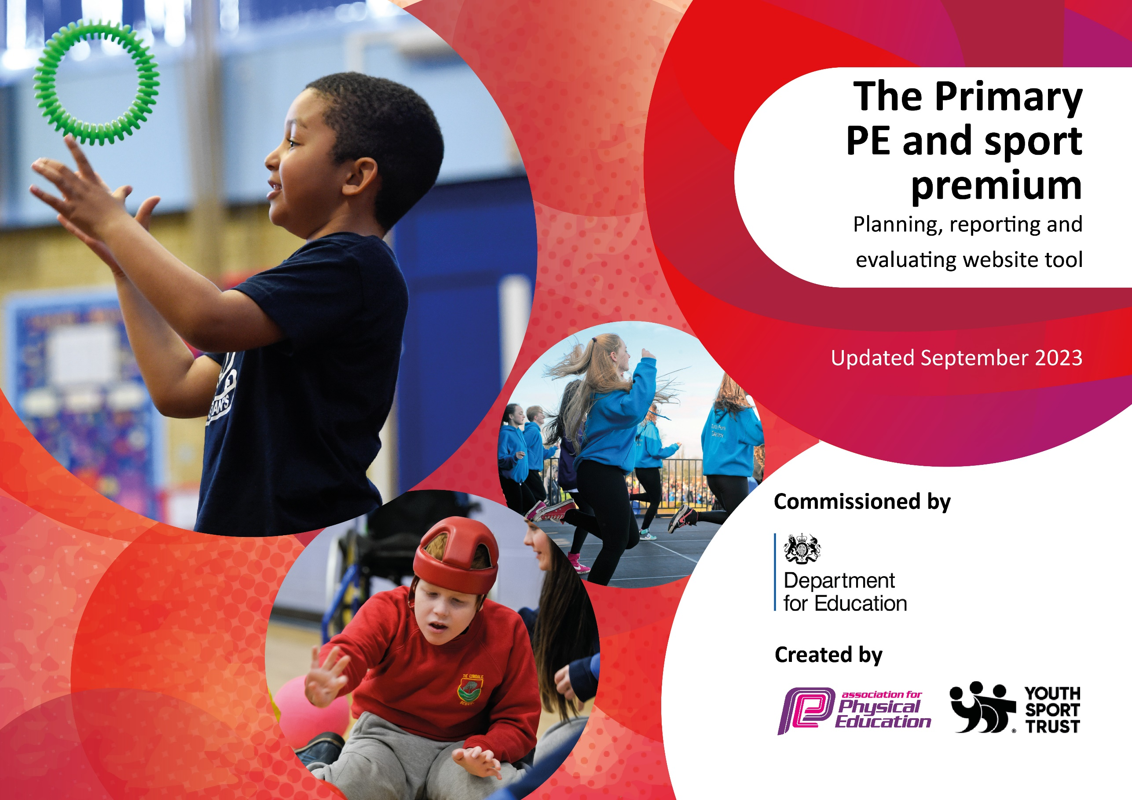

Updated June 2024

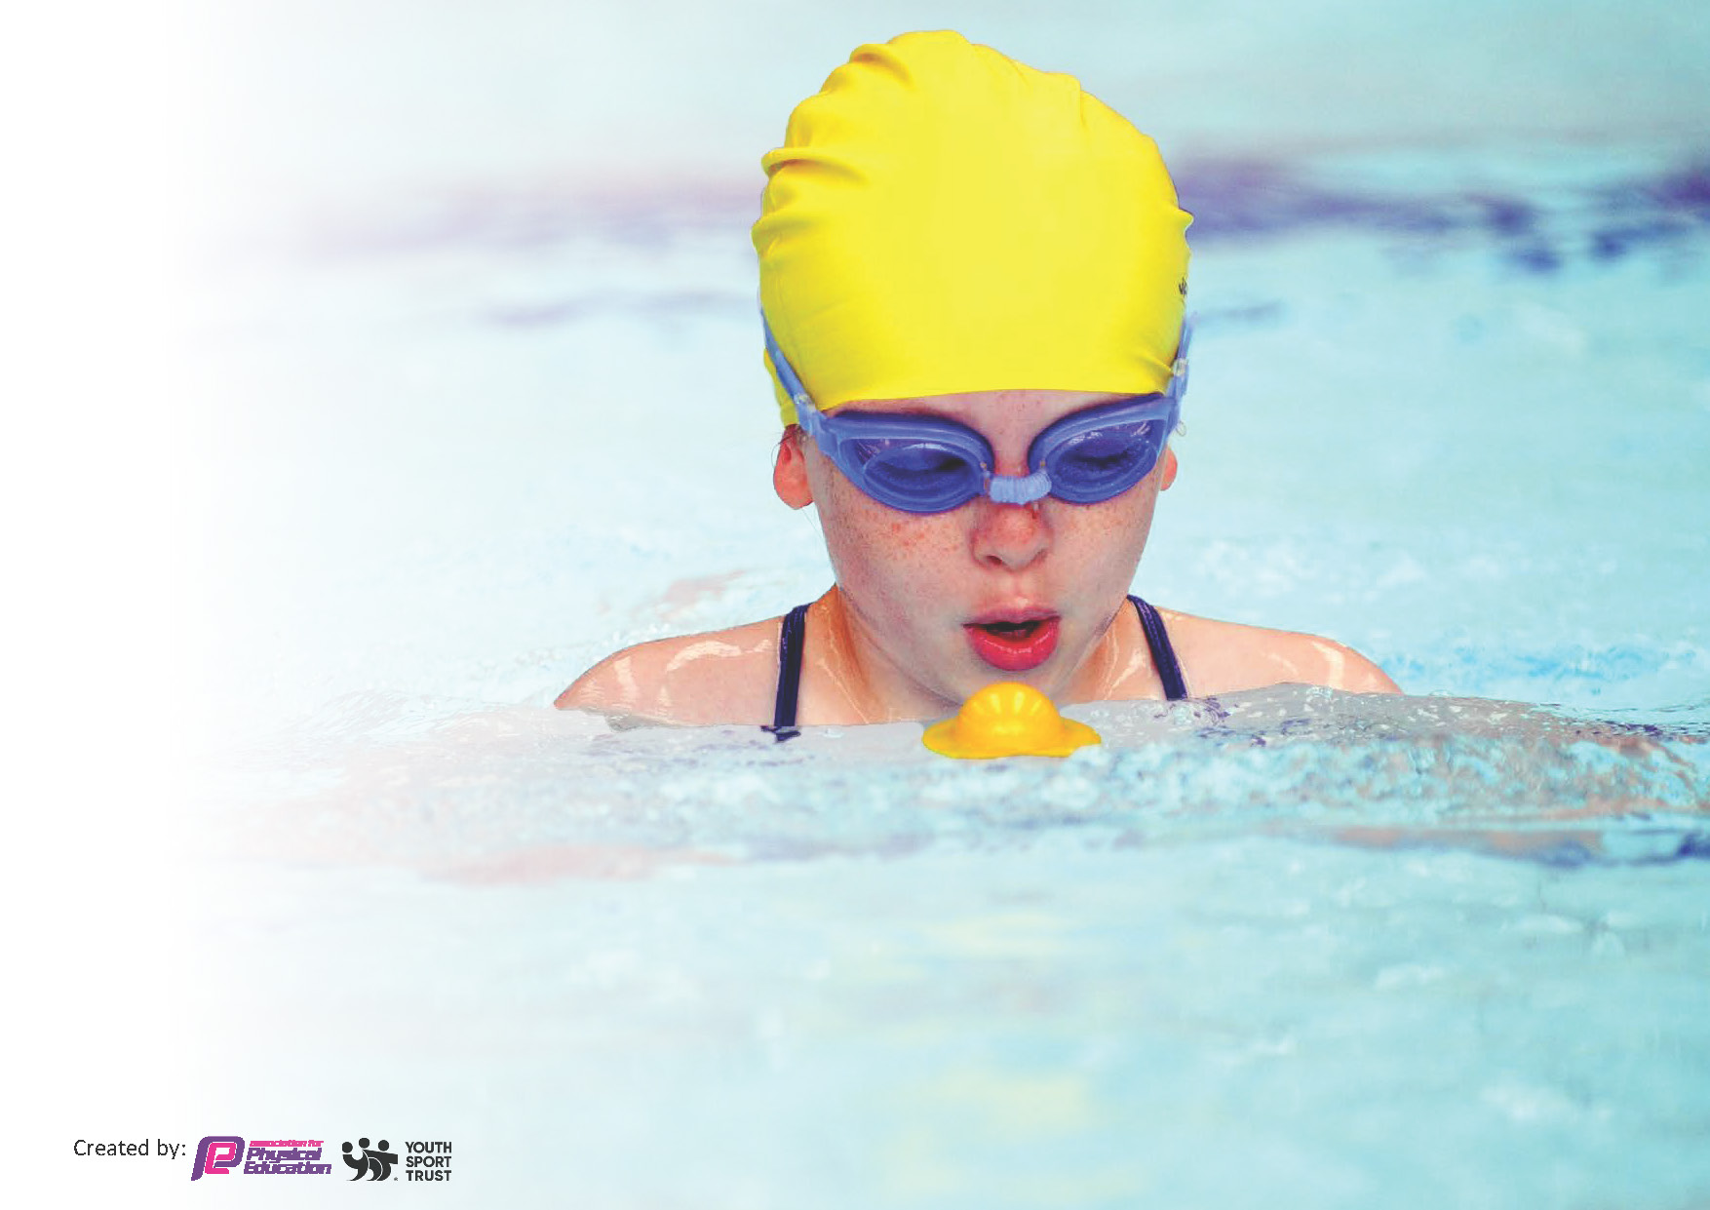
This template can be used for multiple purposes:
by:
- It enables schools to effectively plan their use of the Primary PE and sport premium
- It helps schools to meet the requirements (as set out in guidance) to publish information on their Primary PE and sport premium
- It will be an effective document to support Ofsted inspections enabling schools to evidence progress in Physical Education (PE) and evidence swimming attainment, which forms part of the PE National Curriculum. We would recommend schools consider
the Intent, Implementation and Impact of any spend, as examined within the Education Inspection Framework.

It is important that your grant is used effectively and based on school need.

Schools must use the funding to make additional and sustainable
improvements to the quality of the PE, School Sport and Physical Activity (PESSPA)
they offer. This means that you should use the Primary PE and sport premium to:

- Build capacity and capability within the school to ensure that improvements made now will benefit pupils joining the school in future years
- Develop or add to the PESSPA activities that your school already offers.

The Primary PE and sport premium should not be used to fund capital spend projects; the school’s core budget should fund these. Further detail on capital expenditure can be found in the updated Primary PE and sport premium guidance.

The Primary PE and sport premium guidance, outlines 5 key priorities that funding should be used towards. It is not

necessary that spending has to meet all the key priorities, you should select the priorities that you aim to use any funding towards.

Although completing this template is not a requirement for schools, schools are required to publish details of how they spend this funding. Schools must also outline what the impact this funding has had on pupils’ PE and sport participation and attainment and how any spending will be sustainable in the future. All funding must be spent by 31st July 2024.

The Department for Education has worked closely with the Association for Physical Education (afPE) and the Youth Sport Trust (YST) to develop this template and encourages schools to use it. This template is an effective way of meeting the reporting requirements of the Primary PE and sport premium.
Review of last year’s spend and key achievements (2023/2024)

We recommend you start by reflecting on the impact of current provision and reviewing your previous spend.

Activity/Action | Impact | Comments
Swimming – Year groups 2-5 able to swim for 10 weeks for 40 minutes. The cost of the swimming pool hire, lifeguard and one trained swimming teacher as well as the coach was £1410 | All pupils engaged in the swimming lessons.  We are aware that the middle school do not facilitate swimming lessons so we endeavor to support the children to each the expected standard by Year 6.  We support a range of swimming abilities from non-swimmers to county level swimmers. A number of our swimmers have competed in a range of swimming events. We have also had an increased uptake in our pupils attending local swimming clubs. | This has been successful as we have been fortunate to have a high level of engagement.  We are currently looking at alternative provision to enable all children across the school the opportunity to swim.
Bell boating Regatta – Years 4 and 5 take part in two days of bell boating on the River Avon, learning paddle skills and how to safely enter a boat. Costings include bell boating coaching from qualified and experienced coaches, plus admission and hire of boats etc. The regatta competition.  £1178.16 | It's a great opportunity to get outside and learn a new skill. Pupils have the opportunity to meet pupils from other local schools within the cluster. Being exposed to a wonderful sporting skill is such an opportunity. This may be the opportunity our pupils need to want to learn a new sporting skill. | This is a tradition we have done for many years and we all thoroughly enjoy the experience. It is simply an additional reason why our school is so special and unique.
Sports for schools – Sports for Schools is a social enterprise with a mission to help children to be more physically active. Darren Harris who is a Paralympic blind footballer attended our school and worked with all classes. Inspiring, teaching and supported fundraising opportunities.  £2310 | Over the past couple of decades, scientists have explained and confirmed how physical activity improves many aspects of a child’s life, including their academic performance and general wellbeing.  By inviting a Paralympian into our school, our pupils not only build on Sporting skills but are presented with the life proof that perseverance does pay off and you can achieve anything if you put your mind to it!  Sports for Schools events also helped to raise money for our sporting equipment. | Further more, we value the importance of inviting inspirational sports men and women into our school. We will therefore continue this in the next academic year and expose our pupils to a variety of sporting professionals (karate, martial arts etc)
Sports equipment – Teaching our pupils to the highest standard is a high priority, good quality equipment for each PE lesson is vital. Ensuring we have enough of each item, each item is not broken or malfunctioned, age appropriate and safe. This also includes the maintenance on wall bars in the hall and mats etc.  £1682.31 | - All pupils can engage in activities as there is enough of each resource.  - Pupils feel inspired and excited for lessons as it is exciting using a range of good quality resources.  - All pupils are using safe equipment.  - Pupils have an enhanced chance of succeeding in out of school opportunities as they will have used and understand how to use equipment effectively. | An audit will be carried out before the end of term. As there has been a hand over of PE leaders.
Tower trophies – awards and trophies have been purchased for sports day 2023 and to be used for the foreseeable future. Trophies have dwindled away and only some have returned.  £153.26 | Children are ambitious and determined to excel in sports day. Rewards such as trophies help to motivate our pupils to do their very best. Winning is recognised and awarded. | Pupils do aspire to win trophies and it continues a tradition many schools have done for years.
Pediatric first aid and defib –TED staff training on Pediatric first aid. Staff who attended are recognised first aiders and can successfully use the new defibulator which is now located in our school office.  £714 | Children are in safe hands both in school and out on trips. Staff have up to date first aid training to support our pupils if and when they are hurt. Having more staff trained enables us to be more flexible with staffing for trips and playground duties. The money was also used to go towards our new Defib which is a very important piece of kit if ever we may need it. | First aid training is an area in which we will continue to use our funding for as having the most up to date training and information is key to keeping our children safe here at ECFS.
New PE scheme – Getset4PE is the new PE scheme we have bought into. This includes- progression documents, assessment materials, LT Plans, MT Plans and daily lesson plans. An area in which staff needed extra support was swimming, this new scheme therefore offers full swimming plans and guidance.  £660 | Following on from pupil voice questionnaires children are now enjoying their PE lessons more. They feel they are engaging and exciting, previous to purchasing this new scheme 33% of pupils in KS1 said they didn’t enjoy PE lessons and 27% of pupils in KS2 didn’t enjoy their PE lessons. Since this scheme has been implemented less than 12% in both KS1 & KS2 now declare they do not enjoy their PE lessons. | This scheme is highly recommended and has excellent reviews. I am excited to see how our pupils and teachers can continue to benefit from such a fulfilling scheme.
Play time equipment – We have invested in playtimes and lunchtimes very much since the spring term. This money includes, playtime/ sporting equipment, recommendations from an external driver with regards to our layout of lunchtimes and splitting key stages. New age appropriate basketball hoops are to be purchased and professionally installed.  £3684.77 | What a big impact this has had on our lunchtimes/ playtimes. Volume within the hall is calmer and more manageable due to the external recommendations which has been offered. Children know where they should be and at what stage of their playtimes. Pupils are using age related playtime equipment which enables them to play successfully with each other. | Lunchtimes are much more enjoyable for all.  Previously it was a very loud and intimidating environment for our SEN and younger pupils. Now it is a more manageable environment with pupils mixing with their key stage.
Swimming pool –  Children will have access to a swimming pool within the school grounds. Instead of just ks2 accessing swimming lessons all children here at ECFS will have swimming lessons every day for 2 weeks.  £3600 | All children will be exposed to a swimming pool with professional swimming coaches every day for a period of 2 weeks. Over 500 Schools across the UK have participated in this programme since 2018 and the results have been amazing. | We are very excited to introduce this new swimming adventure, we believe it will be a wonderful start to the new academic year.
Staff sport kit – Staff have the option to purchase a new ECFS PE kit. As a school we are funding 50% to encourage us all as staff to look professional and to continue to represent our school.  £500 | All sporting events, staff and children alike are smart, they represent our school with pride looking smart and professional. The days of the week in which we teach PE staff model to the children how we should dress. | Staff are excited to and mostly on board with the new sporting kit. This is an area in which we would like to offer staff every other year to update their kit.
Total spent - £16900
Total available -
£16900

Key priorities and Planning
This planning template will allow schools to accurately plan their spending.

Action – what are you planning to do | Who does this action impact? | Key indicator to meet | Impacts and how sustainability will be achieved? | Cost linked to the action
Experience days  Tailored CPD  Sports equipment such as a rage of sporting balls and Tri golf set. Additionally following on from experience days new equipment may needs to be purchased.  To Achieve a Gold Sporting award  Inhouse swimming pool | Pupils, teachers and support staff. All of the above will be participating in the experience days and will be exposed to the sporting focus such as (military experience, yogo experience)  We are aiming to use move more to teach focusses units within our PE curriculum. Teachers will therefore have CPD opportunities.  Children will have the use of new and engaging sporting equipment to enable them to play each sport to the best of their ability.  We are striving to gain a gold award in the next academic year and to do so we are targeting our lowest movers. To enable them to access physical activity as much as possible we will fund external drivers to hold lunch time moving sessions, which are engaging and exciting.  Swimmers of all ages and staff for CPD | - The profile of PE and sport is raised across the school as a tool for whole-school improvement  - Broader experience of a range of sports and activities offered to all pupils  - Increased confidence, knowledge and skills of all staff in teaching PE and sport  - The engagement of all pupils in regular physical activity  - Broader experience of a range of sports and activities offered to all pupils  - Increased participation in competitive sports  - The engagement of all pupils in regular physical activity  - Increased participation in competitive sport  - The engagement of all pupils in regular physical activity  - The profile of PE and sport is raised across the school as a tool for whole-school improvement  - Broader experience of a range of sports and activities offered to all pupils  - Increased participation in competitive sports | Pupil’s will feel inspired to choose a new sport or career pathway.  Staff will magpie some activities to use in the classroom or for PE sessions.  Staff will have updated training and will feel equipped to teach areas of the PE curriculum in which they once felt was an area of weakness. Children will have the opportunity to learn from professional sports coaches.  Children will feel excited to join in during PE lessons and all children will have resources to have a wholesome session.  Cpd could be offered during this time and out lunch time supervisors or Teaching assistants could continue this provision in the future.  As a school we have a very high standard of swimmers and we would like to continue this long into the future. Instilling an early passion for swimming can only enhance our chances of this. | £5050  £7000  £500  £1787  £2300

Key achievements 2023-2024
This template will be completed at the end of the academic year and will showcase the key achievements schools have made with their Primary PE and sport premium spending.

Activity/Action | Impact | Comments
External sporting cluster events | Children here at ECFS are outstanding, offering a range of quality first lessons such as swimming, football, cricket, hockey etc our pupils have represented our school valiantly. We have certainly put our school on the map with many first and second placings. | We will continue to attend external sporting events, plus in the future we will be wearing our new sporting kits with pride, once again representing our school to the highest standard.
Playtime/lunch time organisation | This year we have certainly made a break through with the organisation of lunch time/play times here at ECFS. As our numbers are increasing we were reaching full capacity for pupils in the hall. With the money spent from an external driver to offer recommendations and the money used on new age appropriate sporting equipment we are offer a high quality environment for all. | Lunch time/ play time equipment is a being managed by a member of staff each lunch time to ensure it is stored and used appropriately each day rather than being left out in all weathers.

Swimming Data
Meeting National Curriculum requirements for swimming and water safety.
Priority should always be given to ensuring that pupils can perform safe self-rescue even if they do not fully meet the first two requirements of the National Curriculum programme of study

Question | Stats: | Further context  Relative to local challenges
What percentage of your current Year 6 cohort can swim competently, confidently and proficiently over a distance of at least 25 metres? | % | As we cannot address a year 6 cohort here is the data we can show.  35% of ks2 can achieve this target
What percentage of your current Year 6 cohort can use a range of strokes effectively [for example, front crawl, backstroke, and breaststroke? | % | As we cannot address a year 6 cohort here is the data we can show.  35% of ks2 can achieve this target

What percentage of your current Year 6 cohort are able to perform safe self-rescue in different water-based situations? | % | As a first school we only reach year 5. However the 35% of our year 4/5 pupils achieving this is a strong indication that many of our pupils should reach this by year 6.
If your schools swimming data is below national expectation, you can choose to use the Primary PE and sport premium to provide additional top-up sessions for those pupils that did not meet National Curriculum  requirements after the completion of core lessons. Have you done this? | Yes/No | NA
Have you provided CPD to improve the knowledge and confidence of staff to be able to teach swimming and water safety? | Yes/No | Yes previously we had no set planning scheme to support the teaching of swimming. Within our recent teacher voice for PE 2 out of 3 teaching members of staff stated they would like more support when teaching swimming. We therefore bought into a new PE scheme which supplies us with swimming detailed swimming lessons teachers can teach from .

Signed off by:

Head Teacher: | REPENNEY (Rachel Penney)
Subject Leader or the individual responsible for the Primary PE and sport premium: | KBROWN (Kate Brown)
Governor:
Date: | 24.6.24

