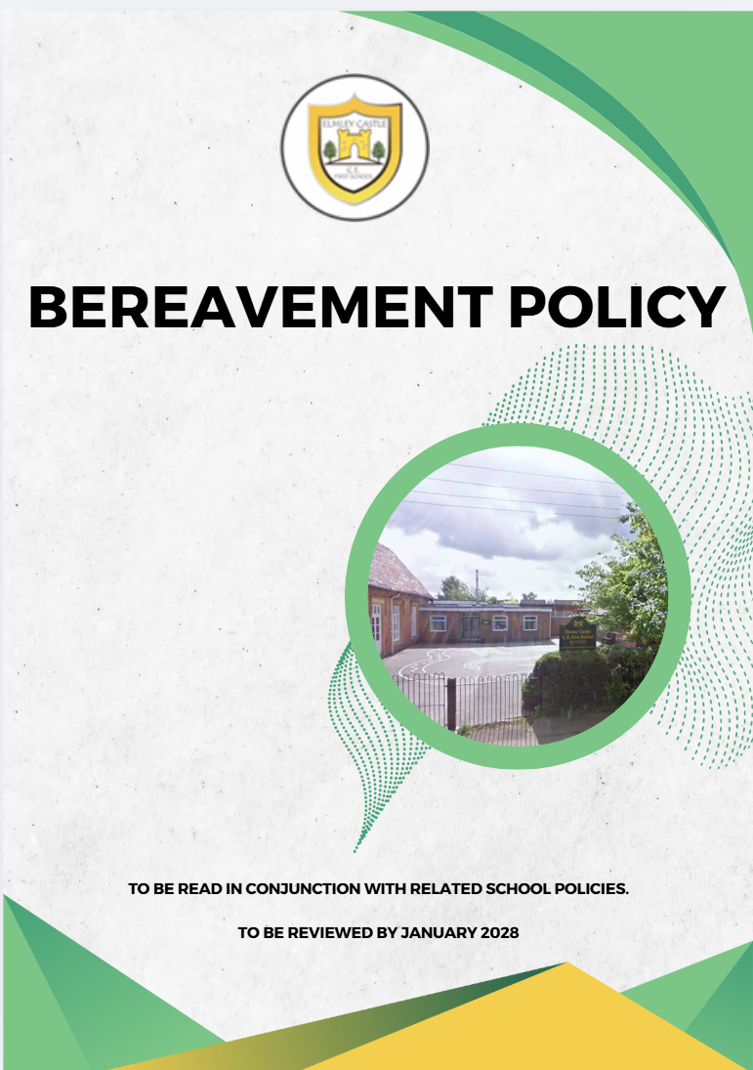
find
Elmley Castle C of E First School School Vision

At Elmley Castle C of E First School, we believe that every child is a light in the world. We love
one another, inspire growth, and serve our community with kindness. We embrace resilience,
learning from our mistakes and growing stronger together. Each day, we strive to shine in all that
we do, creating a safe and welcoming space where everyone can grow in faith, knowledge, and
community. Together, we light the way for a brighter future, serving as beacons of hope and love
to all.
"You are the light of the world. A city set on a hill cannot be hidden." – Matthew 5:14
BLISS
Believe in yourself
Love one another
Inspire greatness
Shine with kindness
Serve with a heart of compassion
Let your Light Shine!

In this policy, the term ‘Headteacher’ refers to the Executive Headteacher when that role is in post. Should the role no longer form part of the school’s leadership structure, the term will revert to referring to the Headteacher.

At Elmley Castle C of E First School, we understand that bereavement is faced by members of our school community at different times, whether this is the death of a family member, a friend or a member of the school community. We understand the importance of providing support to pupils, staff, governors and the wider school community during and after bereavement.

This policy provides a framework whereby this support is provided and outlines how the school will respond to these sensitive situations

This policy operates in conjunction with the following school policies:
- Child Protection and Safeguarding Policy
- Social, Emotional and Mental Health (SEMH) Policy
- Behavioural Policy
- Anti-bullying Policy
- Disciplinary Policy and Procedure
- Leave of Absence Policy
- Critical incidents Policy

1. Aims
This bereavement policy aims to:
- Set out a guideline for how our school will respond to a death in our school community
- Set out a plan for communicating deaths in a timely manner that balances our school community’s interests and transparency with the wishes of the family of the deceased
- Identify best practices for supporting pupils and/or members of staff experiencing bereavement
- Define the roles and responsibilities of key staff members and the governing board
- Provide a roadmap and framework for pupils or staff returning to school following bereavement

2. Roles and responsibilities
The Head of School
The Head of School will be responsible for:
- The overall implementation of this policy.
- Liaising with external agencies, as appropriate, including the Diocese, as a first point of contact for bereavement support for the school community.
- Being the first point of contact for staff, pupils and parents directly involved in a death.
- Ensuring staff have the necessary advice to support bereaved pupils and to deliver sensitive news.
- Making referrals for pupils, staff and other members of the school community to receive support, as required.
- Respond to media requests for information in the case of a publicised death.
- Participate in any multi-agency reviews as requested.
- Lead reintegration meetings for pupils or staff returning to school after a bereavement.

Governing board
The governing board is responsible for monitoring the implementation of this policy and supporting the headteacher.
The governing board will:
- Undertake monitoring of how the school is supporting the bereaved, and the staff who support them through catchups with the headteacher and staff offering pastoral support
- Monitor the headteacher’s emotional wellbeing through regular meetings between the headteacher and chair
- Assist the headteacher, where required, in responding to media requests for information in the case of a publicised death
- Where necessary, arrange for another staff member to take the lead if the headteacher is not available to respond to a death immediately

3. The initial response
- If the family or member of staff contacts the school to inform them of a death, the member of staff that answers the phone will transfer the call to the Headteacher.
- If the school is made aware of the death through a source other than the family, the Headteacher will contact the family either by phone or through a home visit to offer condolences and support.
- The Headteacher will gather factual information about what has happened and establish the family’s wishes with regards to what information will be communicated to the school community and how.
- If a death affects the entire school, e.g. the death of a pupil or member of staff, the Headteacher will inform staff and pupils, whilst being sympathetic to the family’s views.
- If the death affects an individual member of staff, e.g. the death of a relative, the Headteacher will ask the member of staff if they would like this to be communicated to any of their colleagues. If it is decided that the death will be communicated, the Headteacher will discuss with the staff member what information will be communicated and how they would like it to be delivered.
- If the death affects an individual member of staff, whilst on site, the Headteacher will offer them a private, quite place removing them from duties immediately. The Headteacher will offer comfort and support, contacting a family member or friend if requested. The Headteacher will arrange transport home, if needed, and grant compassionate leave in line with school policy.
- If a death affects an individual pupil, e.g. the death of a parent, the Headteacher will ask the family if they would like this to be communicated to the school community. If it is decided that the death will be communicated, the Headteacher will discuss with the family, and the pupil if possible, what information will be communicated and how the family would like it to be delivered.
- If the death of a pupil’s family member occurs while the pupil is at the school, a member of the pupil’s family will be asked to come to the school to inform the pupil of what has happened and to take them home. If this is not possible, arrangements will be made for a member of staff to take the pupil home.
- The Headteacher will make contact with any other agencies as required, e.g. the clergy, Diocese, police, bereavement counsellors or support agencies.
- In the event of the death of the Headteacher, the Governing Board will be responsible for the delegation of duties outlined above.
4. Informing staff and Governors
- Staff and Governors, to include part-time will be informed of the death as soon as possible, where appropriate, and preferably before the pupils are informed. Any information shared will have prior approval from the family.

5. Informing pupils
- If the death affects the whole school, e.g. the death of a staff member or pupil, the Headteacher will strongly recommend to the family that all pupils should be informed; however, if the death does not affect the whole school, it may be more appropriate to just inform certain groups of pupils.
- The Headteacher will make the final decision regarding which pupils will be informed.
- Staff members responsible for informing pupils about the death will be provided with guidance by the Headteacher, regarding what pupils should be told and how to approach difficult questions.
- It is important that children are informed of a death in an age-appropriate manner.
- Where possible, pupils will be informed about the death in small groups by a member of staff who is familiar to them.
- Pupils will be given time to ask questions about what has happened and to talk about how they are feeling.
- Any questions asked by pupils will be answered factually.
- Pupils will be told who they can go to in school for support. Parents will be advised of all avenues of internal and external support which they can access, if they feel it is appropriate.
- Pupils with specific needs that may influence their response to being informed about the death will be identified and told separately. This may include the following:
  - Pupils that had a long-term and/or close relationship with the individual who has died
  - Pupils with a history of loss
  - Pupils with SEND
  - Pupils who have difficulty managing their emotions or behaviour

6. Informing parents
- The Headteacher will have a discussion with the family about whether any parents need to be informed about the death.
- If the death affects the whole school, e.g. the death of a staff member or pupil, the Headteacher will strongly recommend to the family that all parents should be informed; however, if the death does not affect the whole school, it may be more appropriate to just inform parents that are directly affected, if any.
- The Headteacher will compose a letter to parents about the death. The letter will contain the basic, factual information about the death, information about how the school is supporting pupils, how they can support their children, and who to direct questions or concerns to.

7. Funerals and remembrance activities
- With the family’s approval, the Headteacher will arrange for the school to be represented at the funeral and identify which staff and pupils may want to attend, if appropriate.
- The Headteacher will decide if it is necessary for the school to be fully or partially closed.
- Necessary cover arrangements will be made for staff attending the funeral.
- Should any remembrance activity be planned, the family will always be consulted prior to the event. All events of this nature must be respectful of the culture and religious beliefs of the family.

8. The media and social media
- Any communication with the media or social media activity will be agreed with the family.
- Only the Headteacher will deal with media enquiries and communications. Staff will not respond to any media enquiries themselves or make any public statements about the death.
- Staff will not post any information about the death on social media. Should any member of the school community see anything concerning on social media regarding the death, the Headteacher should be informed at once.
- The local authority provides support for schools in managing media coverage, and the school will make use of this support when required

9. Support for pupils who have experienced a significant bereavement, e.g. of a family member
- A member of staff that is familiar with the pupil will be appointed to act as their main point of contact.
- Any support put in place for a pupil will be pupil-led, taking into account the following:
- The circumstances surrounding the death.
- The relationship between the pupil and the person who has died.
- The ability of the pupil’s family to support them following the death, e.g. if a pupil’s parent has died, how able is the surviving parent to support the pupil?
- Characteristics of the pupil, including their age and any SEND they have.
- If a pupil chooses to attend school immediately after a bereavement, staff members will be made aware that the pupil may not be able to work to their usual capacity. The designated staff member will keep in communication with the pupil’s family to inform them about how the pupil is doing.
- If the pupil is absent from school following the bereavement, the designated staff member will make regular contact with them during their absence and appropriate arrangements will be made for their return to the school; this may involve a phased return.
- Any safeguarding concerns regarding a bereaved pupil will be dealt with in line with the Child Protection and Safeguarding Policy.

9. Support for all pupils following the death of a peer or familiar member of staff
- Staff will talk to pupils about what has happened using age-appropriate and developmental stage appropriate language.
- Staff will identify any pupils that may need more direct support and make a referral to the Headteacher who will assess what support might be required.
- Staff will remain vigilant to the following behaviours that a pupil may display immediately after the death of someone close to them:
- Lack of motivation
- Inability to concentrate
- Tiredness and irritability.
- Heightened sensitivity to comments and remarks.
- Inability to take others’ feelings into account.
- Anger, frustration or aggression.
- A general change in behaviour, e.g. becoming unnaturally quiet or withdrawn
- Anxiety.
- Being easily upset by events that would normally be trivial to them.
- Physical complaints, such as headaches, stomach aches and a general tendency to be prone to minor illness

10. Support for the family
- The Headteacher will be the main point of contact between the school and the family or will appoint another member of staff to this role, where appropriate.
- The Headteacher will invite the family into the school to discuss how the school can best support them.
- Any support that is put in place will be decided on a case-by-case basis, depending on the family’s needs and wishes. Support could include the following:
- Sending a letter of condolence.
- Giving the family the opportunity to collect any personal belongings of the person who has died.
- Inviting the family to commemorative events held by the school

11. Support for staff
- Staff directly affected by the death, e.g. if they are a relative or close friend of the individual that has died, will be identified and the appropriate support will be offered.
- The level of support will be decided on a case-by-case basis by the Headteacher, and may include the following:
- Ensuring the staff member is not left on their own.
- Arranging for lessons or other duties to be covered.
- Organising bereavement leave – this will be offered in line with the Schools Leave of Absence Policy.
- All staff members will be offered the opportunity to take up pastoral support, if this is available and provided with information about the internal and external support they can access.
- Staff will be vigilant to the signs that indicate their colleagues have been affected by bereavement and will offer them support or share these concerns with the Headteacher.

12. Other considerations
- For certain circumstances, specific measures may need to be implemented on an individual basis, for instance where a family member or a pupil has a life-threatening illness or is not expected to live. In all such circumstances, any support will be tailored appropriately, with great understanding and respect for the family’s wishes
- Should the school be informed of the suicide of a pupil, parent or member of staff, the following will need to be taken into consideration:
- The need to agree any information to be shared about the cause of death with the family.
- If the death is subject to an ongoing investigation, the Headteacher will check with the police before speaking about the death with pupils who may need to be interviewed by the police.
- Any information distributed to the school community and media regarding the death will:
− Be factually correct but not include detail of the cause of death or method used.
− Not romanticise, glorify or vilify the death.
− Not include details of any suicide note.
− Not include speculation over the motivation for suicide.

- Research indicates that pupils that have been directly affected by suicide are at an increased risk of taking their own life. Staff will report any concerns about pupils to the Headteacher, and the appropriate support will be put in place or a referral to specialist services will be made in line with the Social, Emotional and Mental Health (SEMH) Policy.
- The school will keep in mind the cultural attitudes and behaviours relating to a death and will make sure these needs are taken into consideration when putting support in place for those affected, including the length of bereavement leave for members of staff.
- The needs and feelings of bereaved forces’ pupils will always be considered prior to any school activities relating to the armed forces, e.g. commemorating Armed Forces Day, and additional support will be put in place for pupils as required.
- Pupils who experience a significant bereavement can be at risk of developing social and emotional issues. Staff will report any concerns about pupils to the Headteacher, and the appropriate support will be put in place or a referral to specialist services will be made in line with the Social, Emotional and Mental Health (SEMH) Policy.
- In the event of a child or member of staff becoming terminally ill, their wishes and those of their parents/guardians/next-of-kin should always be respected. Should the child wish to attend school, the class teacher may need to inform the class of the child’s condition.

13. Managing transitions
- Information about pupils that have been bereaved will be recorded on CPOMs
- This information will be shared with relevant parties at key transition points, including the following:
- If the pupil moves school.
- When the pupil moves to middle school.
- If the pupil moves class.
- When the pupil will be taught by a new teacher.

14. Teaching about bereavement and grief
- Different aspects of the curriculum will be used to discuss relationships, feelings and emotions, and to think about how to manage these in relation to family events and death.
- Before delivering any lessons that cover topics of death and bereavement, the teacher will consider how the lesson may affect the bereaved pupils they are teaching.
- Bereaved pupils and their families will be consulted over whether it is appropriate for them to attend lessons about death or bereavement, and alternative arrangements or additional support will be put in place as required.
- Where appropriate, the teacher will discuss what the lesson is going to cover with the pupil and will work with the pupil to design activities that the pupil feels they are able to get involved with.
- Any lessons covering topics of death or bereavement will take account of religious and cultural beliefs.

15. Support for pupils returning to school after bereavement
Reintegration meeting
- A member of the pastoral team will meet with the bereaved pupil and their parents/carers to discuss how best to manage a return to school. The purpose of the meeting will be to:
  - Determine whether the pupil is emotionally ready to return to the classroom either full-time or with adjustments to the timetable to allow for a phased return
  - Address any concerns the pupil and their parents/carers have about the return to school
  - Consult with the pupil about how or even if they want their classmates to know of the death (where relevant)
  - Consider any additional support needed for a pupil who is vulnerable or has special educational needs (SEN) or a disability

- Ongoing support
We will maintain regular contact with the pupil’s parents/carers to monitor how the pupil is coping. We acknowledge significant dates or holidays may be especially difficult. The dates will be monitored and additional support will be available.
We know that grief may impact a pupil’s progress and affect their behavior. To manage this we will;
- Address behavior using our behaviour Policy
- A record will be made of anniversaries and days with regards to the death which may act as a trigger for challenging behavior.
- Any incidents of bullying, where a bereaved pupil is the victim or perpetrator, will be addressed in line with the behavior and anti-bullying policy, taking into account the pupil’s needs and circumstances.
- All staff members will remain vigilant to signs that a bereaved pupil is facing difficulties in relation to their psychological, physical and social development and will refer the pupil to the Headteacher who will put appropriate support in place.
- We will take care to manage changes for bereaved pupils by preparing them in advance (where possible) and taking extra steps to support necessary transitions

- Support for staff returning to school after bereavement
Reintegration meeting
The Headteacher will meet with the bereaved staff member to discuss how best to manage a return to school.
The purpose of the meeting will be to:
- Determine whether the staff member is ready to return to work and the best way to make that return (e.g. a phased return to work or a temporary change in duties)
- Address any concerns the staff member may have about the return to school
- Consult with the staff member about how or even if they want their pupils and colleagues to know of the death (where relevant)
- Set guidelines for communication between the staff member and their line manager to monitor and support the staff member

- Ongoing support
We acknowledge that grief can have an impact on a staff member’s physical and mental health, which can then go on to impact their performance. We also recognise that grieving is highly personal and that there can’t be a one-size-fits-all solution for monitoring and supporting a bereaved person. We will work with each individual to create a system of monitoring and support that works for that person. Whenever necessary we will request additional support from colleagues or from external support agencies.

- Monitoring arrangements
This policy will be reviewed by the Headteacher. At every review, it will be approved by the full governing board. Any updates in the meantime, will be communicated with staff.

- External support agencies
- autism.org.uk/about/family-life/bereavement.aspx – Advice when supporting someone with autism cope with a death.
- childbereavement.org.uk – Supports families and professionals when a child is bereaved or facing bereavement.
- childhoodbereavementnetwork.org.uk - Childhood bereavement.
- childline.org.uk - Free national telephone helpline for children and young people.
- crusebereavementcare.org.uk - All aspects of bereavement.
- griefencounter.org.uk - Helps bereaved children & young people rebuild their lives.
- hopeagain.org.uk - Specifically for young people aged 12-18.
- supportline.org.uk - Confidential emotional support for children, young people & adults.
- papyrus-uk.org - Provides resources & support for those dealing with suicide, depression or distress –
- particularly teenagers & young adults.
- seesaw.org.uk - Grief support service for children and young people.
- sands.org.uk - Providing support for parents & families whose baby is stillborn or dies soon after birth.
- teenissues.co.uk – Discussing the issues teenagers face.
- theredlipstickfoundation.org – Support for families bereaved by suicide.
- uk-sobs.org.uk - Those who are left behind after a suicide can be helped by talking to others who have experienced a similar loss.
- Widowedandyoung.org.uk – peer-peer network for those widowed before their 51st birthday
- winstonswish.org.uk - Help for grieving children and their families
- mentorlink.org.uk – Local charity offering guidance and support

