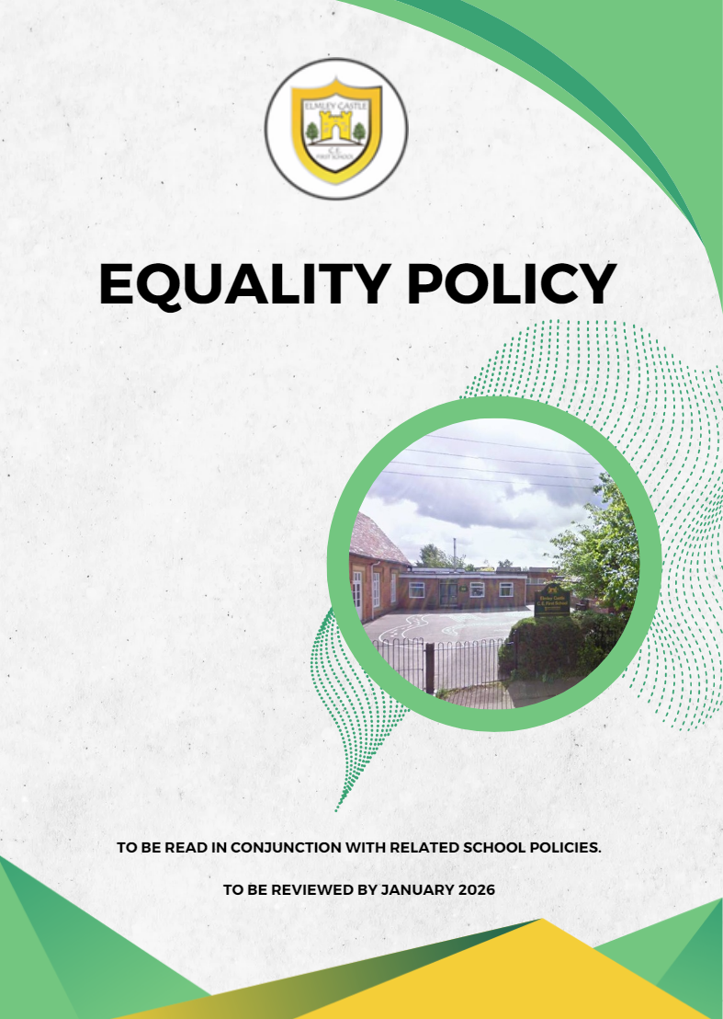

Equality Policy

Our Equality, Diversity & Inclusion Vision

Head Teacher and Governing Body
“Our School and Worcestershire County Council is committed to eliminating all forms of discrimination, creating an inclusive organisational culture and meeting the diverse needs of all our communities in our County.

We aim for all employees to feel they can be themselves, thrive at work and feel respected for who they are. We are focused on building inclusive behaviours that are built on a foundation of respect and appreciation for diversity and inclusion for everyone and in all its forms.

We recognise and value diversity of talent and aim to recruit, develop and retain talented people, value experiences, perspectives and skills. We recognise that being a diverse and inclusive employer helps us to develop a workforce which understands the needs of all our colleagues, and residents, whilst making a difference.

We are committed to ensuring that our school services are needs based and that we support our School Community by fostering good relations between groups who share protected characteristics and those that don’t. We will promote a culture of respect and dignity, and actively remove discrimination wherever we find it. We will identify and remove barriers for our job applicants and current employees and will endeavour to meet our school needs through communication and engagement.”

Contents
Introduction 1
Statement of intent 1
Employment 2
Employment commitments 2
Partners and third parties 2
Procurement 3
Responsibility for policy implementation 3
Examples of harassment / unacceptable behaviour 4
Policy History 5

Introduction

Our School and Worcestershire County Council and Worcestershire Children First (the Council) takes great pride in the diversity of the community it serves and recognises the opportunities and benefits this offers the County. We want to build cohesive communities and recruit, retain and develop a diverse workforce where everyone feels valued, respected, included and welcome.

We recognise that people may experience barriers, which makes it difficult to participate in the life of our community and we aim to advance opportunity and promote the values of inclusion and belonging to everyone in Worcestershire.

Statement of intent

- Our school is committed to equality of opportunity for everyone and understands that the diversity of our community and staff is a strength to the social and economic prosperity, and innovation in the county. Our School commits to working within the Equality Act 2010 and our Public Sector Equality Duty to ensure that no, visitor to the school, job applicant, employee or other person associated with our school is treated inequitably or in an unlawful or unjustifiably discriminatory way.

- Our School recognises that people may experience discrimination and less favourable treatment on the grounds of their protected characteristics – as described within the Equality Act 2010:

Age, Disability, Race,
Sex,
Gender reassignment, Marriage/civil partnership, Pregnancy and maternity, Religion/belief,
Sexual orientation

We also recognise that people may experience discrimination in a range of ways and receive less favourable treatment for other reasons (e.g., on the grounds of their financial or economic status, unrelated criminal convictions, gender identity, education level or location of study, homelessness or lack of a fixed address, political view, or trade union activity).

- Our School as part of Worcestershire County Council will also take proactive steps to pay ‘due regard’ to the need to enhance equality, tackle discrimination and help foster good community relations when exercising its functions.

- The leadership and day to day operation of this policy rests with all colleagues, specifically including the Governing Body and Leadership of the School and they must ensure that all employees within their area of responsibility, partners, and contractors, are aware of the policy and understand their role in its implementation.

Employment

- Our School is part of Worcestershire County Council and recognition of its role as a community leader, and its’ firm commitment to equality of opportunity and as such aims to be an inclusive employer, and to remove any barriers to employment. Our School will continuously review policies, practices, and procedures to identify and remove potential barriers to equality of opportunity.

- Our School will ensure that no job applicant, employee, or leaver receives less favourable treatment which cannot be shown to be justifiable in line with the Equality Act 2010.

Employment commitments

- Recruitment and selection criteria, and procedures will ensure that individuals are selected for employment (or volunteering), promoted, and treated fairly based on their relevant merits and abilities. It is also acknowledged that certain roles are exempt from such practices legally where specific requirements are in place and offers for employment may be subject to a successful DBS check.

- Our School is committed to having a workforce that is representative of the community it serves and will support and enable people to obtain employment on merit.

- Our school will strive to ensure that its employment policy, practices, and arrangements are flexible and adapted to support, as far as is lawful, reasonable, and practicable, specific needs and requirements of individuals and groups.

- Our school is committed to providing a safe and secure environment for all staff, taking action against all forms of discrimination and harassment. Our school will not tolerate any harassment, whether physical or verbal or otherwise, of employees by members of the public or colleagues. Our school will act on any employee grievance relating to discrimination, victimisation, or harassment. Colleagues will also be supported to report any hate crimes, through the appropriate channels and liaise with Victim Support where necessary.

Partners and third parties

- It is recognised that there are stakeholders, partnerships and other third parties who collaborate and / or deliver services or have a relationship with our school as part the Council. It is expected that all parties adhere to the Equality Policy, our values, ethics and practices and copies of this policy will be shared to those we work with, or made available

Procurement

- Our school alongside the Council will ensure that contracts comply with this Equality Policy, strategy, and all relevant / related legislation.

- Our school alongside the Council will encourage the local community to take up opportunities to contract and will seek, wherever appropriate, to offer contracts within the local community’s ability to deliver, ensuring that they comply with Best Value and legislation on procurement and geographic location.

- Contracts will be awarded in a fair and open evaluation process considering a range of factors including price, best value, and ability to deliver the contract. Reasonable opportunity for feedback to unsuccessful bidders will be offered where appropriate.

Responsibility for policy implementation

- Governors, Headteachers, SLT and all employees with supervisory remit are responsible, within our school and their area of work, for implementing and promoting this policy.

- All School employees are responsible for implementing the policy. They must adhere to it as part of their conditions of service and will be supported and encouraged by their managers. Any failure to do so will be considered in accordance with the School’s Disciplinary Procedures and Code of Conduct.

- Employees and those serving the community for, or on behalf of our School must not:
- Ignore incidents of discrimination,
- Unlawfully discriminate against anyone,
- Persuade, incite, or encourage another person to discriminate,
- Harass, victimise, or abuse other employees or members of the public for any reason

- Employees are not expected to tolerate discrimination from other members of the school community, other employees, providers or any third party or partner.

Examples of harassment / unacceptable behaviour

- Harassment

Within the Equality Act 2010 harassment is defined as unwanted behaviour, based on someone’s protected characteristic (or a perception that they have a particular characteristic) that the recipient or a witness finds offensive. Harassment could relate to someone’s race, sex (including pregnancy/maternity), disability, sexual orientation, age, religion/belief, or gender reassignment.

Unwanted behaviour could include:

- spoken or written abuse, using offensive words about a particular racial group, or using phrases or derogatory language
- offensive emails
- comments or posts on websites and social media
- circulating or displaying offensive material or insignia
- images and graffiti
- physical gestures and facial expressions that mock others
- ‘banter’ or jokes that are offensive to the recipient or others
- negative stereotyping
  - telling people to “go back home” or implying certain groups or people are not welcome (implying they do not belong in the UK)
- ‘outing’ someone’s sexual orientation, trans status or gender identity to another person without express permission from the individual or group in question
- refusing to use the correct pronoun for someone who may or may not have transitioned or has undergone gender reassignment

Anything that is unwelcome to the recipient is unwanted. The unwanted behaviour must have the purpose or effect of violating someone’s dignity, or creating a degrading, humiliating, hostile, intimidating or offensive environment.

- Sexual Harassment

Sexual harassment is defined in the Equality Act 2010 as: ‘unwanted conduct [related to a person’s sex] and in the amended Duty 2024 amendment of the act is defined as conduct of a sexual nature which has the purpose or effect of violating an individual’s dignity or creating an intimidating, hostile, degrading, humiliating or offensive environment’. Reasonable steps will be taken to protect our employees and any third party from sexual harassment, if sexual harassment has occurred action will be taken to ensure to stop it from happening again.

Examples of sexual harassment include:

- sexual comments or jokes
- physical behaviour, including unwelcome sexual advances, touching and various forms of sexual assault
- displaying or sharing any image, pictures, photos, or drawings of a sexual nature
- sending emails with a sexual content

