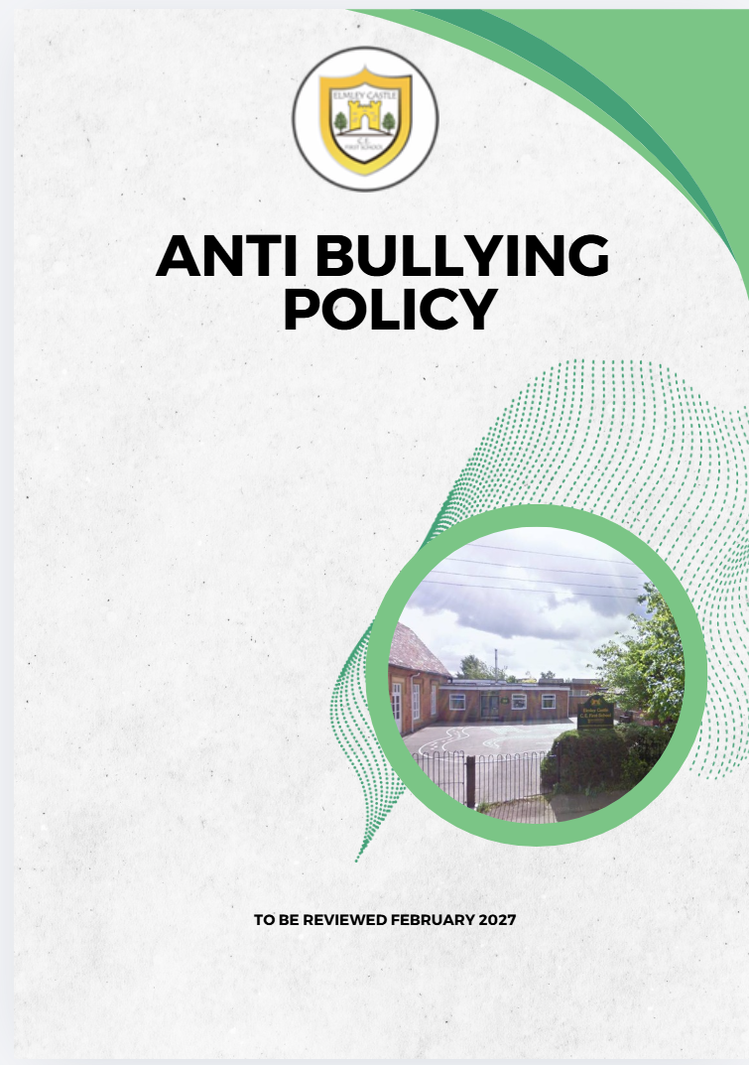
Elmley Castle C of E First School School Vision
At Elmley Castle C of E First School, we believe that every child is a light in the world. We love
one another, inspire growth, and serve our community with kindness. We embrace resilience,
learning from our mistakes and growing stronger together. Each day, we strive to shine in all that
we do, creating a safe and welcoming space where everyone can grow in faith, knowledge, and
community. Together, we light the way for a brighter future, serving as beacons of hope and love
to all.
"You are the light of the world. A city set on a hill cannot be hidden." – Matthew 5:14

BLISS
Believe in yourself
Love one another
Inspire greatness
Shine with kindness
Serve with a heart of compassion
Let your Light Shine!

Our vision underpins our Anti-Bullying Policy. At Elmley Castle CE First School, children live through our Christian values and demonstrate kindness, respect and empathy. Our pupils develop strong emotional literacy and the confidence to challenge behaviour associated with bullying. We aim for every child to achieve happiness, emotional and physical wellbeing, and to flourish spiritually. Through this vision, every child grows as an individual, develops a lifelong love of learning, and learns to love others, the world and themselves.

Anti-Bullying Policy
Keeping children safe from bullying is an integral part of our safeguarding responsibilities. All pupils have the right to learn in a safe, nurturing and supportive environment, free from fear or intimidation. Bullying is anti-social behaviour and affects everyone; it is unacceptable and will not be tolerated. Effective handling of any bullying concerns ensures children can fully benefit from their education.

Definition of Bullying
Bullying is deliberately hurtful behaviour, repeated over a period of time, where it is difficult for the victim to defend themselves. Bullying may be:
- Physical (hitting, kicking, theft)
- Verbal (name-calling, racist remarks)
- Indirect (spreading rumours, exclusion)
- Child-on-child
- Prejudicial
- SVSH or unwanted behaviour

Intent
- To create an environment where bullying is unacceptable.
- To act immediately and positively on all reports of bullying.
- To ensure pupils feel safe, supported and able to speak up.
- To encourage discussion with staff, peers and family.
- To promote vigilance in identifying bullying.
- To address issues through the curriculum.
- To support both victims and perpetrators.

Implementation

- Children are taught how to discuss problems, show self-discipline and demonstrate assertiveness.
- Pupils learn how to keep themselves safe and how to report concerns.
- Positive reward systems reinforce good behaviour; sanctions may include loss of privileges.
- Staff listen carefully and respond sensitively through class time, circle time, assemblies and wellbeing programmes.
- All children know to tell a trusted adult.
- Emotional Journals are used for children to record worries.
- Pupils support one another through structured leadership groups.
- All incidents are taken seriously and reported to the Headteacher.
- Victims are offered immediate support and reassurance.
- Perpetrators are supported to understand their actions and make positive changes.
- Consequences may include warnings, isolation, missed breaktimes and loss of privileges.
- Parents of all children involved are informed as appropriate.
- Persistent bullying may lead to a Pastoral Support Plan or, in extreme cases, exclusion.

Bullying and Special Educational Needs and Disabilities (SEND)
We recognise that children with SEND may be more vulnerable to bullying and may have difficulty recognising or reporting it. Staff provide additional support, ensuring the child understands what has happened and feels safe to talk. A whole school approach ensures consistent expectations and clear understanding of appropriate behaviour.

Monitoring and Review
This policy is promoted and implemented by all staff. Bullying concerns are recorded as part of safeguarding procedures. The policy is monitored annually and formally reviewed every three years.

Related Policies and Documents
- Keeping Children Safe in Education (KCSiE) 2023
- Child-on-Child Policy
- Safeguarding Policy
- SEND Policy
- Staff Handbook
- Positive Handling Policy
- Exclusions Guidance
- Inclusion Policy
- Equal Opportunities Policy

