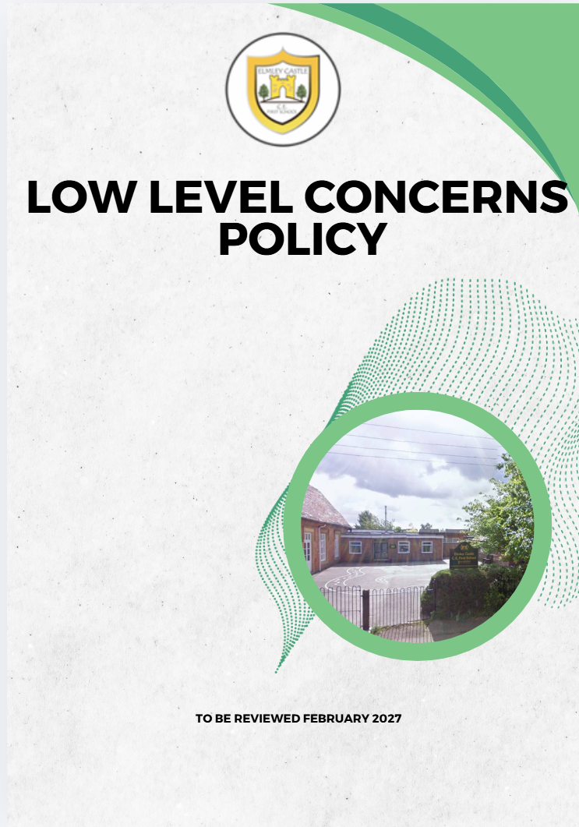

Elmley Castle C of E First School School Vision
At Elmley Castle C of E First School, we believe that every child is a light in the world. We love
one another, inspire growth, and serve our community with kindness. We embrace resilience,
learning from our mistakes and growing stronger together. Each day, we strive to shine in all that
we do, creating a safe and welcoming space where everyone can grow in faith, knowledge, and
community. Together, we light the way for a brighter future, serving as beacons of hope and love
to all.
"You are the light of the world. A city set on a hill cannot be hidden." – Matthew 5:14

BLISS
Believe in yourself
Love one another
Inspire greatness
Shine with kindness
Serve with a heart of compassion
Let your Light Shine!

1. Introduction
Elmley Castle CE First School recognises its duty to create and maintain a culture of openness, trust and transparency in which safeguarding concerns can be shared.
This policy follows:
- Keeping Children Safe in Education (KCSIE)
- Worcestershire Safeguarding Children Partnership expectations
- Worcestershire County Council model safeguarding procedures
It should be read alongside the school’s:
- Safeguarding and Child Protection Policy
- Staff Code of Conduct
- Managing Allegations Against Staff Policy
- Whistleblowing Policy

2. Definition of Low-Level Concerns
A low-level concern is any concern, no matter how small, about an adult working in or on behalf of the school that:
- Does not meet the harm threshold for referral to the LADO, but
- Is inconsistent with the Staff Code of Conduct, or
- Causes a sense of unease, concern, or “nagging doubt”

Examples include (Worcestershire model):
- Being overly friendly or showing favouritism
- Taking photos of pupils on personal devices
- Engaging in unnecessary or inappropriate 1:1 contact
- Using inappropriate language or tone
- Breaching professional boundaries
Low-level concerns are part of a wider safeguarding system and must always be taken seriously.

3. Safeguarding Culture
Elmley Castle CE First School will:
- Ensure all staff understand their responsibility to report concerns
- Promote an open and transparent safeguarding culture
- Encourage professional curiosity and respectful challenge
- Ensure concerns are not minimised or ignored

4. Purpose of Recording Low-Level Concerns
In line with Worcestershire guidance, recording low-level concerns:
- Helps identify patterns of behaviour
- Supports early intervention
- Prevents escalation to harm
- Protects both children and staff

5. Roles and Responsibilities

All Staff
- Must report any low-level concern promptly
- Must record factual information only
- Must not assume someone else will report

Headteacher
- Has overall responsibility for managing low-level concerns
- Reviews all reports
- Determines appropriate action
- Maintains a secure central record

DSL
- Supports threshold decisions
- Advises on safeguarding implications

Governing Body
- Ensures effective safeguarding procedures
- Monitors safeguarding culture and practice

6. Reporting Procedure (Worcestershire-aligned)
- Concerns must be reported immediately or as soon as possible
- Reports should be made to:
  - Headteacher, or
  - Chair of Governors (if concern involves the Headteacher)
- Staff must use:
  - the school’s Low-Level Concern Form, or
  - the school safeguarding system (e.g. CPOMS)

7. Recording and Storage
Records must include:
- Date, time, and context
- Factual description of behaviour
- Names of those involved and witnesses
Records will:
- Be stored securely
- Be kept confidential
- Be reviewed regularly by the Headteacher
Low-level concerns will be kept separate from personnel files unless escalation occurs.

8. Responding to Low-Level Concerns
The Headteacher will:
- Review the concern promptly
- Consider context, intent, and risk
- Check for patterns of behaviour

Outcomes may include:
- No further action (with rationale recorded)
- Informal discussion with the individual
- Advice, guidance or training
- Increased supervision or monitoring
- Formal action if required

9. Escalation
A concern will be escalated where:
- There is a pattern of similar concerns
- Behaviour becomes more serious
- There is risk of harm to a child
In such cases, the school will:
- Follow the Managing Allegations Policy
- Consult with the LADO

10. Confidentiality and Information Sharing
- Information will be shared on a need-to-know basis
- Records will comply with data protection legislation
- Staff involved will be treated fairly and respectfully

11. Staff Support
Elmley Castle CE First School recognises that:
- Being subject to a concern can be stressful
- Staff will be supported appropriately
Support may include:
- Professional discussion
- Guidance and clarification of expectations
- Access to support services if required

12. Whistleblowing
Staff must feel able to raise concerns without fear.
If concerns cannot be raised internally, staff should follow the Whistleblowing Policy or contact external safeguarding bodies.

13. Training and Awareness
- All staff will receive safeguarding training, including low-level concerns
- This policy will be included in induction
- Regular updates will be provided

14. Monitoring and Oversight
- The Headteacher will maintain oversight of all concerns
- Patterns or trends will be identified and addressed
- The Governing Body will receive safeguarding updates (anonymised where appropriate)

15. Policy Statement
Elmley Castle CE First School is committed to maintaining a strong safeguarding culture. All low-level concerns will be recorded, reviewed and acted upon to safeguard children and uphold professional standards.

Appendix A: Worcestershire-Aligned Low-Level Concern Form
Elmley Castle CE First School
Low-Level Concern Reporting Form

Section 1: Person Reporting
Name: ___________________________________
Role: ___________________________________
Date: ___________________________________

Section 2: Person of Concern
Name: ___________________________________
Role: ___________________________________

Section 3: Details of Concern
Please provide a clear, factual account (include date, time, location, context):

Section 4: Nature of Concern (tick if applicable)
☐ Boundary concern
☐ Conduct concern
☐ Communication concern
☐ Professional judgement concern
☐ Other: ___________________________________

Section 5: Witnesses
Name(s): ___________________________________

Section 6: Immediate Action Taken

Section 7: Previous Concerns (if known)

Section 8: Signature
Signed: ___________________________
Date: ___________________________

For Headteacher / DSL Use

Section 9: Initial Review
☐ Low-level concern – no further action
☐ Low-level concern – action required
☐ Escalated to LADO / formal procedures

Section 10: Decision and Rationale

Section 11: Action Taken
______________________________________________________________________________________________________________________________________________________________________________________________________________________________________________________

Section 12: Outcome

Section 13: Follow-Up
☐ Monitoring required
☐ No further action

Signed: ___________________________
Date: ___________________________

Storage:
This form will be stored securely in accordance with safeguarding and data protection requirements and reviewed as part of safeguarding oversight.

