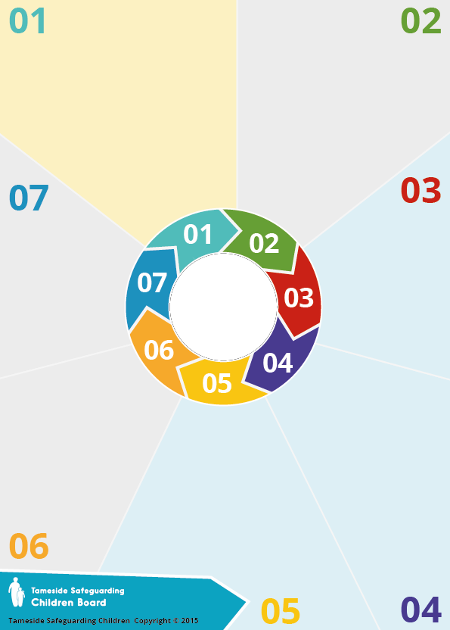
e-safety is a term which
encompasses not only the internet but other ways in which young people communicate using electronic media, e.g. smart phones, gaming consoles
.
The amount of time that children spend online has more than doubled in a decade. The number of 3 to 4 year olds with their own tablet is now at 21% and 53% of this age group go online for around 15 hours each week.

Tablet ownership is higher than smartphone ownership up to the age of 10, the two are then fairly even until age 12, when smartphone ownership begins to outstrip tablet ownership. 83% of 12 to 15 year olds own a smartphone.
Social media accounts for a fifth of all media and communications time for 11-15s.
This takes place throughout the day, and by 9pm 15% of 11-15s are still communicating via social media, and 2% are still messaging at midnight.
Background

Almost all 8-11s and 12-15s who go online say they have been told how to use the internet safely. Nevertheless, going online can expose children to unwanted and potentially dangerous experiences including cyberbullying, sexual harassment, grooming, child sexual exploitation and radicalisation.
- 17% of 8-11s and 29% of 12-15s who go online say they have seen something online that they have found worrying or nasty
- 45% of 12-15s who go online say they
have seen hateful content online in the last year
- one in ten 12-15s have seen something online
or on their phone of a sexual nature that made them feel uncomfortable
- 12% of 12-15s say they have been
bullied on social media, equal to the number who say they have been bullied face to face.

Why it matters



Children and Parents
Media Use & Attitudes Report 2021:

https://www.ofcom.org.uk/research-and-data/media-literacy-research/childrens/children-and-parents-media-use-and-attitudes-report-2021

Children’s online activities, risks
& safety: Research review 2017

E-Safety

What to do?

Do I have sufficient understanding of children’s use of digital media and key current research findings?

Do I keep my own information private on social media?

Do I understand the role of CEOP?

Do I know how I should respond to any social media requests from children or young people that I work with?

A research survey of 1,559 UK teenagers, published by Childnet in
December 2017, found that:
•in the last year almost a third of girls aged 13-17 years (31%) have received unwanted sexual messages online from their peers (11% of boys).
- Over half of UK teenagers have witnessed their peers circulating nude or nearly nude images of someone they know.
- 12% said that their boyfriend or girlfriend had pressured them to share nude images in the last year, with girls being more likely to report this (14%) than boys (7%).
- 23% have witnessed young people secretly taking sexual images of someone and sharing them online, also referred to as ‘creep shots’ or ‘upskirting’, while 8% admitted they had done this in the last year.
- 26% reported that they had received sexual comments on a photo they posted of themselves in the last year, with girls being significantly more likely to experience this (33%) compared to boys (14%).

Emerging research
suggests that some young
people are less resilient to online risks, including children who suffer physical, emotional and/or sexual abuse and neglect, witness domestic violence and/or family breakdown

Girls are more likely to offer positive reinforcement to their peers online than boys

Boys are more likely to be concerned about violent content online while girls are more concerned about contact and conduct-related risk.
Information
Questions
Information

