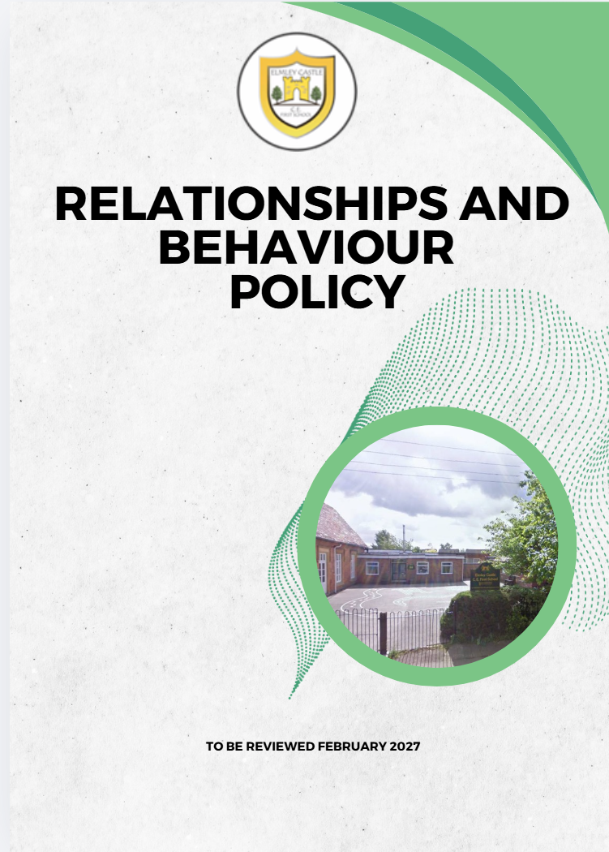
Elmley Castle C of E First School School Vision
At Elmley Castle C of E First School, we believe that every child is a light in the world. We love one another, inspire growth, and serve our community with kindness. We embrace resilience, learning from our mistakes and growing stronger together. Each day, we strive to shine in all that we do, creating a safe and welcoming space where everyone can grow in faith, knowledge, and community. Together, we light the way for a brighter future, serving as beacons of hope and love to all.
"You are the light of the world. A city set on a hill cannot be hidden." – Matthew 5:14
BLISS
Believe in yourself
Love one another
Inspire greatness
Shine with kindness
Serve with a heart of compassion
Let your Light Shine!
Curriculum
Our school family provides a purposeful, inclusive curriculum which is experiential, creative and memorable. We inspire a life-long love of learning by encouraging our children to be independent, resilient and curious. Success for our children means that they are happy, confident and responsible individuals who aspire to be the best that they can be wherever their journey through life may take them.

Protective Behaviours
At Elmley Castle C of E First School we work together to use a Protective Behaviours ‘language of safety’ and that we follow these two universal themes :
We all have the right to feel safe all of the time
We can talk with someone about anything, even if it feels awful or small.

INTRODUCTION

The purpose of this policy is:
- To create an environment which encourages and reinforces positive behaviour using our Protective Behaviours principles;
- To promote our school values which foster and encourage safe and positive behaviour attitudes;
- To establish clear guidelines and rules, based on common sense and safety, by which the school will operate;
- To encourage calm, consistency and a considered response to both safe and unsafe behaviour;
- To provide information to families in order to achieve consistency in the messages children receive about safe/ positive and unsafe/negative behaviour and behaviours that help or harm our school culture;
- To ensure that the school’s expectations and strategies are widely known and understood.
- To ensure all members of the school community create a positive, safe environment in which bullying, physical threats or abuse and intimidation are not tolerated, in which pupils are safe and feel safe and everyone is treated respectfully; and any incidents of bullying, discrimination, aggression, and derogatory language (including name calling) are dealt with quickly and effectively.

Children should begin to learn about positive behaviour at home before compulsory school age. Building on this foundation and in partnership with families we aim to create a happy, friendly, safe and caring environment where children grow to respect:
- one another
- themselves
- all staff and other adults working in school, e.g. volunteer helpers
- their families
- school property
- visitors to and neighbours of the school
- the rules and ethos of the school
- that everyone matters

This policy sets out:
- Our School Rules: Be Ready, Be Respectful, Be Safe
- What we mean by positive behaviour and negative behaviour, safe/right and unsafe/poor choices
- Our practice including roles and responsibilities, monitoring and reporting
- Contact with families
- The role of our older children in Year 5
- Rewards for positive/helpful behaviours and consequences for negative/harming behaviours
- Indicative examples of low, medium and high behaviours

It is a statutory requirement for schools to have such policies and to publish them on the school’s website.
This policy will be reviewed annually by the Senior Leadership Team (SLT) and trustees who will have read the guidance Behaviour and discipline in schools - Guidance for governing bodies - GOV.UK

SCHOOL ETHOS AND CULTURE

The adults encountered by the children at school have an important responsibility to model high standards of behaviour, both in their dealings with the children and with each other, as their example has an important influence on the children.

We use Protective Behaviours to ensure we have a consistent language of safety, and this is underpinned by the two key protective behaviours themes:

- We all have the right to feel safe all the time.
- We can talk with someone about anything, even if it feels awful or small.

Protective Behaviours helps us to:
- Increase our self-confidence and empower us to develop our own thinking and problem-solving skills
- Understand what safety feels like
- Recognise Early Warning signs which tell us when we are not feeling safe
- Understand the difference between safe, adventurous and unsafe situations
- Challenge ourselves and take safe risks, in order to try new things

As adults we will create and demonstrate:
- Relentless Routines – Consistency from all adults in following agreed expectations.
- Visible Kindness – Offer each other and the children a welcoming smile, creating a sense of belonging.
- Language of Safety – Use the protective behaviours approach to ensure all children feel safe, valued, and supported.
- Authentic Connections – Be authentic, listen attentively, engage, and connect with every child.
- High Expectations – Model excellent behaviour and attitudes to learning at all times, inside and outside the classroom.
- Appreciation and Recognition – Show genuine appreciation for the efforts and contributions of all pupils and staff.
- Calm and Considered Responses – Respond to behaviour with consistency, calmness, and dignity—never anger.
- Restorative Conversations – Prioritise repairing relationships and reintegrating pupils after conflict.

By doing this we will:
- Create a positive, safe and inclusive climate with high expectations
- Emphasise the importance of being valued as an individual within the group
- Provide a caring and effective learning environment
- Model and encourage relationships based on kindness, respect and understanding of the needs of others

Maintaining a positive culture requires constant work and at Elmley we positively reinforce the behaviour which reflects the values of the school and prepares pupils to engage in their learning.

Sometimes a pupil’s behaviour will be unacceptable, and pupils need to understand that there are consequences for their behaviour and these consequences are an important part of our approach.

Approach and Strategy
Our approach places focus on regulation, relation, repair, reasoning and teaching rather than punishment. It encourages practices that lead to resilience, acceptance of personal responsibility, self-esteem, self-respect, confidence as well as humility, empathy and compassion for others.
In school we talk about behaviours that help our school culture, and behaviours that harm our school culture.
Strategies and Techniques used to support this approach include:
∙ Explicit teaching about positive behaviour, both for learning and for the development and maintenance of relationships, as well as effective and respectful conflict resolution.
∙ Teaching, demonstrating and reinforcing consistent practices throughout the school and routines within classrooms.
∙ Developing norms and setting clear expectations which are promoted and required constantly through the use of normative language, e.g. ‘In this classroom/school we share resources / listen when someone else is talking / take turns / show respect when someone makes a mistake…’
∙ Developing routines for specific sequences of behaviour that pupils are required to perform every day without significant deviation, e.g. entry routines, class dismissal, corridor conduct, worship conduct, transitions between activities, obtaining silence, etc. All adults have high expectations of all children.
∙ Use of restorative conversations where possible e.g. for conflict resolution, following behaviour causing harm, reintroduction to class following any form of exclusion. (appendix 1)
∙ Teaching and frequent referral to The School Rules. This includes providing examples of what behaviour will help pupils succeed, what behaviour will hinder or cause harm and the consequences of both and may include age appropriate examples.
Restorative approaches:
A restorative approach is not based on an authoritarian approach although consequences are still clear, as is shown in our approach to harmful behaviour. This approach offers an evidence informed way of addressing harmful and unsafe behaviour through learning, whilst protecting positive relationships. The table below compares the differences between the Authoritarian approach and the Restorative approach.

Authoritarian Approaches  The focus is on: | Restorative Approaches  The focus is on:
Rules and rule-breaking | Harm done to individuals
Blame or guilt | Responsibility and problem-solving
Adversarial processes | Dialogue and negotiation
Punishment to deter | Repair, apology and reparation
Impersonal processes | Interpersonal processes
and, as a result:
The needs of those affected are often ignored | The needs of those affected are addressed
Unmet needs behind the behaviour are ignored, behaviours continue | Unmet needs behind behaviour are addressed, new behaviours are learned
Accountability = being punished | Accountability = putting things right

Core Principle
Regulate → Reflect → Repair → Reconnect → Re-enter

Our School Rules underpin the culture (appendix 2):
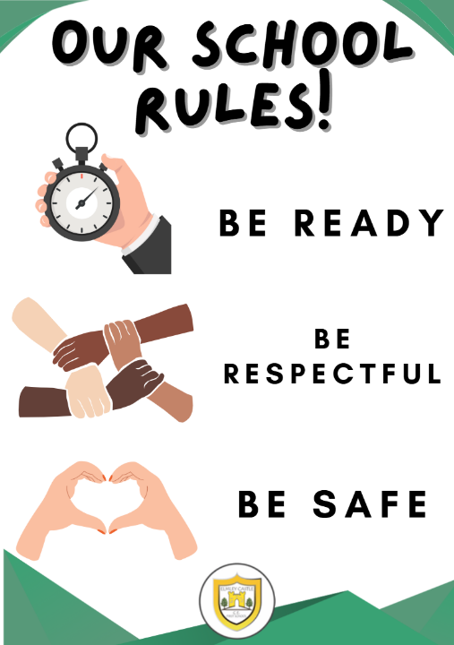

Application of consequences are the school’s appropriate response to the actions of the individual.
Positive behaviour is encouraged through the use of a combination of intrinsic and extrinsic rewards.
The consequences of behaviour which results in harm or hinders learning focus on restoration rather than punishment.
The intention is to explore harm suffered, acknowledge it as an undesired experience, to make amends, through consequences for repair, and ensure such harm is unlikely to happen again.

Rewards: Positive behaviours that help our school culture
In each class, teachers consistently acknowledge good behaviour in a variety of ways throughout the day; this may include positive praise, role modelling, comments written by the teacher in children’s reading diary or on work, book tokens, star of the week, stickers and team points.

Consequences: Behaviours that ‘harm’ the culture
Teachers consistently revisit our Elmley Rules and the expectations for behaviour. For most of our children, this reinforces the positive behaviour that is experienced as part of our school culture.

- RIP – Reprimand In Private. When addressing harmful behaviour, staff will interact in reference to our School Rules in a way that does not humiliate an individual child (i.e. not negatively critical in front of other children or an audience).

- If a member of school staff deals with unsafe behaviour, they will respond assertively in accordance with our Relationships & Behaviour policy and Safeguarding procedures.

Graduated response to ‘harmful’ behaviour (see appendix 3):

Reminder - a visual or verbal prompt from an adult, reminding a child of the expectations and explicitly addressing the behaviour.

Reflection - if a child fails to modify their behaviour after receiving a reminder(s) they will be directed to reflect on their behaviour choices. Reflection will take place with the adult that is affected by or intervening with the behaviour using a restorative mini-chat. (2-5 minutes)
Reflection should be:
- Immediate enough to connect to behaviour
- The pupil is calm enough to listen and allow thinking
- Short enough to remain instructional and for the pupil return to learning

Repair – some behaviours may require more than just reflection time. Consequences should aid repair, be logical in relation to reinforcing school expectations and be appropriate to the context.
Repair should be:
- Timed close enough for connection to the behaviour
- Avoid long delays; delayed repair can feel disconnected
- Be repaired immediately if a minor incident (a quick apology, helping pick up dropped items)
- Repaired later that day for more serious incidents that may require structured repair

Medium or High level behaviours (see appendix 4):
Should any child be engaging in behaviours that are clearly very harmful or unsafe or choose to not follow staff instruction when they intervene, staff may apply an immediate consequence.
Any physical behaviour including retaliation is absolutely unacceptable and the school will respond robustly to any incident. Consequences for this behaviour will be proportionate and significant, and may include suspension or exclusion.

Suspension or exclusion from school takes place only in exceptional circumstances and normally when all other options have been exhausted. (Please see the Exclusion Policy for more information).

Safe Touch - Safe touch is used to calm, soothe and regulate a child’s emotions and is an important developmental experience. The brain does not develop neural pathways to initiate calming and self-soothing unless and until safe emotional regulation has been experienced within a positive relationship with a significant adult. Where children have had insufficient experience of safe touch, calming and support with regulation, this may be a priority to help their brains develop access to thinking, judging, evaluating and choosing mechanisms.

Safe touch is one of the key ways of regulating children’s emotions, but it is a strategy that staff should only use in the presence of another adult using Positive Handling Training.

At Elmley we consider whether the misbehaviour gives cause to suspect that a pupil is suffering, or is likely to suffer, harm. Where this may be the case as set out in Part 1 of Keeping children safe in education, school staff should follow the school’s child protection policy and speak to the designated safeguarding lead (or deputy). They will consider if pastoral support, an early help intervention or a referral to children’s social care is appropriate.

Children with Special Education Needs and Disability or Other Additional Needs
Whilst the expectation is that all pupils follow our School Rules, we recognise that there may be circumstances which necessitate some pupils requiring additional support with their behaviour. This may be due to a specific identified need or disability or unusually challenging events or circumstances. In these cases, the SENDCo will work alongside the class teacher and teaching partner to adapt the system to meet their needs.
We recognise that some behaviours are more likely be associated with particular types of SEND, such as a pupil with speech, language and communication needs who may not understand a verbal instruction. Behaviour will often need to be considered in relation to a pupil’s SEND, although it does not follow that every incident of misbehaviour will be connected to their needs.

We know the importance of managing pupil behaviour effectively, whether or not the pupil has underlying needs. When a pupil is identified as having SEND, the graduated approach is used to assess, plan, deliver and then review the impact of the support being provided.

The law also requires Elmley Castle C of E First School to balance a number of duties which will have bearing on our Relationships & Behaviour policy and practice, particularly where a pupil has SEND that at times affects their behaviour. In particular:

- Our duties under the Equality Act 2010 to take such steps as is reasonable to avoid any substantial disadvantage to a disabled pupil caused by the school’s policies or practices;
- Under the Children and Families Act 2014, we have a duty to use our ‘best endeavours’ to meet the needs of those with SEND; and if a pupil has an Education, Health and Care plan, the provisions set out in that plan must be secured and we must co-operate with the local authority and other bodies.
We will endeavour to anticipate likely triggers of unsafe or harmful behaviour and put in place support to prevent these. Illustrative examples of preventative measures include (but are not limited to):

- short, planned movement breaks for a pupil whose SEND means that they find it difficult to sit still for long;
- adjusting seating plans to allow a pupil with visual or hearing impairment to sit in sight of the teacher;
- uniform requirements for a pupil with sensory issues or who has severe eczema;
- for staff in understanding neurodiversity such as autism.

Any preventative measure should take into account the specific circumstances and requirements of the pupil concerned.

Working in Partnership
To aid consistency, which has been shown to be an important feature of effective social, emotional and behavioural development in pupils, we believe in working in close partnership with families / carers. We will therefore keep families / carers informed of our values, aims and practices, e.g. through publication of policies, provision of workshops and information meetings, and their child’s learning and behaviour, e.g. through a mix of formal and informal parent’s meetings, telephone calls, and written communication. Where necessary we will engage in or initiate partnerships with other agencies.

Contact with parents
A positive partnership with parents is crucial to building trust and developing a common approach to relationships and behaviour expectations and strategies for dealing with problems.
Parents can expect to be kept informed of their child’s relationships and behaviour at school and staff will contact parents to share positive messages as well as any concerns.
In the case of persistent misbehaviour or, more rarely a serious misdemeanour, discussions with parents will take place to establish ways of helping the child improve. For example, it may be necessary to devise a support plan in conjunction with the parents. In some cases, behavioural problems may be linked to the social, emotional and mental health of a child and could lead to the involvement of external agencies to support both at school and in the home.
Parents who have concerns about behaviour in the school should make an appointment to speak with the class teacher in the first instance. Where concerns are not being addressed or the nature of the concern is more serious parents should ask to see the Headteacher.

Year 5 pupils
We recognise the very special contribution the Year 5 pupils can make to the organisation and daily routine of the school. Each September all Year 5 pupils take a more senior role at the school and are expected to assume additional leadership responsibilities. They are expected to set a great example by helping and supporting younger pupils and demonstrating responsible behaviour.

Monitoring behaviour
The school monitors behaviour to identify patterns, areas of concerns and/or triggers of challenging behaviour in order to implement appropriate strategies of support.

The Behaviour Log (appendix 5) is used to record and monitor low and medium incidents. If a child reaches a threshold of 5 incidents within a half term, the Headteacher will be notified and parents will be invited in to discuss concerns and strategies needed to improve behaviour.

CPOMS will be completed for high incidents. Teachers will ‘tag’ incidents appropriately taking care to accurately categorise the behaviour. CPOMS will be monitored by the Headteacher. The school will carefully monitor any incident of child-on-child abuse including homophobic or racist abuse or sexual harassment and take immediate action. They will also look carefully at any repeated friendship issues and assess these with consideration to the definitions of bullying.

Where high level incidents involve extreme violence and/or the use of restraint or classroom evacuation this will also be recorded in more detail using an incident form

The Headteacher will report to Governors through the termly Headteacher’s Report.

Physical intervention
According to the DfE document Restrictive interventions, including the use of reasonable force, in schools April 2026 staff should only physically intervene in the following situations:
- causing injury to themselves or others
- committing a criminal offence
- damaging property
- causing disorder among pupils at the school, whether during a teaching session or otherwise.
Some staff have received Positive Handling Training and will use de-escalation strategies before using physical intervention when it is safe to do so.

Valuables
Children should not bring items of value to the school (money, games, toys, etc).
Pupils who need to have mobile phones in school MUST hand them in to the school office on entry to the school.
Children who need to bring money to school are responsible for this, and it should be a sensible amount.
Children are responsible for their own watches during P.E. and other sporting activities. Pupils are not allowed any internet enabled watches.

References:
Anti Bullying Alliance Website: Restorative-practice 2024
Creating A Culture: How School Leaders Can Optimise Behaviour 2017
The Beginner Teacher’s Behaviour Toolkit: Summary
Paul Dix; When the Adults Change, Everything Changes; 2017
John Allison; Social Discipline and Restorative Practices; 2009
Gloucestershire CC; Restorative Practice Implementation In Gloucestershire Schools Guidance Handbook
The EEF Improving Behaviour in Schools 2021
Appendix 1
Restorative Practice Flowchart

REGULATE BEFORE INVESTIGATE
Are pupils calm enough to reflect?
Support regulation:
- Breathing
- Short walk
- Calm space
No restorative conversation while escalated.

REFLCT: ASK THE RESTORATIVE QUESTIONS
- What happened?
- What were you thinking/feeling?
- Who has been affected?
- How were they affected?
- What needs to happen to make it right?
Listen without interrupting.
Stay neutral.
Focus on harm, not blame.

REPAIR THE HARM AND RECONNECT
Possible actions:
☐ Genuine apology written or verbal
☐ Repair or replace property
☐ Rebuild/play together
☐ Structured support at playtime
☐ Behaviour agreement
Consequence must be logical and linked to the behaviour.

RE-ENTRY
✔ Agreement made
✔ Repair action completed
✔ Clear plan for next time
Message to pupils:
“We make mistakes. We repair them. We move forward.”

Appendix List 3
Graduated response to ‘harmful’ behaviour:

- Reminder - this may be a visual or verbal prompt from an adult, reminding a child of the expectations and explicitly addressing the behaviour e.g. “At Elmley, we listen when the adult is talking, show me that you are ready by putting your pencil down and looking this way.”

- Reflection - Following harmful behaviours within the school day, if a child fails to modify their behaviour after receiving a reminder(s) they will be directed to reflect on their behaviour choices. Reflection will take place, once the child is calm, with the adult that is affected by or intervening with the behaviour. The adult will discuss their behaviour choices with them and support the pupil to think about how they can meet the expectations in future. For younger children or children with language and communication difficulties a visual reflection book is used to support.

2a. Reflection during break or lunchtime -
If children need reflection time during break or lunchtime, they will be asked to sit out of free play for 5 minutes (e.g. on a bench or suitable space to reflect, away from the situation). The adult will discuss their behaviour choices with them and support the pupil to think about how they can meet the expectations in future. If behaviours continue, reflection time might be extended. Pupils with persistent difficulties at unstructured times may need the support of an adult who will support them to interact positively, building social skills and trust to play independently.

2b. Reflection due to an incident at the end of lunchtime -
If a child needs reflection to regulate at the end of lunchtime they may need to go inside earlier so they are ready to start the afternoon in a positive and calm way.

- Consequences to Repair – some behaviours may require more than just reflection time. Consequences should aid repair, be logical in relation to reinforcing school expectations and be appropriate to the context. If a child receives a consequence for repair, the class teacher will inform the parent that this has been applied.

Examples of behaviour and consequences (suggestions, as these behaviours are rare and consequences will be specific to the individual pupil and the context for the behaviour):

Behaviour | Consequence for repair
Persistent classroom disruption | - during carpet teaching, move away from the group until ready to re-join  - move away from the table/group that is being disrupted to a work station in the classroom  - if disruption continues, take work outside of the classroom, with an adult close by, to complete for 5-10 minutes  - a verbal or written apology to the teacher for disrupting learning
Creating a mess without consideration /being disrespectful to staff during lunchtime | - help to clear dinner hall, give out knives and forks etc  - verbal apology or create a sorry card in own time and present back
Swearing/name calling/put downs/gossiping about peers | - research the word used to understand it’s meaning and offer a verbal apology explaining they no longer think this is an appropriate word choice  - write a letter of apology to the individual(s) harmed  - circle time with a small group to explore impact of behaviours
Graffiti/property damage | -help clean, repair, or repaint  -write a letter or speak to repairs/cleaning team to apologise
Pushing/messing around in the line  (as a preventative measure- children to be lined up in same order every day e.g. register order) | - pupil walks in with the teacher. Holding hands if smaller child  - child moved away and to an appropriate place in the line  - temporary loss of privileges. Eg – line leader/register monitor if they show they cannot be responsible for their own behaviour.  - verbal apology to the person pushed
Hurting another child hitting, biting, scratching | -separate the children immediately  - explain to the child ‘At Elmley we cannot let you bite/scratch. It hurts.’  - show the child the injury and say ‘They are upset. You have hurt them. You need to help to make it better.’  - child to offer ice-pack , tissue etc  - child to offer an apology verbal or written  - child briefly removed from activity and told ‘You have hurt someone while playing with the blocks. You are showing me you are not ready to play with the blocks right now.’  -inform parents  - for younger children or those with communication and language difficulties, use the reflection book to support once regulated
Fighting | - separate the children immediately to ensure everyone is safe  - restorative conversations individually  -restorative meeting together (if appropriate)  - verbal or written apology  - temporary separation from activities together (if needed)  - temporary loss of privileges  - if necessary, may include temporary suspension/exclusion  - inform parents

Appendix 4
Behaviour Level Grid
This is an indicative but not exhaustive list to provide exemplification and clarification. School staff will determine level of behaviour

Level | Behaviour | Support offered; one or more of | Recording
Low | - Interrupting or distracting others  - Ignoring instructions  - Testing boundaries  - Not engaged with learning  - Damage through carelessness | - Follow approach to harmful behaviour (1 and 2)  - Incomplete work sent home in an envelope | - Recorded on class behaviour log
Medium | - Persistent disruptive behaviour  - Deliberate refusal to follow instructions  - Deliberate damage  - Leaving class without permission  - Verbal confrontation  - Swearing  - Physical – lower level (push, grab etc) | - Follow approach to harmful behaviour (1-3 may include consequence for repair)  - Incomplete work sent home in an envelope  - Phone call/meeting with parents  - Behaviour support and monitoring plan  - Discussion with SENDCO | - Class Teacher records incident on class behaviour log and inform parents.  - Class teacher may inform Headteacher if this becoming more frequent
High | - Persistent disruptive and challenging behaviour  - Persistent Bullying  - Racist abuse  - Homophobic/LBGTQ+ related abuse  - Child on Child Abuse  - Child on Child sexual violence and sexual harassment  - Online abuse  - Leaving school grounds  - Theft  - Vandalism  - Physical – high level (punching, kicking fighting) towards staff/adults/children  - Acts of extreme danger incl use of a weapon  - Very serious challenge to authority | - Headteacher involvement  - Behaviour support and monitoring Support Plan, Pastoral Support Plan may be considered.  - Discussion with SENDCO  - External support if required  - Regular meetings with parents  - Work sent home which must be completed if suspended or excluded  - Reintegration meeting  - Consequences for repair | - Class Teacher records incident on CPOM and inform parents.  - Racist incident report  - Report to governors via Head Teacher report  - If suspension or exclusion, Head Teacher will inform parents by phone & letter home, Education Inclusion Team alerted and Chair of Governors informed  - Escalation to Police and/or Social Services

Appendix 5


