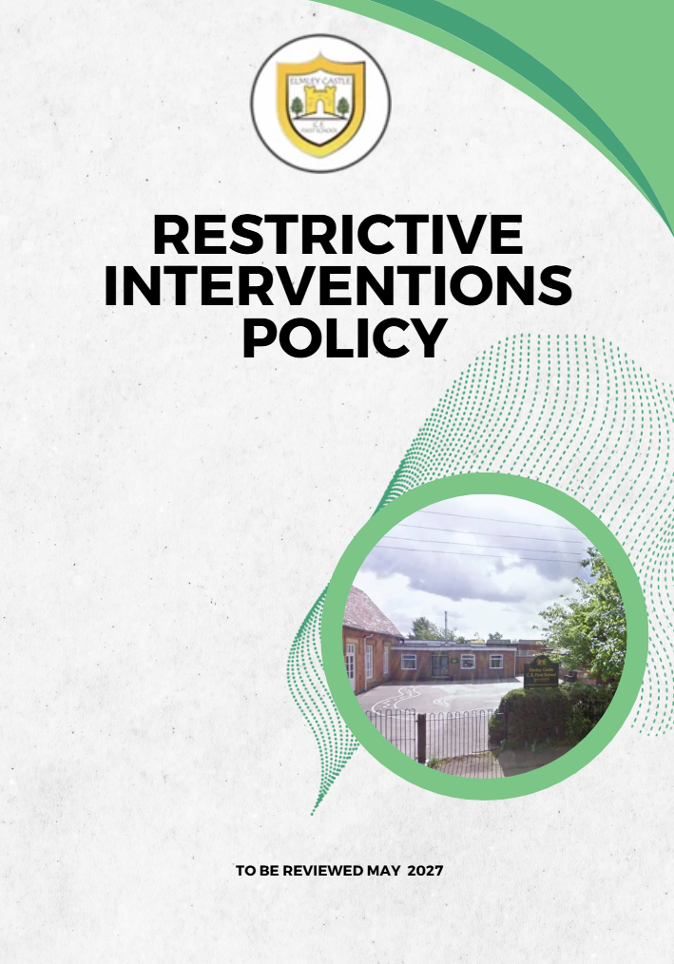

Elmley Castle C of E First School Vision

At Elmley Castle C of E First School, we believe that every child is a light in the world. We love
one another, inspire growth, and serve our community with kindness. We embrace resilience,
learning from our mistakes and growing stronger together. Each day, we strive to shine in all that
we do, creating a safe and welcoming space where everyone can grow in faith, knowledge, and
community. Together, we light the way for a brighter future, serving as beacons of hope and love
to all.

"You are the light of the world. A city set on a hill cannot be hidden." – Matthew 5:14

BLISS
Believe in yourself
Love one another
Inspire greatness
Shine with kindness
Serve with a heart of compassion
Let your Light Shine!

1. Statement of Intent
At Elmley Castle CE First School, in line with our Christian vision—“Let Your Light Shine”—we believe every child deserves to learn in a safe, nurturing environment. We are committed to minimising the use of restrictive interventions and ensuring any such measures are lawful, proportionate, and focused on preserving the dignity, welfare, and rights of every pupil.
2. Legal and Statutory Framework
This policy is based on:
- DfE: Restrictive interventions, including use of reasonable force, in schools (effective April 2026).
- Schools (Recording and Reporting of Seclusion and Restraint) (No. 2) (England) Regulations 2025.
3. Definitions
Restrictive Interventions: Any action that limits a pupil’s movement or freedom to act, including physical restraint, seclusion, or forced holding.
Reasonable Force: Physical force necessary to prevent harm, criminal activity, or serious disruption.
Seclusion: Placement of a pupil alone in a safe environment against their will to prevent harm.
4. Principles and Preventative Approach
- Restrictive interventions must never be used as punishment.
- Emphasis on prevention, early support, and de-escalation.
- Staff promote positive relationships and emotional regulation.
5. Criteria for Use
Staff may use reasonable force solely to:
- Prevent injury.
- Stop a pupil committing a criminal offence.
- Stop property damage or serious disruption.
6. SEND and Vulnerable Pupils
Adjustments must be made for pupils with SEND. Staff must consider triggers and support plans.
7. Staff Training and Preparedness
Only trained staff may use restrictive interventions. Training must include legal context, de-escalation, safe techniques, and safeguarding.
8. Recording and Reporting
From April 2026:
- All incidents must be recorded the same day.
- Records must include details of the incident, staff involved, pupil needs, reason for intervention, duration, and injuries.
- Parents must be informed promptly.
9. Oversight, Monitoring and Review
- Governors analyse incident trends.
- Policy reviewed annually or earlier if required.
10. Complaints and Allegations
Concerns will follow the school’s Complaints Procedure and safeguarding policies.

