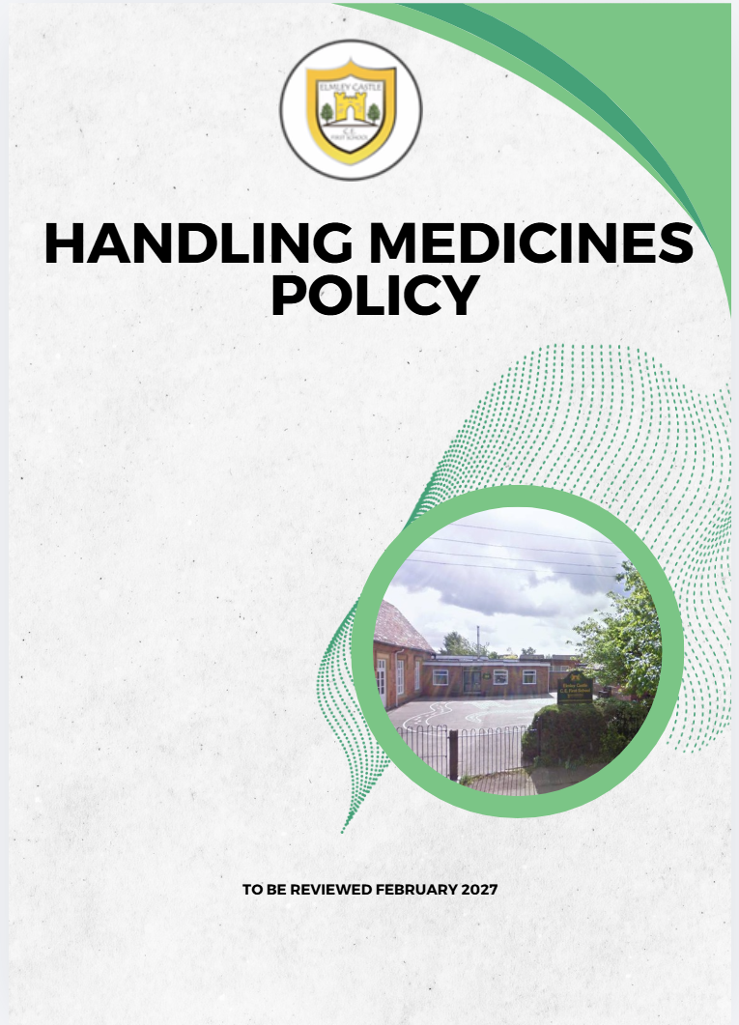

Elmley Castle C of E First School School Vision
At Elmley Castle C of E First School, we believe that every child is a light in the world. We love
one another, inspire growth, and serve our community with kindness. We embrace resilience,
learning from our mistakes and growing stronger together. Each day, we strive to shine in all thatwe do, creating a safe and welcoming space where everyone can grow in faith, knowledge, andcommunity. Together, we light the way for a brighter future, serving as beacons of hope and love to all.
"You are the light of the world. A city set on a hill cannot be hidden." – Matthew 5:14

BLISS
Believe in yourself
Love one another
Inspire greatness
Shine with kindness
Serve with a heart of compassion
Let your Light Shine!

1. Introduction
This policy sets out the procedures for safely managing, administering, and storing medicines at school. It follows DfE statutory guidance on supporting pupils with medical conditions, recent medical guidance regarding allergy management and safe administration of medicines in schools, and Worcestershire County Council Guidance for Schools on supporting children with medical difficulties and medication management.

2. Legal and Statutory Framework
- Children and Families Act 2014, Section 100
- DfE: Supporting Pupils with Medical Conditions (2025 update)
- DfE guidance on allergies and emergency medication requirements (2026)
- Equality Act 2010
- Worcestershire County Council Guidance on Medical Difficulties in School (2026)

3. Aims of the Policy
- To ensure medicines are handled safely and appropriately.
- To ensure pupils with medical needs can attend school regularly and participate fully in the curriculum.
- To set out clear roles, responsibilities, and expectations for staff, parents, and healthcare professionals.
- To minimise risks associated with administering and storing medicines in school.

4. Roles and Responsibilities
Governing Body:
- Ensures the school has appropriate medical needs and medicines policies.
- Reviews the policy annually.
- Ensures staff receive training.
Headteacher:
- Implements policy and procedures.
- Ensures safe handling and administration training.
- Ensures IHPs are completed.
Designated Staff / First Aiders:
- Administer medicines following training.
- Maintain records.
- Store medicines safely.
- Follow emergency procedures.
Parents/Carers:
- Provide correct medical information.
- Provide medicines in original labelled containers.
- Complete consent forms.
- Replace expired medication.
Pupils:
- May self-administer inhalers/emergency medicine with permission.

5. Managing Medicines on School Premises
The school will administer:
- Prescription medicines with proper labelling.
- Medicines necessary during the school day.
- Emergency medication kept with/near the pupil.
The school will NOT administer:
- Non-prescription pain relief (e.g., paracetamol/Calpol) unless prescribed.
- Herbal/homeopathic remedies.

6. Procedures for Administering Medicines
Before administration:
- Check pupil name, medicine, label, dosage, expiry date, consent.
During:
- Only trained staff administer.
- Two adults at all times to administer medicines
After:
- Record dose.
- Report errors.
- Contact parents when needed.

7. Emergency Medication
- Maintain spare adrenaline auto-injectors.
- Ensure allergy/emergency training.
- Keep emergency medication accessible.
- Follow Individual Health Plans (IHP) emergency procedures.

8. Storage of Medicines
- Store in locked cupboard.
- Emergency meds accessible.
- Refrigerated meds stored in medical fridge.
- Accept minimal quantities.

9. Record Keeping
- Maintain Medication Administration Records (MAR)
- Check expiry logs.
- Maintain register of medical needs.
- Keep written parental agreements.

10. Training
- Only trained staff may administer.
- Training must match IHP requirements.
- Courses e.g., Opus Pharmserve awareness.

11. School Trips and Activities
- Include pupils with medical needs.
- Complete risk assessments.
- Carry emergency medication.

12. Disposal of Medicines
- Return to parents.
- Replace expired items.
- No disposal onsite.

13. Hygiene and Infection Control
- Wash hands before/after.
- Wear gloves when appropriate.
- Follow spillage procedures.

14. Complaints
- Use school Complaints Policy.

15. Monitoring and Review
- Annual review.
- Update upon new guidance.

