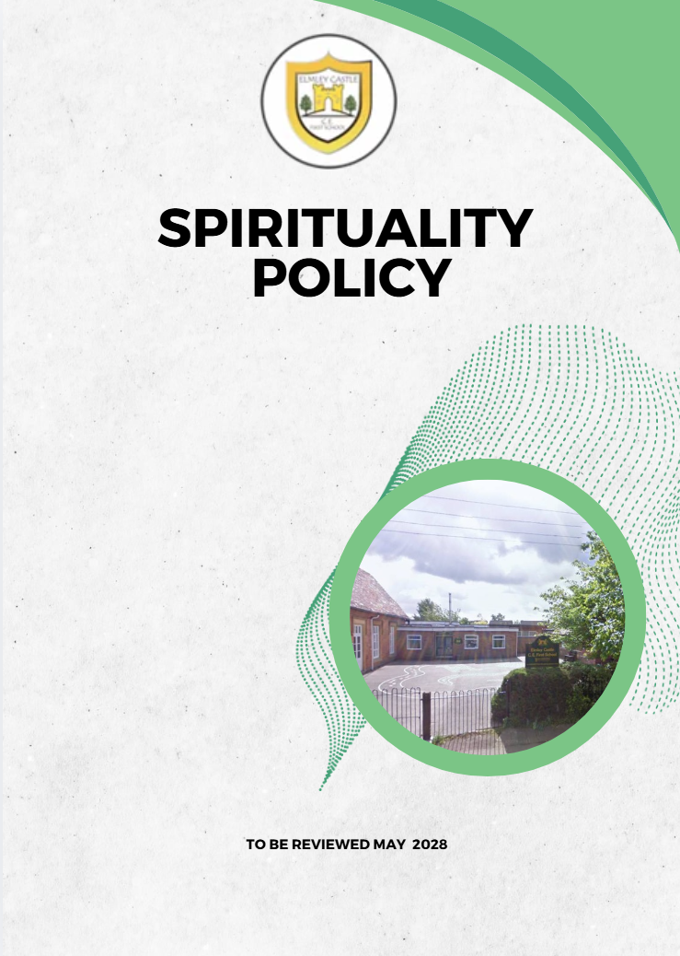

Let Your Light Shine
"You are the light of the world. A city set on a hill cannot be hidden." – Matthew 5:14

1. Our Christian Vision
At Elmley Castle, we believe that every child is a light in the world.
Rooted in Jesus’ words from Matthew 5:14, our vision shapes everything we do:
“We love one another, inspire growth, and serve our community with kindness.
We embrace resilience, learning from our mistakes and growing stronger together.
We strive to shine in all that we do, creating a safe and welcoming space where everyone grows in faith, knowledge and community.
Together, we light the way for a brighter future, serving as beacons of hope and love to all.”
This vision is lived through our BLISS principles:

BLISS
- Believe in yourself
- Love one another
- Inspire greatness
- Shine with kindness
- Serve with a heart of compassion
These values guide our understanding of spiritual development as we help each child let their light shine.

2. Purpose of This Policy
This policy explains how Elmley Castle CE First School:
- defines spirituality
- nurtures spiritual development across school life
- provides inclusive opportunities for all children and adults
- lives out the SIAMS expectation that “the school’s Christian vision enables people to flourish.”
Spiritual development is a whole-school responsibility, not limited to RE or worship.

3. What We Mean by Spirituality
Spirituality is the growth of the human spirit — the inner life of meaning, purpose, connection and hope.
At Elmley Castle, spirituality is understood as the ability to:
- reflect deeply on life’s experiences
- respond with compassion, courage or creativity
- connect with oneself, others, creation and God
- grow as a person living out our Christian vision
Children express spirituality in different ways. All are honoured.
Our approach is inclusive, welcoming families of all faiths and worldviews.

4. The Spiritual Capacities We Nurture
Aligned with SIAMS, our vision and the Church of England Vision for Education, we nurture children’s ability to:
- Believe in themselves and know they are loved by God.
- Love one another with empathy, respect and forgiveness.
- Inspire and be inspired through awe, wonder, creativity and curiosity.
- Shine with kindness, acting with compassion, courage and gratitude.
- Serve others, making wise, hopeful choices that contribute to community and the world.
- Live with resilience—reflecting, learning, and growing through challenge.
- Engage with big questions and mystery.
- Experience stillness, reflection and prayerful moments.
- Recognise beauty in creation and feel connected to it.
- Celebrate joy and appreciate moments of goodness.
These capacities underpin all spiritual experiences in school.

5. Our Core Framework: Head, Heart, Hands
To guide our spiritual practice, we use:
Head: Thinking and Understanding
These are moments that spark curiosity, awe and wonder. Children are encouraged to ask questions, explore new ideas and discover more about themselves, others, the world and God.
Questions we might ask:
- What have I noticed?
- What have I learned?
- What makes me wonder?
Heart: Reflecting and Feeling
These are moments when children reflect on their experiences, thoughts and emotions. They consider what is important to them, how experiences connect with their values and beliefs and how they might respond.
Questions we might ask:
- How does this make me feel?
- Why is this important?
- What might God be saying to me through this experience?
Hands: Responding and Living Out Values
These are moments when children put their learning and reflections into action. They are encouraged to show kindness, courage, compassion and service in their daily lives.
Questions we might ask:
- What can I do next?
- How can I make a positive difference?
- How can I let my light shine through my actions?
This model is used in Collective Worship.

6. Spirituality in Collective Worship
Collective Worship is a central pillar of our spiritual life. It is:
- invitational
- inclusive
- inspirational
- rooted in Scripture and Christian teaching
- shaped by Anglican tradition
- reflective of our BLISS principles.
Worship provides opportunities for:
- prayer, stillness and contemplation
- joyful praise and celebration
- exploring the Bible
- responding to big questions
- deepening Christian understanding
- developing spiritual vocabulary
- pupil-led contributions and leadership
- living out “Let Your Light Shine” in everyday actions

7. Spirituality Across the Curriculum
Spiritual development is not an “add-on”; it is an integral part of learning.
Teachers look for moments that offer:
- wonder at the natural world
- moral and ethical reflection
- personal meaning and identity
- emotional expression
- empathy and compassion
- courageous advocacy
- creativity and imagination

8. The Environment and School Culture
Spirituality is nurtured through the climate we create:
- Reflection areas in every classroom
- A central prayer and spirituality space
- Scripture and values displayed meaningfully
- Prayer resources accessible to all
- Opportunities to enjoy nature and outdoor spaces
- Celebrations of kindness, service and achievement
- A relational culture based on love, respect and belonging
We aim to create a school where “light shines from every child.”

9. Beyond the Curriculum
We enrich spirituality through:
- Church services and partnership with St Mary’s
- Community events
- Vision afternoons
- Forest School
- Arts, music and drama
- Charity events and social action
- Class spirituality books
- Whole School Personal Development Floor Book
These experiences help children deepen their sense of purpose and connection.

10. Inclusion and Diversity
We affirm that spirituality belongs to every child:
- Children of all faiths and none
- Children with SEND
- Children with different cultural backgrounds
- Children at different stages of development
Practices are invitational, never coercive. Every child has space to explore safely.

11. Monitoring and Evaluation
We evaluate our provision through:
- Pupil voice
- Worship evaluations
- Book looks
- Staff reflections
- Governor monitoring
- SIAMS self-evaluation
Impact is seen in children’s behaviour, values, empathy, curiosity and ability to reflect.

12. Roles and Responsibilities
- Headteacher: Strategic lead for spiritual development.
- Worship Lead/RE Lead: Supports planning, delivery and monitoring.
- All staff: Model values, identify spiritual moments and nurture children’s responses.
- Governors: Monitor effectiveness through the SIAMS framework.
- Pupils: Actively participate in worship, reflection and service.

13. Review
This policy will be reviewed annually by the Headteacher and Local Governing Board to ensure continuing alignment with SIAMS and the school’s Christian vision.

