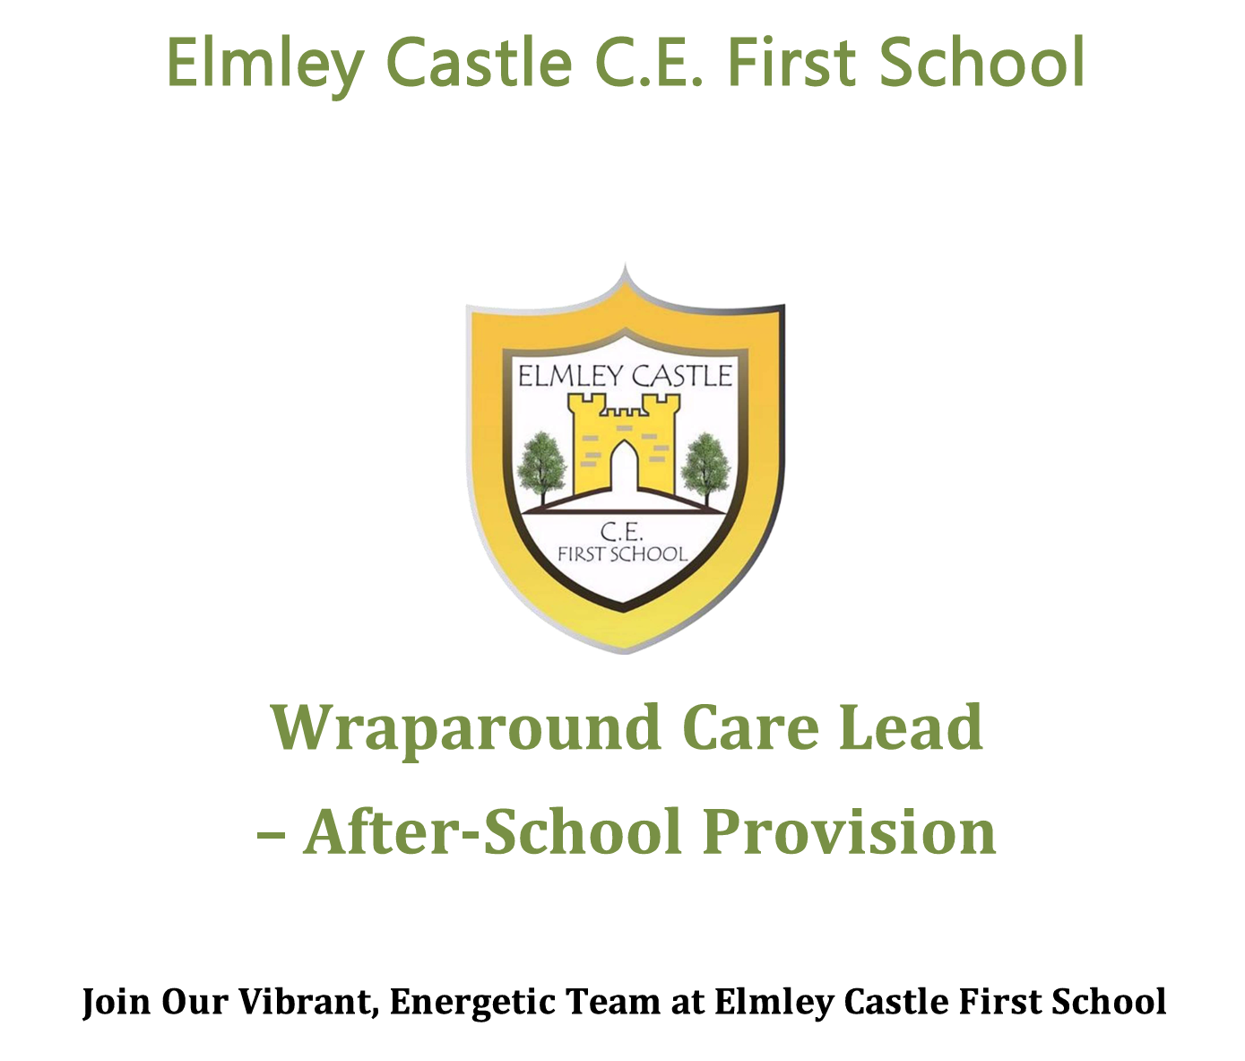

Wraparound Care Assistant for CHIEFS
Breakfast Club Provision
Start date November 2026

About the Role
We are looking for a caring, enthusiastic, and reliable Breakfast Club Assistant to join CHIEFS at Elmley Castle First School. This is a fantastic opportunity to support children at the start of their school day, helping to create a calm, positive, and nurturing environment.
As a WRAP Assistant you will:
- Prioritise safeguarding above all else, ensuring the safety and welfare of every child.
- Support high-quality, safe, and nurturing before school care for children aged 3–10 years.
- Create a welcoming and calm start to the day, supporting children’s emotional wellbeing.
- Provide engaging, low-key activities suited to the morning environment (e.g. quiet play, board games, reading).
- Promote positive behaviour and respectful interactions.
- Organise and serve a simple, healthy breakfast in line with food hygiene procedures.
- Ensure a smooth and safe transitions between school and WRAP

What We’re Looking For
- A kind, calm, and reliable individual who enjoys working with young children.
- A positive, organised, and proactive approach.
- A team player committed to excellent safeguarding practices.
- The ability to create a nurturing and structured start to the day.
Full training provided, including:
- Safeguarding and child protection
- Food hygiene
- First aid
- Play-work and activity planning

What We Offer
- A friendly, supportive school team
- Ongoing professional development opportunities
- A rewarding role supporting children’s wellbeing and readiness for learning
- A calm and enjoyable working environment

Qualifications and Pay
- A Level 2 Teaching Assistant qualification is desirable but not essential.
- Experience of working with primary-aged children would be advantageous.
- A commitment to safeguarding, promoting children's wellbeing, and supporting an inclusive environment is essential.
- Full training will be provided, including safeguarding, food hygiene, first aid, and playwork principles.
- Worcestershire County Council TA2 Scale, pro rata, depending on experience

Working Hours
- Breakfast Club Approx. 7.5 hours per week (term time only)
- Typical hours 7.30-9am Monday to Friday
(Hours can be adjusted to meet school needs)

Application Details
- Application Deadline: Friday 16th October 2026 (12:00 midday)
- Interview Date Week commencing 19th October
- Applications must be submitted on the official application form.

Safeguarding Statement
Elmley Castle C.E. First School is committed to safeguarding and promoting the welfare of children and young people. All staff and volunteers are expected to share this commitment.
Appointments are subject to:
- Enhanced DBS check
- Right to work in the UK
- Identity and qualification checks
- Satisfactory references

About Our School
Elmley Castle C.E. First School is a caring, supportive village school located in the rural Cotswold village of Elmley Castle. We pride ourselves on fostering a nurturing, inclusive, and community-focused environment.

Vision and Values
“Let Your Light Shine!”
At Elmley Castle C of E First School, we believe every child is a light in the world. We nurture growth, resilience, and kindness, creating a safe and welcoming space for all.

BLISS Values
- Believe in yourself
- Love one another
- Inspire greatness
- Shine with kindness
- Serve with compassion

