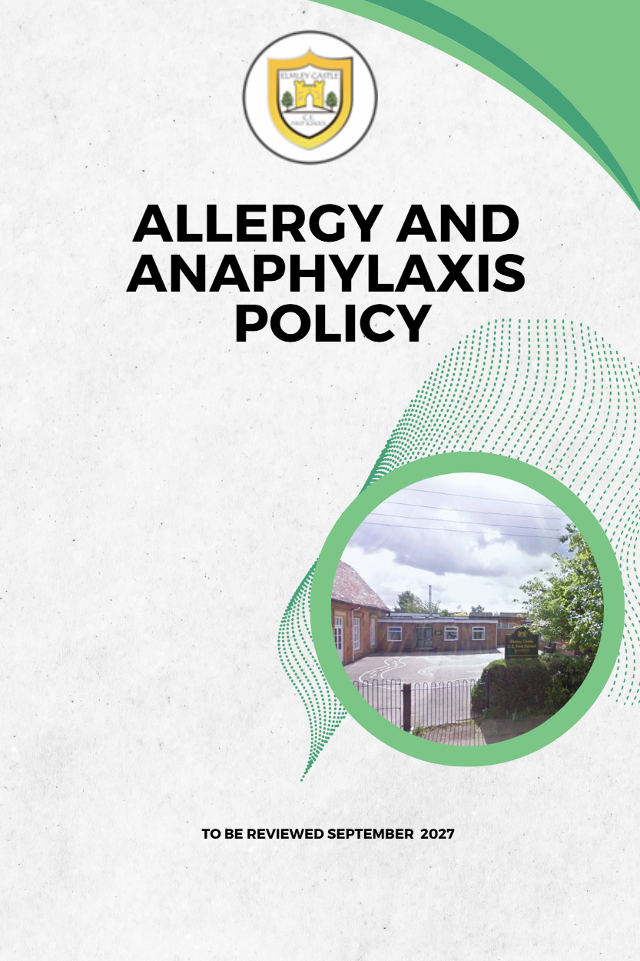

Contents
Introduction 3
Role and responsibilities 3
Parent Responsibilities 3
Staff Responsibilities 3
Pupil Responsibilities 4
Headteacher Responsibilities 4
Governing Body Responsibilities 4
Allergy Action Plans 4
Individual Healthcare Plans 5
Emergency Treatment and Management of Anaphylaxis 5
Supply, storage and care of medication 7
‘Spare’ adrenaline auto-injectors in school 7
Staff Training 8
Inclusion and safeguarding 8
Catering 8
School trips 9
Allergy awareness and nut bans 10
Risk Assessment 10
Useful Links 10

Elmley Castle C of E First School Vision
At Elmley Castle C of E First School, we believe that every child is a light in the world. We love one another, inspire growth, and serve our community with kindness. We embrace resilience, learning from our mistakes and growing stronger together. Each day, we strive to shine in all that we do, creating a safe and welcoming space where everyone can grow in faith, knowledge, and community. Together, we light the way for a brighter future, serving as beacons of hope and love to all.
"You are the light of the world. A city set on a hill cannot be hidden." – Matthew 5:14

BLISS
Believe in yourself
Love one another
Inspire greatness
Shine with kindness
Serve with a heart of compassion

Let your Light Shine!

Introduction

An allergy is a reaction of the body’s immune system to substances that are usually harmless. The reaction can cause minor symptoms such as itching, sneezing or rashes but sometimes causes a much more severe reaction called anaphylaxis.

Anaphylaxis is a serious, life-threatening allergic reaction. The whole body is affected often within minutes of exposure to the allergen, but sometimes it can be hours later. Causes can include foods, insect stings, and drugs.

Most healthcare professionals consider an allergic reaction to be anaphylaxis when it involves difficulty breathing or affects the heart rhythm or blood pressure. Anaphylaxis symptoms are often referred to as the ABC symptoms (Airway, Breathing, Circulation).

It is possible to be allergic to anything which contains a protein, however most people will react to a fairly small group of potent allergens.

Common UK Allergens include (but are not limited to):-
Peanuts, Tree Nuts, Sesame, Milk, Egg, Fish, Latex, Insect venom, Pollen and Animal Dander.

This policy sets out how Elmley Castle CE First School will support pupils with allergies, to ensure
they are safe and are not disadvantaged in any way whilst taking part in school life.

Role and responsibilities

Parent Responsibilities

  - On entry to the school, it is the parent’s responsibility to inform the school office of any allergies. This information should include all previous serious allergic reactions, history of anaphylaxis and details of all prescribed medication.
  - Parents are to supply a copy of their child’s Allergy Action Plan to school. If they do not currently have an Allergy Action Plan this should be developed as soon as possible in collaboration with a healthcare professional
e.g. GP/allergy specialist.
  - Parents are responsible for ensuring any required medication is supplied, in date and replaced as necessary.
  - Parents are requested to keep the school up to date with any changes in allergy management. The Allergy Action Plan will be kept updated accordingly.

Staff Responsibilities

  - All staff will complete anaphylaxis training. Training is provided for all staff on a yearly basis and on an ad-hoc basis for any new members of staff.
  - Staff (regular or cover classes) must be aware of the pupils in their care who have known allergies as an allergic reaction could occur at any time and not just at mealtimes. Any food-related activities must be supervised with due caution.

  - Staff leading school trips will ensure they carry all relevant emergency supplies. Visit leaders will check that all pupils with medical conditions, including allergies, carry their medication. Pupils unable to produce their required medication will not be able to attend the excursion.
  - The class teacher and allergy lead will ensure that the up-to-date Allergy Action Plan is kept with the pupil’s medication.
  - It is the parent’s responsibility to ensure all medication in in date
  - The allergy lead keeps a register of pupils who have been prescribed an adrenaline auto-injector (AAI) and a record of use of any AAI(s) and emergency treatment given.
  - The allergy lead ensures that any reaction or near misses is recorded and reported internally or in accordance with RIDDOR.

Pupil Responsibilities

  - Pupils are encouraged to have a good awareness of their symptoms and to let an adult know as soon as they suspect they are having an allergic reaction.
  - Pupils who are trained and confident to administer their own AAIs will be encouraged to take responsibility for carrying them on their person at all times.

Headteacher Responsibilities
- Appropriate systems are in place.
- Staff receive training.
- Risk assessments are completed.
- Emergency medication is accessible.
- Relevant information is shared appropriately.

Governing Body Responsibilities
- Ensure appropriate arrangements are in place to support pupils with allergies.
- Monitor implementation of this policy.
- Ensure sufficient staff are trained.
- Review the policy regularly.

Allergy Action Plans

Allergy action plans are designed to function as individual healthcare plans for children with food allergies, providing medical and parental consent for schools to administer medicines in the event of an allergic reaction, including consent to administer a spare adrenaline auto- injector.

British Society of Allergy and Clinical Immunology (BSACI) Allergy Action Plans are produced by a medical professional and should not be created by school. These are a national plan that has been agreed by the BSACI, Anaphylaxis UK and Allergy UK. The allergy action plans are designed to function as an individual healthcare plan.

Individual Healthcare Plans
Where appropriate, pupils with severe allergies or complex medical needs will also have an Individual Healthcare Plan (IHP) developed in partnership with parents, healthcare professionals and the school. The IHP will outline triggers, symptoms, medication, emergency procedures, roles and responsibilities and arrangements for educational visits and extracurricular activities.

Emergency Treatment and Management of Anaphylaxis

What to look for:
Symptoms usually come on quickly, within minutes of exposure to the allergen.

Mild to moderate allergic reaction symptoms may include:
- a red raised rash (known as hives or urticaria) anywhere on the body
- a tingling or itchy feeling in the mouth
- swelling of lips, face or eyes
- stomach pain or vomiting.

More serious symptoms are often referred to as the ABC symptoms and can include:
AIRWAY - swelling in the throat, tongue or upper airways (tightening of the throat, hoarse voice, difficulty swallowing).
- BREATHING - sudden onset wheezing, breathing difficulty, noisy breathing.
- CIRCULATION - dizziness, feeling faint, sudden sleepiness, tiredness, confusion, pale clammy skin, loss of consciousness.

The term for this more severe reaction is anaphylaxis. In extreme cases there could be a dramatic fall in blood pressure. The person may become weak and floppy and may have a sense of something terrible happening. This may lead to collapse and unconsciousness and, on rare occasions, can be fatal.

If the pupil has been exposed to something they are known to be allergic to, then it is more likely to be an anaphylactic reaction.

Anaphylaxis can develop very rapidly, so a treatment is needed that works
rapidly. Adrenaline is the mainstay of treatment, and it starts to work within seconds.

What does adrenaline do?
- It opens up the airways
- It stops swelling
- It raises the blood pressure

As soon as anaphylaxis is suspected, adrenaline must be administered without delay. Action:

- Keep the child where they are, call for help and do not leave them unattended.
- LIE CHILD FLAT WITH LEGS RAISED – they can be propped up if struggling to breathe but this should be for as short a time as possible.
- USE ADRENALINE AUTO-INJECTOR WITHOUT DELAY and note the time given. AAIs should be given into the muscle in the outer thigh. Specific instructions vary by brand – always follow the instructions on the device.
- CALL 999 and state ANAPHYLAXIS (ana-fil-axis).
- If no improvement after 5 minutes, administer second AAI.
- If no signs of life commence CPR.
- Call parent/carer as soon as possible.

Whilst you are waiting for the ambulance, keep the child where they are. Do not stand them up, or sit them in a chair, even if they are feeling better. This could lower their blood pressure drastically, causing their heart to stop.

All pupils must go to hospital for observation after anaphylaxis even if they appear to have recovered as a reaction can reoccur after treatment.

Supply, storage and care of medication

Depending on their level of understanding and competence, pupils will be encouraged to take responsibility for and to carry their own two AAIs on them at all times in a suitable bag/container, this will be brought outside at breaktimes, PE and Forest School lessons

For younger children or those not ready to take responsibility for their own medication, there should be an anaphylaxis kit which is kept within 5 minutes of them, not locked away and accessible to all staff.

Medication should be stored in a suitable container and clearly labelled with the pupil’s name. The pupil’s medication storage container should contain:
- Two AAIs i.e. EpiPen® or Jext®
- An up-to-date allergy action plan
- Antihistamine as tablets or syrup (if included on allergy action plan)
- Spoon if required
- Asthma inhaler (if included on allergy action plan).

It is the responsibility of the child’s parents to ensure that the anaphylaxis kit is up-to-date and clearly labelled, however the school allergy lead will check medication kept at school on a termly basis and send a reminder to parents if medication is approaching expiry.

Parents can subscribe to expiry alerts for the relevant AAIs their child is prescribed, to make sure they can get replacement devices in good time.

Older children and medication
Older children, whenever possible, assume responsibility for their emergency kit under the guidance of their parents. However, symptoms of anaphylaxis can come on very suddenly, so school staff need to be prepared to administer medication if the young person cannot.

Storage
AAIs should be stored at room temperature, protected from direct sunlight and temperature extremes.

Disposal
AAIs are single use only and must be disposed of as sharps. Used AAIs can be given to ambulance paramedics on arrival or can be disposed of in a pre-ordered sharps bin. Sharps bins to be disposed of by a clinical waste contractor. The sharps bin is kept in the DT area.

‘Spare’ adrenaline auto-injectors in school

Elmley Castle First School has purchased spare AAIs for emergency use in children who are risk
of anaphylaxis, but their own devices are not available or not working (e.g. because they are out of date) or are experiencing anaphylaxis for the first time.

These are stored in the white storage cupboard in main corridor clearly labelled ‘Emergency
Anaphylaxis Adrenaline Pen’, kept safely, not locked away and accessible and known to all staff.

The allergy lead is responsible for checking the spare medication is in date on a monthly basis and to replace as needed.

Written parental permission for use of the spare AAIs is included in the pupil’s allergy action plan.

Staff Training

The named staff members (at least 2) responsible for coordinating staff anaphylaxis training and the upkeep of the school’s anaphylaxis policy are:-

Kirstie Hay (allergy lead)
Natalie Harbron (Headteacher)

All staff will complete AllergyWise® allergy and anaphylaxis training annually, and on an ad-hoc basis during induction of new staff.

Training includes:
- Knowing the common allergens and triggers of allergy
- Spotting the signs and symptoms of an allergic reaction and anaphylaxis. Early recognition of symptoms is key, including knowing when to call for emergency services
- Administering emergency treatment (including AAIs) in the event of anaphylaxis – knowing how and when to administer the medication/device
- Measures to reduce the risk of a child having an allergic reaction e.g. allergen avoidance, knowing who is responsible for what
- Managing allergy action plans and ensuring these are up to date

Elmley Castle CE First School ensures that staff undertake a practical session using trainer devices (these can be obtained from the manufacturers’ websites: www.epipen.co.uk and www.jext.co.uk

Inclusion and safeguarding

Elmley Castle CE First School is committed to ensuring that all children with medical conditions,
including allergies, in terms of both physical and mental health, are properly supported in school so that they can play a full and active role in school life, remain healthy and achieve their academic potential.

Catering

All food businesses (including school caterers) must follow the Food Information Regulations 2014 which states that allergen information relating to the ‘Top 14’ allergens must be available for all food products.

The school’s menu is available for parents to view termly in advance with all ingredients listed and allergens highlighted on the organisation website (Pershore Deli) The school allergy lead will inform the Catering Manager of pupils with food allergies.

The school maintains an up-to-date allergy register which is shared with relevant staff, including catering providers. Photographs of pupils with severe allergies are displayed confidentially in staff areas and catering areas where appropriate. The Allergy Lead is responsible for ensuring records remain accurate and are reviewed whenever changes are notified by parents

Parents/carers are encouraged to meet with the allergy lead to discuss their child’s needs.

The school adheres to the following Department of Health guidance recommendations:

- Bottles, other drinks and lunch boxes provided by parents for pupils with food allergies should be clearly labelled with the name of the child for whom they are intended.
- The pupil should be taught to also check with catering staff, before selecting their lunch choice.
- Where food is provided by the school, staff should be educated about how to read labels for food allergens and instructed about measures to prevent cross contamination during the handling, preparation and serving of food. Examples include: preparing food for children with food allergies first; careful cleaning (using
warm soapy water) of food preparation areas and utensils. For further information, parents/carers are encouraged to liaise with the Catering Manager.
- Food should not be given to primary school age food-allergic children without parental engagement and permission (e.g. birthday parties, food treats).
- Use of food in crafts, cooking classes, science experiments and special events (e.g. fetes, assemblies, cultural events) needs to be considered and may need to be restricted/risk assessed depending on the allergies of particular children and their age.

School trips

Staff leading school trips will ensure they carry all relevant emergency supplies. Trip leaders will check that all pupils with medical conditions, including allergies, carry their medication. Pupils unable to produce their required medication will not be able to attend the excursion.

All the activities on the school trip will be risk assessed to see if they pose a threat to allergic pupils and alternative activities planned to ensure inclusion.

Overnight school trips should be possible with careful planning and a meeting for parents with the lead member of staff planning the trip should be arranged. Staff at the venue for an overnight school trip should be briefed early on that an allergic child is attending and will need appropriate food (if provided by the venue).

Sporting Excursions
Allergic children should have every opportunity to attend sports trips to other schools. The school will ensure that the P.E. teacher/s are fully aware of the situation. The school being visited will be notified that a member of the team has an allergy when arranging the fixture. A member of staff trained in administering adrenaline will accompany the team. If another school feels that they are not equipped to cater for any food-allergic child, the school will arrange for the child to take alternative/their own food.

Most parents are keen that their children should be included in the full life of the school where possible, and the school will need their co-operation with any special arrangements required.

Allergy awareness and nut bans

Elmley Castle CE First supports the approach advocated by Anaphylaxis UK towards nut
bans/nut free schools. They would not necessarily support a blanket ban on any particular allergen in any establishment, including in schools. This is because nuts are only one of many allergens that could affect pupils, and no school could guarantee a truly allergen free environment for a child living with food allergy. They advocate instead for schools to adopt a culture of allergy awareness and education.

A 'whole school awareness of allergies' is a much better approach, as it ensures teachers, pupils and all other staff are aware of what allergies are, the importance of avoiding the pupils’ allergens, the signs & symptoms, how to deal with allergic reactions and to ensure policies and procedures are in place to minimise risk.

Risk Assessment

Elmley Castle CE First School will conduct a detailed individual risk assessment for all new joining
pupils with allergies and any pupils newly diagnosed, to help identify any gaps in our systems and processes for keeping allergic children safe.

School and individual risk assessments can be downloaded for free from: https://www.anaphylaxis.org.uk/downloads-form/safer-schools-download/.

Useful Links

Anaphylaxis UK - https://www.anaphylaxis.org.uk/

- Safer Schools Programme - https://www.anaphylaxis.org.uk/education/safer- schools-programme/

- AllergyWise for Schools online training - https://www.allergywise.org.uk/p/allergywise-for-schools1

Allergy UK - https://www.allergyuk.org

- Whole school allergy and awareness management - https://www.allergyuk.org/schools/whole-school-allergy-awareness- andmanagement

BSACI Allergy Action Plans - https://www.bsaci.org/professional- resources/resources/paediatric-allergy-action-plans/

Spare Pens in Schools - http://www.sparepensinschools.uk

Department for Education Supporting pupils at school with medical conditions - https://assets.publishing.service.gov.uk/government/uploads/system/uploads/attachment_ data/file/803956/supporting-pupils-at-school-with-medical-conditions.pdf

Department of Health Guidance on the use of adrenaline auto-injectors in schools - https://assets.publishing.service.gov.uk/government/uploads/system/uploads/attachment_ data/file/645476/Adrenaline_auto_injectors_in_schools.pdf

Food allergy quality standards (The National Institute for Health and Care Excellence, March 2016) https://www.nice.org.uk/guidance/qs118

Anaphylaxis: assessment and referral after emergency treatment (The National Institute for Health and Care Excellence, 2020) https://www.nice.org.uk/guidance/cg134?unlid=22904150420167115834

