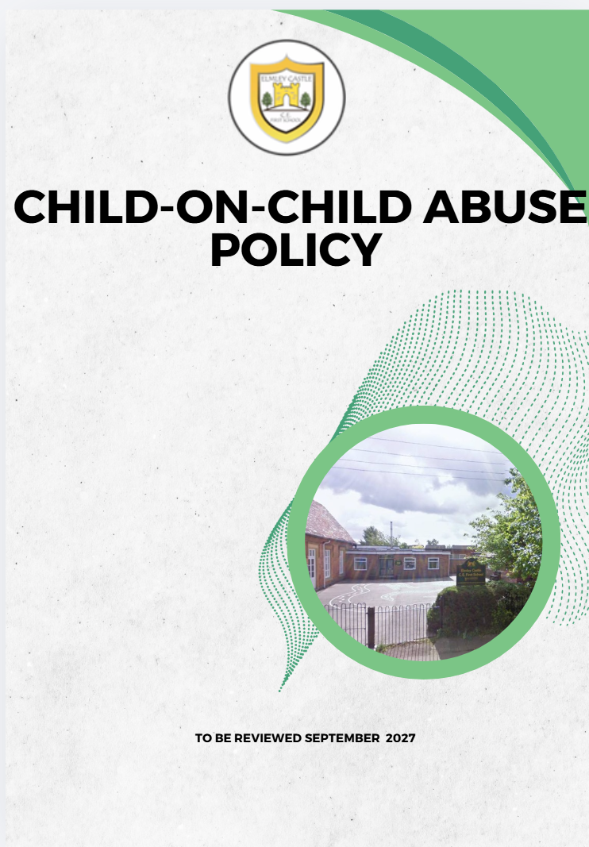

Including sexual violence and sexual harassment between children

This policy has been reviewed; to the best of our knowledge, we do not feel it impacts negatively on any specific group or individual within our school community.

Elmley Castle C of E First School Vision
At Elmley Castle C of E First School, we believe that every child is a light in the world. We love
one another, inspire growth, and serve our community with kindness. We embrace resilience,
learning from our mistakes and growing stronger together. Each day, we strive to shine in all that
we do, creating a safe and welcoming space where everyone can grow in faith, knowledge, and
community. Together, we light the way for a brighter future, serving as beacons of hope and love
to all.
"You are the light of the world. A city set on a hill cannot be hidden." – Matthew 5:14

BLISS
Believe in yourself
Love one another
Inspire greatness
Shine with kindness
Serve with a heart of compassion

Let your Light Shine!

Contents
Child-on-child Abuse Policy 2026 0
Including sexual violence and sexual harassment between children 1
1. Context and Definition 3
2. Responsibility 4
3. Purpose of Policy 5
4. Framework and Legislation 5
5 Abuse and harmful behaviour 5
6 Types of abuse 6
7. Expected Staff Action 9
8. Recognising child-on-child abuse 10
9. Points to consider 12
10. Next Steps 12
11 Preventative Strategies 14
12 Where to go for further information 19
ANNEX A 20

Context and Definition

Elmley Castle CE First School who work with children are advised to maintain an attitude of ‘it could happen here’ and ‘It most likely is’ where safeguarding is concerned. When concerned about the welfare of a child, staff should always act in the best interests of the child.

Child-on-child abuse, as defined in Keeping Children Safe in Education guidance (KCSIE), refers to abuse or harassment that occurs between children. This can include physical, sexual, or emotional abuse, as well as online bullying and harassment. Schools and colleges are expected to have policies and procedures in place to address this issue, including reporting, investigation, and support for both victims and those accused of abuse.

We are aware of:

Making clear that there is a zero-tolerance approach to sexual violence and sexual harassment, that it is never acceptable, and it will not be tolerated. It should never be passed off as “banter”, “just having a laugh”, “a part of growing up” or “boys being boys”. Failure to do so can lead to a culture of unacceptable behaviour, an unsafe environment and in worst case scenarios a culture that normalises abuse, leading to children accepting it as normal and not coming forward to report it.

• recognising, acknowledging, and understanding the scale of harassment and abuse and that even if there are no reports it does not mean it is not happening, it may be the case that it is just not being reported
• challenging physical behaviour (potentially criminal in nature) such as grabbing bottoms, breasts and genitalia, pulling down trousers, flicking bras and lifting up skirts. Dismissing or tolerating such behaviours risks normalising them
Child-on-child abuse is behaviour by an individual or group, intending to hurt others physically, sexually or emotionally.

All our staff recognise that children are capable of abusing their peers. All staff should be aware of safeguarding issues from child-on-child abuse including:

- bullying (including online bullying)
- physical abuse such as hitting, kicking, shaking, biting, hair pulling, or otherwise causing physical harm
- sexual violence and sexual harassment
- sharing nudes or semi nudes (also known as youth produced sexual imagery); and
- initiation/hazing type violence and rituals.

This abuse can:
- Be motivated by perceived differences e.g. on grounds of race, religion, gender, sexual orientation, disability or other differences
- Result in significant, long lasting and traumatic isolation, intimidation or violence to the victim; vulnerable adults are at particular risk of harm

Children who may be more vulnerable
Elmley Castle CE First School recognises that some children may be more vulnerable to experiencing child-on-child abuse and may face additional barriers to recognising, reporting or disclosing concerns.
Particular consideration will be given to:
- Children with Special Educational Needs and Disabilities (SEND)
- Children with communication and interaction needs
- Children with Education, Health and Care Plans (EHCPs)
- Looked After and Previously Looked After Children
- Young carers
- Children who have experienced trauma, abuse, neglect or domestic abuse
- Children with mental health needs
- Children who are frequently absent from education
Staff will remain professionally curious, ensure children are listened to and adapt safeguarding responses to meet individual needs. Additional support and reasonable adjustments will be made where necessary to enable children to disclose concerns and access support.
Stopping violence and ensuring immediate physical safety is the first priority of any education setting, but emotional bullying can sometimes be more damaging than physical. School staff, alongside their Designated Safeguarding Lead and/or Deputy, have to make their own judgements about each specific case and should use this policy guidance to help.

Responsibility
Our staff are aware of the reporting systems within our school which support safeguarding, and these should be explained to them as part of staff induction. This should include the:
- Safeguarding/child protection policy (which should amongst other things also include the policy and procedures to deal with child-on-child abuse)
It also emphasises that the voice of the child must be heard
‘Governing bodies, proprietors and school leaders should ensure the child’s wishes and feelings are taken into account when determining what action to take and what services to provide. Systems should be in place for children to express their views and give feedback. Ultimately, all system and processes should operate with the best interests of the child at their heart.’
Governing bodies and proprietors should ensure that the school contributes to multi-agency working in line with statutory guidance Working Together to Safeguard Children part 2.
Child-on-child abuse is referenced in the Safeguarding and Child Protection Policy. The sensitive nature and specific issues involved with child-on-child necessitate separate policy guidance.
At Elmley Castle CE First School we continue to ensure that any form of abuse or harmful behaviour is dealt with immediately and consistently to reduce the extent of harm to the young person, with full consideration to the impact on that individual child’s emotional and mental health and well-being.

Purpose of Policy
The purpose of this policy is to define child-on-child abuse, set out the school's preventative approach and provide clear procedures for recognising, reporting and responding to concerns.
At Elmley Castle CE First School we have the following policies in place that should be read in conjunction with this policy:
  - Anti-Bullying including Online Bullying Policy
  - Safeguarding and Child Protection Policy
  - Managing Allegations / Whistleblowing Policy
  - Relationships and Behaviour Policy
  - Health & Safety Policy
  - Online Safety Policy

4. Framework and Legislation
This policy is supported by the key principles of the Children’s Act, 1989 that the child’s welfare is paramount. Another key document is Working Together, 2023 highlighting that every assessment of a child, ‘must be informed by the views of the child’. (Working Together, 2023) This is echoed by Keeping Children Safe in Education, 2026 through ensuring procedures are in place in schools and settings to hear the voice of the child.

Abuse and harmful behaviour
It is necessary to consider
- what abuse is and what it looks like
- how it can be managed
- what appropriate support and intervention can be put in place to meet the needs of the individual
- what preventative strategies may be put in place to reduce further risk of harm.
As a school we adopt a zero-tolerance approach to sexual violence and sexual harassment, that it is never acceptable, and it will not be tolerated. It should never be passed off as “banter”, “just having a laugh”, “a part of growing up” or “boys being boys”. Failure to do so can lead to a culture of unacceptable behaviour, an unsafe environment and in worst case scenarios a culture that normalises abuse, leading to children accepting it as normal and not coming forward to report it
- Children are vulnerable to abuse by their peers. Such abuse should be taken as seriously as abuse by adults and should be subject to the same child protection procedures.
- Children can abuse other children. This can include (but is not limited to): abuse within intimate partner relationships; bullying (including cyberbullying); sexual violence and sexual harassment; physical abuse such as hitting, kicking, shaking, biting, hair pulling, or otherwise causing physical harm; sharing nudes and semi nudes and initiation/hazing type violence and rituals.
- Staff should be aware of the potential uses of information technology for bullying and abusive behaviour between young people.
- Staff should be aware of the added vulnerability of children and young people who have been the victims of violent crime (for example mugging), including the risk that they may respond to this by abusing younger or weaker children.
The child alleged to have caused harm is likely to have considerable unmet needs as well as posing a significant risk of harm to other children. Evidence suggests that such children may have suffered considerable disruption in their lives, may have witnessed or been subjected to physical or sexual abuse, may have problems in their educational development and may have committed other offences. They may therefore be suffering, or be at risk of suffering, significant harm and be in need of protection. Any long-term plan to reduce the risk posed by the alleged child alleged to have caused harm must address their needs.

Types of abuse
There are many forms of abuse that may occur between peers and this list is not exhaustive. Each form of abuse or prejudiced behaviour is described in detail followed by advice and support on actions to be taken.

Physical abuse
This may include hitting, kicking, nipping/pinching, shaking, biting, hair pulling, or otherwise causing physical harm to another person. There may be many reasons why a child harms another and it is important to understand why a young person has engaged in such behaviour, including accidently before considering the action or punishment to be undertaken.

Age-Appropriate Sexual Behaviour and Harmful Sexual Behaviour
Elmley Castle CE First School recognises that children, particularly younger children, may display behaviours that are part of normal childhood curiosity and development. However, all sexualised behaviour should be carefully considered within the context of a child's age, stage of development, understanding, frequency of occurrence and the impact on others.
Staff should remain professionally curious and avoid making assumptions that behaviour is harmless solely because of a child's age. Any concerns about sexualised behaviour should be discussed with the Designated Safeguarding Lead.
The school will use professional guidance, including the Brook Traffic Light Tool and the Harmful Sexual Behaviour Framework, to help distinguish between:
- Developmentally expected behaviour
- Inappropriate behaviour requiring education and support
- Problematic behaviour requiring assessment
- Harmful or abusive sexual behaviour requiring safeguarding intervention
Where concerns are identified, a proportionate response will be taken which prioritises the safety and wellbeing of all children involved, whilst recognising that children displaying harmful sexual behaviour may also require safeguarding support.

Sexual violence and sexual harassment
This must always be referred immediately to the Designated Safeguarding Lead
Sexual violence and sexual harassment can occur between two children of any age and sex. It can also occur through a group of children sexually assaulting or sexually harassing a single child or group of children.
Sexually harmful behaviour from young people is not always contrived or with the intent to harm others. There may be many reasons why a young person engages in sexually harmful behaviour and it may be just as distressing to the young person who instigates it as to the young person it is intended towards. Sexually harmful behaviour may include
- inappropriate sexual language
- inappropriate role play
- sexual touching
- sexual assault/abuse.
Staff should be aware of the importance of:
- making clear that sexual violence and sexual harassment is not acceptable, will never be tolerated and is not an inevitable part of growing up
- not tolerating or dismissing sexual violence or sexual harassment as “banter”, “part of growing up”, “just having a laugh” or “boys being boys”; and
- challenging behaviours (potentially criminal in nature), such as grabbing bottoms, breasts and genitalia, flicking bras and lifting up skirts. Dismissing or tolerating such behaviours risks normalising them
- Upskirting: where someone takes a picture under a person’s clothing (not necessarily a skirt) without permission and or knowledge, with the intention of viewing their genitals or buttocks (with or without underwear) to obtain sexual gratification, or cause the victim humiliation, distress or alarm. It is a criminal offence. Anyone of any gender, can be a victim

Bullying
Bulling is unwanted, aggressive behaviour among school aged children that involves a real or perceived power imbalance. The behaviour is repeated, or has the potential to be repeated, over time. Both young people who are bullied and who bully others may have serious, lasting problems.
In order to be considered bullying, the behaviour must be aggressive and include:
- An Imbalance of Power: Young people who bully use their power—such as physical strength, access to embarrassing information, or popularity—to control or harm others. Power imbalances can change over time and in different situations, even if they involve the same people.
- Repetition: Bullying behaviours happen more than once or have the potential to happen more than once.
Bullying includes actions such as making threats, spreading rumours, attacking someone physically or verbally or for a particular reason e.g. size, hair colour, gender, sexual orientation, and excluding someone from a group on purpose.

Online Bulling
Online Bullying is the use of technology (social networking, messaging, text messages, e- mail, chat rooms etc.) to harass threaten or intimidate someone for the same reasons as stated above.
Child-on-child abuse can take place online, offline or both simultaneously. Abuse occurring online can be just as harmful as abuse occurring face-to-face and can often have a lasting and significant impact on children. Online abuse may include bullying, harassment, coercive behaviour, sharing of nudes and semi-nudes, sexual harassment, sexual exploitation, the sharing of images without consent, threatening behaviour and the encouragement of harmful or unsafe behaviours. Staff should be aware that online abuse can occur through social media, gaming platforms, messaging services, live streaming and other digital technology.

- Online bullying can take many forms
- Abusive or threatening texts, emails or messages
- Posting abusive comments on social media sites
- Sharing humiliating videos or photos of someone else
- Stealing someone’s online identity
- Spreading rumours online
- Trolling – sending someone menacing or upsetting messages through social networks, chatrooms or games
- Developing hate sites about another person
- Prank calls or messages
- Group bullying or exclusion online
- Anonymous messaging
- Encouraging a young person to self-harm
- Pressuring children to send sexual messages or engaging in sexual conversations

Sharing nudes and semi nudes
Sending nudes and semi nudes relates to the sending of indecent images, videos and/or written messages with sexually explicit content; these are created and sent electronically. They are often ‘shared’ via social networking sites and instant messaging services.
Upskirting: typically involves taking a picture under a person’s clothing without them knowing, with the intention of viewing their genitals or buttocks to obtain sexual gratification, or cause the victim humiliation, distress or alarm. It is a criminal offence. Anyone of any gender, can be a victim.
This must always be referred immediately to the Designated Safeguarding Lead

Initiation/Hazing
Hazing is a form of initiation ceremony which is used to induct newcomers into an organisation such as a private school, sports team etc. There are a number of different forms, from relatively mild rituals to severe and sometimes violent ceremonies. The ceremony welcomes newcomers by subjecting them to a series of trials which promote a bond between them. After the hazing is over, the newcomers also have something in common with older members of the organisation, because they all experienced it as part of a rite of passage. Many rituals involve humiliation, embarrassment, abuse, and harassment.

Prejudiced Behaviour
The term prejudice-related bullying refers to a range of hurtful behaviour, physical or emotional or both, which causes someone to feel powerless, worthless, excluded or marginalised, and which is connected with prejudices around belonging, identity and equality in wider society – for example disabilities and special educational needs, ethnic, cultural and religious backgrounds, gender, home life, (for example in relation to issues of care, parental occupation, poverty and social class) and sexual identity.

Expected Staff Action
All concerns, disclosures, incidents or allegations of child-on-child abuse must be reported to the Designated Safeguarding Lead (DSL) or Deputy DSL immediately and recorded on the school's safeguarding recording system in accordance with the Safeguarding and Child Protection Policy.
Staff should not attempt to investigate concerns themselves. The DSL will assess the information, determine the appropriate level of intervention and, where necessary, make referrals to Children's Social Care, the Police, Early Help or other agencies.
Where a child is at immediate risk of harm, staff should take appropriate action to safeguard the child and inform the DSL without delay

Recognising child-on-child abuse
An assessment of an incident between peers should be completed and consider:
  - Chronological and developmental ages of everyone involved
  - Difference in their power or authority in relation to age, race, gender, physical, emotional or intellectual vulnerability
  - All alleged physical and verbal aspects of the behaviour and incident
  - Whether the behaviour involved inappropriate sexual knowledge or motivation
  - What was the degree of physical aggression, intimidation, threatening behaviour or bribery?
  - The effect on the victim
  - Any attempts to ensure the behaviour and incident is kept a secret
  - The child or young person’s motivation or reason for the behaviour, if they admit that it occurred
  - Whether this was a one-off incident, or longer in duration
It is important to deal with a situation of peer abuse immediately and sensitively. It is necessary to gather the information as soon as possible to get the true facts. It is equally important to deal with it sensitively and think about the language used and the impact of that language on both the children and the parents when they become involved. Avoid language that may create a ‘blame’ culture and leave a child labelled.
Staff will talk to the children in a calm and consistent manner. Staff will not be prejudiced, judgmental, dismissive or irresponsible in dealing with such sensitive matters.

Taking Action
- Always take complaints seriously
- Gain a statement of facts from the pupil(s)
- Assess needs of victim and alleged child who is accused of causing harm
- Consider referral to Police or Social Care
- Contribute to multi-agency assessments
- Convene a risk management meeting
- Record all incidents and all action taken

Recording sexualised behaviour
- Be clear, explicit and non-avoidant, and avoid vague statements or euphemisms
- Record as soon as possible, as you can quickly forget or confuse detail
- Follow the prompts on your safeguarding and child protection recording form
- Use proper names for body parts but record exactly any language or vocabulary used by the child. Use the child’s exact words in quotation marks.
- Note where and when the incident happened and whether anyone else was around.

Gather the Facts
Speak to all the young people involved separately, gain a statement of facts from them and use consistent language and open questions for each account. Ask the young people to tell you what happened. Use open questions, ‘where, when, why, who’. (What happened? Who observed the incident? What was seen? What was heard? Did anyone intervene?). Do not interrogate or ask leading questions.

Consider the Intent
Has this been a deliberate or contrived situation for a young person to be able to harm another?

Decide on your next course of action
If you believe any young person to be at risk of significant harm you must report to the Designated Safeguarding Lead immediately; they will follow the school’s Safeguarding and Child Protection Policy.
If MASH and the police intend to pursue this further, they may ask to interview the young people in school or they may ask for parents to come to school to be spoken to. It is important to be prepared for every situation and the potential time it may take.

Informing parents/carers
The best way to inform parents/carers is face to face. Although this may be time consuming, the nature of the incident and the type of harm/abuse a young person may be suffering can cause fear and anxiety to parents/carers whether their child is the child who was harmed or who harmed another.
In all circumstances where the risk of harm to the child is evident then the school should encourage the young person to share the information with their parent/carer (they may be scared to tell parents/carers that they are being harmed in any way).

Points to consider

What is the age of the children involved?
How old are the young people involved in the incident and is there any age difference between those involved? In relation to sexual exploration, children under the age of 5, in particular 1-4 year olds who are learning toileting skills may show a particular interest in exploration at around this stage. This, however, should not be overlooked.

Where did the incident or incidents take place?
Was the incident in an open, visible place to others? If so, was it observed? If not, is more, supervision required within this particular area?

What was the explanation by all children involved of what occurred?
Can each of the young people give the same explanation of the incident and also what is the effect on the young people involved? Is the incident seen to be bullying for example, in which case regular and repetitive? Is the version of one young person different from another and why?

What is each of the children’s own understanding of what occurred?
Do the young people know/understand what they are doing? E.g. do they have knowledge of body parts, of privacy and that it is inappropriate to touch? Is the young person’s explanation in relation to something they may have heard or been learning about that has prompted the behaviour? Is the behaviour deliberate and contrived? Does the young person have understanding of the impact of their behaviour on the other person?

Repetition
Has the behaviour been repeated to an individual on more than one occasion? In the same way it must be considered has the behaviour persisted to an individual after the issue has already been discussed or dealt with and appropriately resolved?

Next Steps
Once the outcome of the incident(s) has been established it is necessary to ensure future incidents of abuse do not occur again and consider the support and intervention required for those involved

For the young person who has been harmed
What support they require depends on the individual young person. It may be that they wish to seek counselling or one to one support via a mentor. It may also be that they feel able to deal with the incident(s) on their own or with support of family and friends; in which case it is necessary that this young person continues to be monitored and offered support should they require it in the future. If the incidents are of a bullying nature, the young person may need support in improving peer groups/relationships with other young people, or some restorative justice work with all those involved may be required.
Other interventions that could be considered may target a whole class or year group for example a speaker on online bullying, relationship abuse etc. It may be that through the continued curriculum of Relationship and Sex Education (from 2020), PSHE and SMSC that certain issues can be discussed and debated more frequently.
If the young person feels particularly vulnerable it may be that a risk assessment can be put in place for them whilst in school so that they have someone named that they can talk to, support strategies for managing future issues and identified services to offer additional support.

For the young person who has displayed harmful behaviour
It is important to find out why the young person has behaved in such a way. It may be that the young person is experiencing their own difficulties and may even have been harmed themselves in a similar way. In such cases support such as one to one mentoring or counselling may also be necessary.
Particular support from identified services may be necessary through an early help referral and the young person may require additional support from family members.
Once the support required to meet the individual needs of the young person has been met, it is important that the young person receives a consequence for their behaviour. This may be in the form of restorative justice e.g. making amends with the young person they have targeted if this has been some form of bullying. In the cases of sexually harmful behaviour, it may be a requirement for the young person to engage in one to one work with a particular service or agency (if a crime has been committed this may be through the police or youth offending service). If there is any form of criminal investigation ongoing it may be that this young person cannot be educated on site until the investigation has concluded. In which case, the young person will need to be provided with appropriate support and education elsewhere.
It may be that the behaviour that the young person has displayed may continue to pose a risk to others, in which case an individual risk assessment may be required. This should be completed via a multi- agency response to ensure that the needs of the young person and the risks towards others are measured by all of those agencies involved including the young person and their parents. This may mean additional supervision of the young person or protective strategies if the young person feels at risk of engaging in further inappropriate or harmful behaviour.
The school may also choose a punishment as a consequence such as exclusion or internal exclusion/inclusion/seclusion for a period of time to allow the young person to reflect on their behaviour.

Further advice and guidance Lucy Faithful foundation which offers a confidential chat service supporting young people concerned about their own or someone else’s sexual thoughts and behaviours SHORE SPACE

After care
It is important that following the incident the young people involved continue to feel supported and receive help even if they have stated that they are managing the incident. Sometimes the feelings of remorse, regret or unhappiness may occur at a much later stage than the incident. It is important to ensure that the young people do not engage in any further harmful behaviour either towards someone else or to themselves as a way of coping (e.g. self-harm). For this reason, regular reviews with the young people following the incident(s) are imperative.

Preventative Strategies
Child-on-child abuse can and will occur on any site even with the most robust policies and support processes. It is important to develop appropriate strategies to proactively prevent child-on-child abuse.
This school has an open environment where young people feel safe to share information about anything that is upsetting or worrying them. There is a strong and positive PSHE/RSHE curriculum that tackles such issues as prejudiced behaviour and gives children an open forum to talk things through rather than seek one on one opportunities to be harmful to one another. The school makes sure that ‘support and report’ signposting is available to young people.

Supporting Vulnerable Pupils
Elmley Castle CE First School recognises that some children may be more vulnerable to child-on-child abuse and may face additional barriers to reporting concerns. This may include children with SEND, children with communication and interaction needs, children with EHCPs, looked after and previously looked after children, young carers, and children who have experienced trauma or adverse childhood experiences.
Staff are trained to recognise these vulnerabilities and will make appropriate adjustments to communication, investigation and support processes to ensure that all children can share concerns and access help. Particular consideration is given to pupils with SEND to ensure safeguarding responses take account of their individual needs and level of understanding.
Staff will not dismiss issues as ‘banter’ or ‘growing up’ or compare them to their own experiences of childhood. Staff will consider each issue and each individual in their own right before taking action.
Young people are part of changing their circumstances and, through school council and pupil voice for example, we encourage young people to support changes and develop ‘rules of acceptable behaviour’. We involve pupils in the positive ethos in school; one where all young people understand the boundaries of behaviour before it becomes abusive.
Fig.1 Overview of child-on-child abuse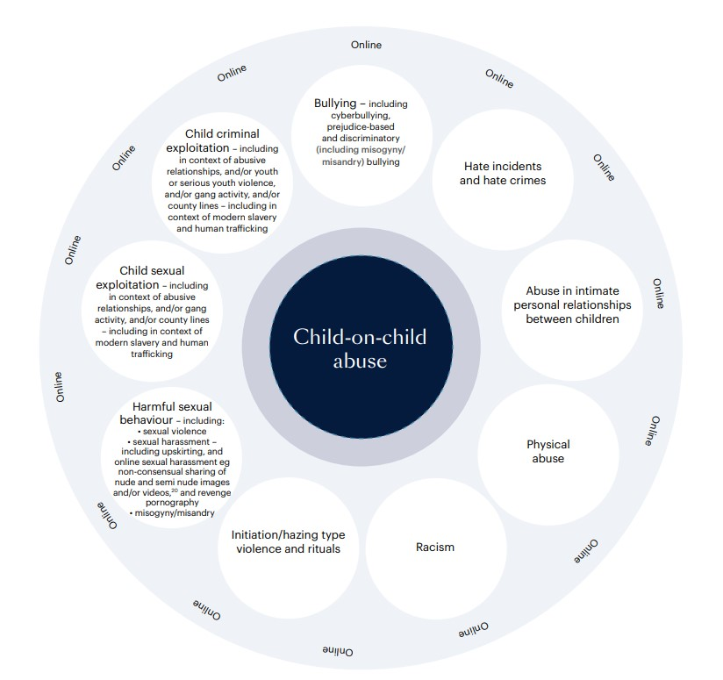

Fig 2 Sexual behaviours continuum model

Normal | Inappropriate | Problematic | Abusive | Violent
 | Single instances of inappropriate sexual behaviour  Socially acceptable behaviour within peer group  Context for behaviour may be inappropriate  Generally consensual and reciprocal | Problematic and concerning behaviours  Developmentally unusual and socially unexpected  No overt elements of victimisation  Consent issues may be unclear  May lack reciprocity or equal power  May include levels of compulsivity | Victimising intent or outcome  Includes misuse of power  Coercion and force to ensure victim compliance  Intrusive  Informed consent lacking, or not able to be freely given by victim  May include elements of expressive violence | Physically violent sexual abuse  Highly intrusive  Instrumental violence which is physiologically and/sexual arousing to the child alleged to have caused harm  Sadism

Definitions-
Sexual Violence:
Rape
Assault by penetration
Sexual assault

Sexual Harassment:
Unwanted conduct of a sexual nature, including sexual remarks, sexual taunts, physical behaviour or online sexual harassment
Victim Reassured
- Taken seriously and kept safe
- Confidentiality not promised
- Listen to victim non-judgmentally
- Record the disclosure (facts as reported)
- Two staff present (one being the DSL, or reported to the DSL as soon as possible)
- Victim sensitively informed about referral to other agencies
- If victim does not give consent to share, staff may still lawfully share in order to protect child from harm and to promote the welfare of children
- Parents of victim informed
ANONYMITY:
Note that in cases of sexual violence there is legal protection of the victim’s identity. Remember that this also includes sharing on social media and discussion amongst pupils in the school.
Rem

DISCIPLINARY MEASURES TAKEN
(may be undertaken based on balance of probabilities, unless prejudicial or unreasonable)

Ensure actions do not jeopardise the investigation
School to work closely with police and/or other agencies
CRIMINAL PROCESS ENDS
- Conviction of Caution: follow behaviour policy, consider Permanent Exclusion. If pupil remains in school, make expectations clear; keep victim and child alleged to have caused harmapart. Consider victim’s wishes.
- Not Guilty: support victim and alleged perpetrator
- No Further Action: support victim and alleged perpetrator
Record Keeping -
Remember to record all concerns, discussions, decisions and reasons for decisions.
REPORT RECEIVED
(from the victim or third-party)
[Onsite, offsite or online]

DISCIPLINARY MEASURES TAKEN
(School’s Behaviour Policy/Anti Bullying Policy)
SAFEGUARD AND SUPPORT VICTIM
AND (ALLEGED) PERPETRATOR

SAFEGUARD AND SUPPORT VICTIM AND (ALLEGED) PERPETRATOR
Considerations
(Sexual Violence, Sexual Harassment and Harmful Sexual Behaviours)
Immediately: Consider how to support the victim and the alleged child alleged to have caused harm

EARLY HELP
Non-violent Harmful Sexual
Behaviours

(see NSPCC Harmful Sexual Behaviours Framework and the Brook Traffic Light Tool)
RISK ASSESSMENT
Case-by-case basis
- Wishes of the victim
- Nature of the alleged incident
- Ages of the children
- Developmental stage of the child
RISK ASSESSMENT
Immediately
Do not wait for outcome of referral before protecting the victim
Emphasis on victim being able to continue normal routines
Alleged child alleged to have caused harmremoved from any classes with victim (also consider shared spaces and journey to and from school)
[not a judgment of guilt]
REFER TO POLICE
All incidents of rape, assault by penetration or sexual assault
Discuss next steps with police, for example, disclosing information to other staff, informing alleged child alleged to have caused harmand their parents
REFER TO
SOCIAL CARE
All incidents where a child has been harmed, is at risk of harm or in immediate danger
Social Care staff will decide next steps. Be ready to escalate if necessary.
MANAGE INTERNALLY
One-off incidents which the school
believes that the child(ren)are not in
need of early help or statutory
in intervention, which would be appropriate to deal with internally under the school’s behaviour policy or anti -bullying policy
.
- Any power imbalance
- One-off, or part of a pattern of behaviour
- Any ongoing risks
- Other related issues and wider context

Where to go for further information

  - Working together to safeguard children 2023: statutory guidance (publishing.service.gov.uk)
  - Searching, Screening and Confiscation (publishing.service.gov.uk)
  - DfE KCSIE 2025 (2026 Updated)
  - DfE: Preventing and Tackling Bullying, July 2017
  - Suspension and permanent exclusion guidance September 2024 (publishing.service.gov.uk)
  - Teaching online safety in schools - GOV.UK (www.gov.uk)
  - Behaviour in Schools - Advice for headteachers and school staff Feb 2024 (publishing.service.gov.uk)
  - DfE: Mental health and behaviour in schools, November 2018
  - DfE: Children Missing Education, August 2024
  - DfE: Mental health and behaviour in schools, November 2018
  - UKCIS: Sexting guidance for schools, 2024 (An updated copy of this guidance is due autumn term 2020)
  - Gov.uk: Equality Act 2010: advice for schools

ANNEX A

Risk Assessment

Basic information
Referrer Name and role
Referrer Contact details (email address and phone number)
Name of school(s) for victim(s)
Name of school(s) for child/ren alleged to have caused harm
Did incident occur on school premises? If not where did the incident occur?

considerations | RISK (consider victim, Child alleged to have caused harm, other pupils and staff) | Risk Level (High, Medium or low) | actions to reduce risk | Revised Risk Level (High, Medium or low)
What is the incident?
Who was involved?
Where did it happen
Does this incident constitute a crime? Assault, sexual assault, rape, sharing of indecent images of children, etc etc. As such has this been referred to the police?
Is it necessary to limit contact between the children involved?
Refer to KCSIE 2026 PART 5 and DFE guidance on sexual harassment and sexual violence in schools and colleges.
Is there an actual or perceived threat from the child alleged to have caused harm to the victim and/or others?
Is either the victim or the child alleged to have caused harm at risk of physical harm as a result of this incident (for example, bullying or ‘retribution’ by peers)?
Do they share classes?
Do they share break times?
Do they share peer/friendship groups?
Do they share transport to/from school?
Are they likely to come into contact with each other (or anyone else involved in/with knowledge of the incident) outside of school?
How can such contact be limited?
Is there a risk of harm from social media and gossip?

Further action taken by the school or college: Please complete for each child involved.

Action | YES/NO | Date
Police informed
Referral to FFD
Referral to external support services
Referral to internal support services
Referral to CAMHS
Referral to early help
Internal Early Help and Support
Other

Action | YES/NO | Date
Police informed
Referral to FFD
Referral to external support services
Referral to internal support services
Referral to CAMHS
Referral to early help
Other

