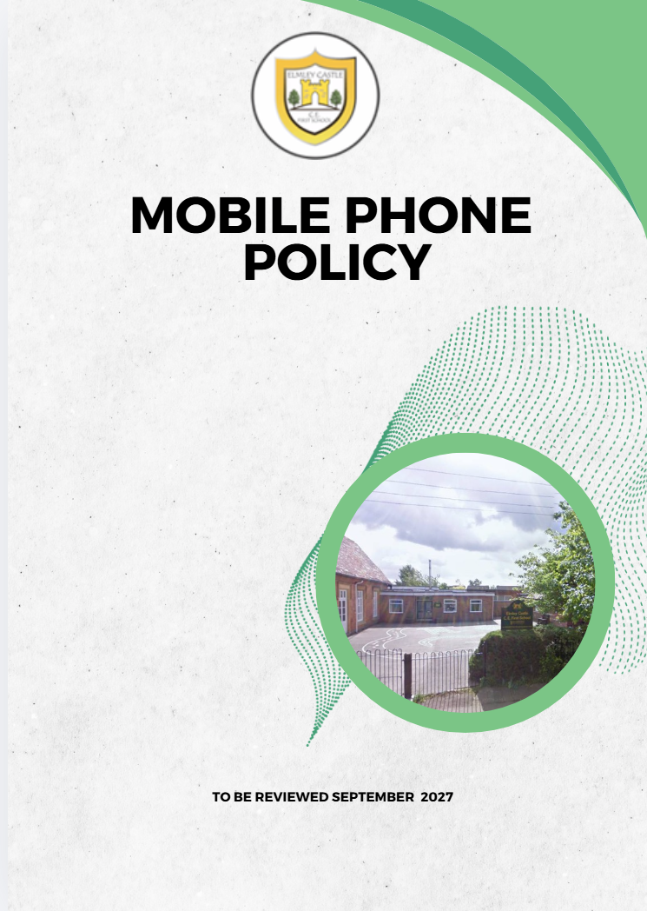
Contents
1. Introduction and aims 2
2. Relevant guidance 3
3. Roles and responsibilities 3
4. Use of mobile phones by staff 4
5. Use of mobile phones by pupils 5
First Breach 6
Repeated Breaches 7
Collection of Confiscated Devices 7
Serious Breaches Involving Safeguarding Concerns 7
Searching Mobile Phones 8
Inappropriate Content Found on a Device 8
Relationship to the Behaviour Policy 8
6. Use of mobile phones by parents/carers, volunteers and visitors 9
Expectations for Parents, Visitors and Volunteers 9
School Events 9
Volunteers and School Trips 9
Failure to Comply 10
7. Loss, Theft or Damage 10
8. Monitoring and review 11
9. Appendix 1: Pupil Agreement 12
10. Appendix 2: Permission form allowing a pupil to bring their phone to school 13
11. Appendix 3: Template mobile phone information slip for visitors 14

1. Introduction and aims

Elmley Castle C of E First School Vision

At Elmley Castle C of E First School, we believe that every child is a light in the world. We love one another, inspire growth, and serve our community with kindness. We embrace resilience, learning from our mistakes and growing stronger together. Each day, we strive to shine in all that we do, creating a safe and welcoming space where everyone can grow in faith, knowledge, and community. Together, we light the way for a brighter future, serving as beacons of hope and love to all.
"You are the light of the world. A city set on a hill cannot be hidden." – Matthew 5:14

BLISS
Believe in yourself
Love one another
Inspire greatness
Shine with kindness
Serve with a heart of compassion

Let your Light Shine!

At Elmley Caste CE First School our policy aims to:
- Ensure our environment is mobile phone-free by default.
- Ensure the safe, responsible and lawful use of mobile phones, where applicable.
- Provide clear guidelines for the use of mobile phones by pupils, staff, parents/carers, visitors and volunteers.
- Support and complement the school's wider safeguarding, behaviour, online safety and data protection arrangements, including the:
  - Child Protection and Safeguarding Policy;
  - Positive Behaviour and Relationships Policy;
  - Online Safety (E-Safety) Policy;
  - Staff Code of Conduct;
  - Data Protection and GDPR Policy;
  - ICT Acceptable Use Policy; and
This policy also aims to address some of the challenges posed by mobile phones in school, including:
- Risks to safeguarding and child protection.
- Data protection and privacy concerns.
- The risk of cyberbullying and online harm.
- Disruption to learning and concentration.
- The inappropriate use of technology and social media.
- Risks associated with photography, video recording and the sharing of images without consent.

2. Relevant guidance
This policy meets the requirements of section 36 of the Children’s Wellbeing and Schools Act 2026, and the Department for Education (DfE)’s mobile phone guidance and behaviour guidance. Further guidance that should be considered alongside this policy is Keeping Children Safe in Education.

3. Roles and responsibilities
3.1 Staff
All staff (including teachers, support staff and supply staff) are required to actively enforce this policy and challenge any breach of mobile phone restrictions immediately and consistently.
Volunteers, or anyone else otherwise engaged by the school, must alert a member of staff if they witness, or are aware of, a breach of this policy.
The Head Teacher is responsible for monitoring the policy and reviewing it annually, and holding staff and pupils accountable for its implementation.
Staff will address any questions or concerns from parents/carers quickly and clearly communicate the reasons for prohibiting the use of mobile phones.

3.2 Governors
The governing body has an active role in monitoring and reviewing this policy to ensure it is effective, proportionate and aligned with statutory guidance.
Governors will:
- Review and formally approve the mobile phone policy as part of the school’s policy cycle
- Receive updates from the Headteacher on the implementation of the policy, including any significant breaches or safeguarding concerns
- Monitor how effectively the policy supports pupil welfare, behaviour and safeguarding, in line with the school’s duties under Keeping Children Safe in Education
- Consider feedback from staff, pupils and parents/carers as part of the annual review process
- Ensure that the policy reflects the needs of the school’s context (Pre-School to Year 5) and maintains a clear, consistent mobile phone-free approach
- Provide appropriate challenge and support to leaders to ensure the policy is applied consistently and fairly
Where relevant, responsibility for monitoring may be delegated to a named governor (e.g. safeguarding or behaviour governor), who will report back to the full governing body.

4. Use of mobile phones by staff
The DfE’s mobile phone guidance says that staff should not use their own mobile phone for personal reasons in front of pupils throughout the school day. All schools should be mobile phone-free environments by default: anything other than this should be by exception only.
4.1 Personal mobile phones
Staff (including volunteers, contractors and anyone else otherwise engaged by the school) are not permitted to use their personal mobile phone during the school day, while children are present. Use of personal mobile phones must be restricted to non-contact time, and to areas of the school where pupils are not present (such as the staffroom).
There may be circumstances in which it’s appropriate for a member of staff to have use of their phone during contact time for personal reasons. For instance (this list is non-exhaustive):
- For emergency contact by their child, or their child’s school
- In the case of acutely ill dependents or family members
The headteacher will decide on a case-by-basis whether to allow for special arrangements.
If special arrangements are not deemed necessary, school staff can use the school office number as a point of emergency contact.

4.2 Data protection
Staff must not use their personal mobile phones to process personal data, or any other confidential school information, including entering such data into generative artificial intelligence (AI) tools such as chatbots (e.g. ChatGPT and Google Gemini).
Refer to Data Protection policy and ICT acceptable use policy.
4.3 Safeguarding
Staff must not give their personal contact details to parents/carers or pupils, including connecting through social media and messaging apps.
Staff must avoid publicising their contact details on any social media platform or website, to avoid unwanted contact by parents/carers or pupils.
Staff must not use their personal mobile phones to take photographs or recordings of pupils, their work, or anything else that could identify a pupil. If it’s necessary to take photos or recordings as part of a lesson / school trip / activity, this must be done using school equipment.
4.4 Using personal mobiles for work purposes
In some circumstances, it may be appropriate for staff to use personal mobile phones or a similar device during the school day in front of pupils for work. Such circumstances may include, but are not limited to:
- Use of multi-factor authentication
- Emergency evacuations
- Supervising off-site trips
- Supervising residential visits
In these circumstances, staff will:
- Use their mobile phones in an appropriate and professional manner, in line with our staff code of conduct
- Not use their phones to take photographs or recordings of pupils, their work, or anything else that could identify a pupil
- Refrain from using their phones to contact parents/carers. If necessary, contact must be made via the school office
4.5 Sanctions
Staff that fail to adhere to this policy may face disciplinary action.
See the school’s staff disciplinary policy for more information.

5. Use of mobile phones by pupils
The DfE’s mobile phone guidance says that the use of mobile phones is prohibited throughout the school day.

At Elmley Castle C of E First School, pupils are not permitted to bring or use mobile phones in school.

As a small primary setting, the vast majority of our pupils are accompanied to and from school by a parent/carer. Therefore, there is no expectation that pupils require a mobile phone for independent travel.

If a mobile phone is brought onto school premises without prior agreement, it will be handed to a member of staff immediately and stored securely in the school office until it is collected by a parent/carer at the end of the day.

This approach ensures a consistent, safeguarding-led position which supports our aim of maintaining a mobile phone-free learning environment.

Pupils will be taught the risks that are associated with the use of mobile phones, both in school and more broadly, to ensure they understand the decision to prohibit the use of mobile phones throughout the school day. These risks can include a loss of focus in lessons, classroom disruption and an increase in bullying. Pupils will be encouraged to see a mobile-phone free environment as desirable and valuable.
5.1 Use of smartwatches by pupils
The DfE’s mobile phones guidance includes in the term ‘mobile phones’ all devices with communications and smart technology that the school chooses to include in their policy.
Smartwatches are wristwatches with smart technology in them. They can be used to tell the time, send and receive text and voice messages, make calls and listen to music. Some smartwatches have wellness and health-related features.
Pupils are not permitted to wear smartwatches that have communication or camera functions (including the ability to send/receive messages or make calls).
Simple analogue or digital watches may be worn.
If a pupil is found wearing a smartwatch with communication features, it will be treated in the same way as a mobile phone and must be handed to staff for secure storage until the end of the school day.
5.2 Exceptions
Given the age of our pupils, children are not permitted to travel to or from school independently, and therefore do not require mobile phones for this purpose.
Exceptions to this policy will only be made in very rare circumstances, where there is a clearly evidenced safeguarding or medical need. Examples may include:
– A pupil with a specific medical condition requiring a linked monitoring device
– A pupil with an identified safeguarding need agreed with the DSL
In such cases:
– Prior written permission must be obtained from the Headteacher
– A risk assessment will be completed
– A signed mobile phone agreement (Appendix 1 and 2) must be in place
– The device must never be used during the school day without explicit staff permission

5.3 Sanctions
At Elmley Castle C of E First School, pupils are not permitted to bring or use mobile phones, smartphones, smartwatches with communication capabilities, or similar connected devices during the school day unless agreed in advance for exceptional circumstances.
Any breach of this policy will be dealt with consistently, proportionately and in line with the school's Positive Behaviour and Relationships Policy.

First Breach
If a pupil is found with a mobile phone or prohibited smartwatch:
- The device will be confiscated immediately by a member of staff.
- The device will be switched off (where possible) and taken to the school office.
- A record of the incident will be made.
- The pupil will be reminded of the school's expectations.

Repeated Breaches
Where a pupil repeatedly breaches the policy:
- Parents/carers will be informed.
- The device will be confiscated and retained securely in the school office.
- The Headteacher may require a parent/carer meeting to discuss concerns.
- Additional behaviour sanctions may be applied in accordance with the Behaviour Policy.

Collection of Confiscated Devices
- Confiscated devices will normally only be returned directly to a parent/carer.
- Devices will not be returned to pupils.
- Collection will usually take place from the school office at the end of the school day.

Serious Breaches Involving Safeguarding Concerns
More serious sanctions may be applied where a device has been used to:
- Access inappropriate or harmful content.
- Bully, intimidate or harass another pupil.
- Take photographs, audio recordings or video recordings without permission.
- Share images or information relating to pupils, staff or visitors.
- Access social media during the school day.
- Circumvent the school's safeguarding or online safety procedures.
In such circumstances:
- The device will be confiscated immediately.
- The incident will be referred to the Headteacher and Designated Safeguarding Lead (DSL).
- Parents/carers will be informed as soon as reasonably possible.
- Appropriate behaviour sanctions will be applied.
- Safeguarding procedures will be followed where necessary.
- The school may involve external agencies, including Children's Services or the Police, where a criminal offence or significant safeguarding concern is suspected.

Searching Mobile Phones
School staff have powers under the Education and Inspections Act 2006 and DfE guidance on Searching, Screening and Confiscation to search a mobile phone when there is good reason to do so, including where staff reasonably suspect that the device contains:
- Pornographic or inappropriate images.
- Evidence of bullying or harassment.
- Evidence relating to a criminal offence.
- Content that may place a child or another person at risk of harm.
Any search will be authorised by the Headteacher (or a senior leader acting on their behalf), carried out lawfully, and recorded appropriately. The school will have regard to safeguarding, data protection and DfE guidance at all times.

Inappropriate Content Found on a Device
If inappropriate, harmful or illegal content is identified:
- The device may continue to be retained while investigations take place.
- The DSL will be informed immediately.
- Relevant evidence may be preserved where required.
- Parents/carers will be informed unless doing so would place a child at risk.
- Appropriate safeguarding referrals will be made.
- Where necessary, the school will seek advice from the Police, Children's Services, the Local Authority Designated Officer (LADO) or other relevant agencies.

Relationship to the Behaviour Policy
Breaches of the Mobile Phone Policy are considered breaches of the school's Positive Behaviour and Relationships Policy because they can:
- Disrupt learning.
- Undermine school routines.
- Present safeguarding risks.
- Affect the wellbeing of others.
Sanctions will therefore be applied fairly and consistently in line with the school's behaviour principles, taking account of the pupil's age, SEND needs, individual circumstances and any reasonable adjustments required.

6. Use of mobile phones by parents/carers, volunteers and visitors
Elmley Castle C of E First School is committed to maintaining a safe, respectful and mobile phone-free environment for pupils throughout the school day. Parents/carers, visitors, volunteers, governors and contractors are expected to support and adhere to this policy whenever they are on the school site or engaged in school activities. The school will provide information about mobile phone expectations through visitor signage, safeguarding information, volunteer induction processes and staff guidance.

Expectations for Parents, Visitors and Volunteers
Whilst on school premises, parents/carers, visitors, volunteers, governors and contractors must:
- Keep mobile phone use to an absolute minimum when children are present.
- Not use mobile phones in classrooms, learning areas, intervention spaces, toilets, changing areas or other locations where pupils are present.
- Not take photographs, videos or audio recordings of pupils, staff or volunteers without prior permission from the Headteacher.
- Use any photographs taken at public school events solely for personal family use.
- Not post photographs or videos of other children on social media or online platforms without the explicit consent of the parents/carers of those children.
- Follow all safeguarding, confidentiality and data protection requirements whilst on the school site.

School Events
At public events such as performances, sports days, celebrations and fundraising events, parents/carers may take photographs or recordings of their own child, provided that:
- The recording is for personal use only.
- The recording does not intentionally include other children.
- Images or recordings are not shared on social media where other pupils may be identifiable.
- Any requests from school staff regarding photography are followed immediately.

Volunteers and School Trips
Volunteers assisting in school or accompanying educational visits must not:
- Use their phone whilst supervising pupils except in an emergency and with the knowledge of a member of staff.
- Take photographs, videos or recordings of pupils on personal devices.
- Use mobile phones to communicate with parents/carers regarding pupils.
- Access social media whilst supervising children.
All photographs required during educational visits must be taken using school-authorised equipment by a member of staff.
Volunteers and parent helpers must report any pupil found using a mobile phone, smartwatch or prohibited device to a member of staff immediately. Volunteers do not have authority to search pupils or confiscate devices; any sanctions or confiscation will be undertaken by school staff in accordance with Section 5 of this policy.

Failure to Comply
Any parent, visitor, volunteer or contractor who fails to follow this policy may be asked to stop using their device immediately. Where concerns relate to safeguarding, confidentiality, data protection or the welfare of pupils, the Headteacher may:
- Require the individual to leave the site.
- Withdraw permission for future volunteering or visits.
- Report the matter in accordance with the school's safeguarding procedures.
- Take any further action considered necessary to protect pupils and staff.
The school reserves the right to restrict or withdraw access to the site where mobile phone use presents a safeguarding risk or breaches school expectations

7. Loss, Theft or Damage
Whilst the school takes reasonable steps to ensure that any mobile phone handed in to staff is stored securely, pupils bring mobile phones or other smart devices onto the school site at their own risk. The school accepts no responsibility for the loss, theft or damage of any personal mobile phone, smartwatch, accessory or SIM card brought onto school premises.
Where a mobile phone has been authorised for exceptional circumstances and is handed to school staff on arrival, it will be stored securely in the school office until the end of the school day.
If a pupil believes that their mobile phone has been lost, stolen or damaged whilst on school premises, they must report this immediately to a member of staff. The school will take reasonable steps to investigate the matter; however, responsibility for personal devices remains with the pupil and their parent/carer.
Any theft of a mobile phone or other electronic device will be treated as a serious matter and dealt with in accordance with the school's Positive Behaviour and Relationships Policy. Where appropriate, parents/carers and external agencies, including the police, may be informed.
Parents/carers are strongly advised to ensure that any authorised device brought to school is clearly labelled and protected by a passcode, PIN or other security measures

8. Monitoring and review
The school is committed to ensuring that this policy has a positive impact on pupils’ education, behaviour and welfare. When reviewing the policy, the school will take into account:
- Feedback from parents/carers and pupils
- Feedback from staff
- Records of behaviour and safeguarding incidents
- Relevant advice from the Department for Education, the local authority and any other relevant organisations
If there are any concerns regarding this policy, these should be brought to the attention of the headteacher in a timely manner.
9. Appendix 1: Acceptable use agreement for pupils allowed to bring their phones to school due to exceptional circumstances

For pupils who have been given permission by the Headteacher to bring a mobile phone to school in exceptional circumstances
At Elmley Castle C of E First School, we are a mobile phone-free school. If you have been given permission to bring a mobile phone to school, you must follow these rules:
- I understand that I must not use my mobile phone during the school day unless a member of staff gives me permission.
- I will switch my phone off before entering school and hand it to a member of staff if required.
- I will not use my phone in classrooms, corridors, toilets, changing areas, playgrounds or any other area where pupils are present.
- I will never take photographs, videos or audio recordings of pupils, staff, volunteers or visitors.
- I will use kind and respectful language online and will not use technology to upset, bully or hurt another person.
- I understand that the school's behaviour expectations apply both in and out of school when I am using technology or social media.
- I will not access, view, send or share content that is inappropriate, unkind, harmful or illegal.
- I will keep my personal information safe and will not share passwords or personal details with other people. (School online safety expectation.)
- If a member of staff asks to see or hand over my phone, I will do so immediately and respectfully. Refusing to do so may result in a behaviour sanction and my phone being confiscated.
- I understand that if I break these rules, my phone may be confiscated, my parents/carers may be contacted and further sanctions may be applied in line with the school's Positive Behaviour and Relationships Policy.

Pupil Agreement
I have read and understood these expectations and agree to follow them whenever I bring a mobile phone to school.
Pupil Name: ___________________________
Pupil Signature: ________________________ Date: ___________
Parent/Carer Name: _____________________
Parent/Carer Signature: __________________ Date: ___________
Headteacher Approval (where applicable): _____________________

10. Appendix 2: Permission form allowing a pupil to bring their phone to school

Use this form if you don’t normally allow pupils to bring their phones to school, but are granting an exception.
It should be signed by parents/carers.
pupil details
Pupil name:
Year group/class:
Parent/carer(s) name(s):

The school has agreed to allow __________________ to bring their mobile phone to school because they:
- Need the phone to support their medical needs
Pupils who bring a mobile phone to school must abide by the school’s policy on the use of mobile phones, and its [code of conduct / acceptable use agreement].
The school reserves the right to revoke permission if a pupil does not abide by the policy.

Parent/carer signature: _____________________________________

For school use only
Authorised by:
Date:

11. Appendix 3: Template mobile phone information slip for visitors

Print out and cut copies of this slip to give to visitors when they arrive at your school.
Use of mobile phones and similar devices in our school
Our school is a mobile phone-free environment.
- Please keep your mobile phone on silent/vibrate while on the school grounds
- Please do not use phones where pupils are present. If you must use your phone, you may go to outside the school building/carpark
- Do not take photos or recordings of pupils (unless it is your own child), or staff
- Do not use your phone in lessons, when working with pupils or while children are present
The school accepts no responsibility for phones that are lost, damaged or stolen while you are on the school grounds.
A full copy of our mobile phone policy is available from the school office.

Use of mobile phones and similar devices in our school
Our school is a mobile phone-free environment.
- Please keep your mobile phone on silent/vibrate while on the school grounds
- Please do not use phones where pupils are present. If you must use your phone, you may go to outside the school building/carpark
- Do not take photos or recordings of pupils (unless it is your own child), or staff
- Do not use your phone in lessons, when working with pupils or while children are present
The school accepts no responsibility for phones that are lost, damaged or stolen while you are on the school grounds.
A full copy of our mobile phone policy is available from the school office.

Use of mobile phones and similar devices in our school
Our school is a mobile phone-free environment.
- Please keep your mobile phone on silent/vibrate while on the school grounds
- Please do not use phones where pupils are present. If you must use your phone, you may go to outside the school building/carpark
- Do not take photos or recordings of pupils (unless it is your own child), or staff
- Do not use your phone in lessons, when working with pupils or while children are present
The school accepts no responsibility for phones that are lost, damaged or stolen while you are on the school grounds.
A full copy of our mobile phone policy is available from the school office.

