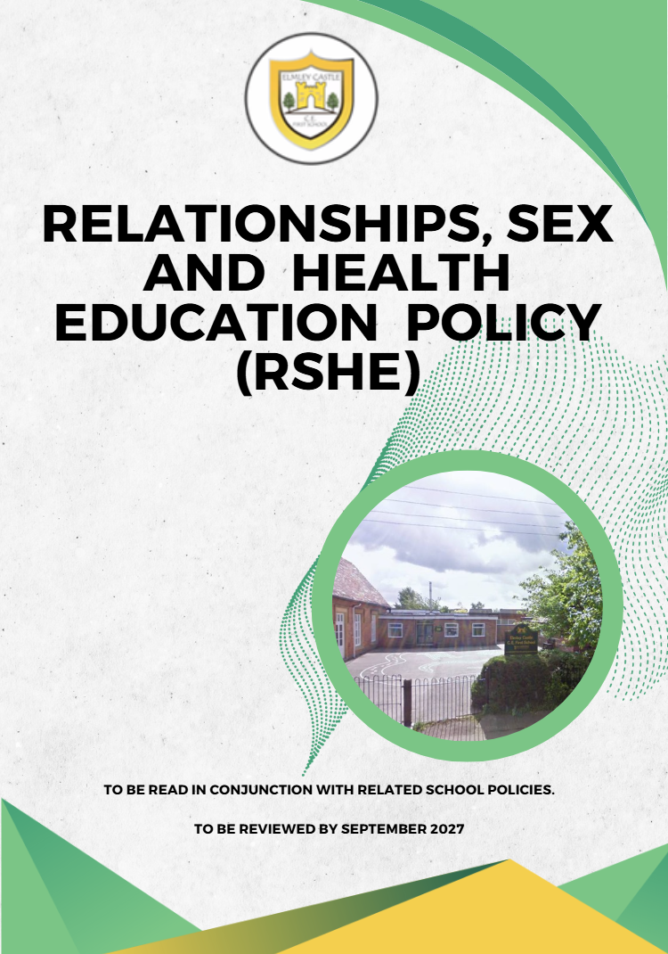

Contents
1 Intent and Aims 2
2 Individual Responsibilities 3
3 Explanation of the right to withdraw 5
4 Structure of school level content 5
5 Equality, Diversity and Inclusion 7
6 Safeguarding 7

Elmley Castle C of E First School Vision

At Elmley Castle C of E First School, we believe that every child is a light in the world. We love
one another, inspire growth, and serve our community with kindness. We embrace resilience,
learning from our mistakes and growing stronger together. Each day, we strive to shine in all that
we do, creating a safe and welcoming space where everyone can grow in faith, knowledge, and
community. Together, we light the way for a brighter future, serving as beacons of hope and love
to all.

"You are the light of the world. A city set on a hill cannot be hidden." – Matthew 5:14

BLISS
Believe in yourself
Love one another
Inspire greatness
Shine with kindness
Serve with a heart of compassion
Let your Light Shine

1 Intent and Aims
  - The intent of RHSE is to encourage the emotional and social development of our pupils and involves learning about sexual health, sexuality, healthy lifestyles diversity and personal identity. This policy complies with the Department for Education's statutory guidance for Relationships Education, Relationships and Sex Education (RSE) and Health Education, the Education Act 1996, Equality Act 2010, Keeping Children Safe in Education (KCSIE 2026), and other relevant statutory guidance.
This policy has been developed with regard to:
- Relationships Education, Relationships and Sex Education (RSE) and Health Education statutory guidance
- Education Act 1996
- Equality Act 2010
- Keeping Children Safe in Education (KCSIE 2026)
- SEND Code of Practice 2015
- Children and Families Act 2014
- Human Rights Act 1998
1.2 The aims of RHSE are:
- To foster a safe school community where pupils can learn, grow and develop positive, healthy behaviour for life.
- To nurture secure learning environments where children can be inquisitive and curious, develop tolerance, empathy and self-esteem and show respect and consideration for others.
- To meet our safeguarding obligations by providing a preventative programme that enables children to learn about the safety and risks in relationships.
- To ensure that all pupils are prepared for the physical and emotional changes they go through during puberty.
- To provide age-appropriate knowledge about sexual health and human development, together with an opportunity to consider the values and attitudes around sexual health issues.
- To help pupils to keep themselves safe, both on and offline, to develop positive relationships with others and to understand the difference between consenting and exploitative relationships.

2 Individual Responsibilities
Different aspects of RHSE provision are supported by the Headteacher, Subject Lead, teachers, support staff, specialist services and health professionals.
Governance of policy
2.1 The Local Governing Body are responsible for:
- approval of this policy
- monitoring the work of the RHSE Lead and support and challenge on matters relating to RHSE provision in accordance with the policy
- have regard to the guidance issued by the secretary of state as outlined in section 403 of the Education Act 1996 and do its best to ensure that RHSE provision is in place in accordance with this act.
Governance of pupil/parental views
2.2 The Local Governing Body is responsible for:
- supporting the school with required actions from the termly Headteachers report
- gathering pupil voice to contribute to the monitoring of priorities for RHSE provision
- tracking themes in parental complaints in relation to RHSE
- reporting any serious or persistent concerns
Governance of curriculum content, delivery, impact and subsequent staff training.
2.3 The Headteacher is responsible for:
- ensuring RHSE is taught consistently across the school and for managing requests to withdraw students from non-science components of RHSE. This includes making sure that:
- RSHE is resourced, staffed and timetabled in a way that ensures the school can fulfil its legal obligations
- RSHE is effectively led and well-planned and the quality of provision is subject to regular and effective self-evaluation
- Clear information is provided for parents on the subject content and the right to request their child is withdrawn
- Staff wellbeing is considered. It is recognised that there are topics which are sensitive in RSHE that may be difficult to teach depending on the life experiences of the teacher delivering the curriculum. Therefore, the Headteacher should be sensitive to staff well-being and needs by offering relevant support.
2.4 School Subject Lead is responsible for:
- ensuring the school is curriculum compliant by following the statutory guidance. This includes: monitoring that lessons are age-appropriate and accessible to all; auditing each of the RHSE strands to assess the impact of provision on pupils and make relevant changes to ensure the content delivered is relevant and timely
- supporting staff with teacher training activities. This could include support with: ensuring the pupils can make progress in achieving the expected educational outcomes; teaching is delivered in ways accessible to all pupils including those with SEND
2.5 Teaching Practitioners are responsible for:
- delivering the agreed RHSE curriculum in a professional, sensitive and positive manner, remaining balanced and not dependent on any personal views. This includes ensuring that all pupils feel comfortable in a ‘safe’ learning environment. The teacher is expected to consider their own needs by forward planning and identifying topics which may be sensitive to teach due to personal life experiences and ask to be supported effectively
- delivering the agreed RHSE curriculum so that it is accessible for all and there is progress and development of all the pupils in their class. Quality First Teaching (QFT) is the first step in responding to pupils with SEND. Staff are required to consult the SEND register to support their teaching of RHSE.
- Modelling the positive attributes drawn on in RHSE
- Monitoring progress against British values
- Responding appropriately to students whose parents wish them to be withdrawn from the non-science component of RHSE
- raise any subsequent safeguarding concerns according to the school policy.
2.6 Pupils are expected to:
- fully engage in RHSE and when discussing lesson content display the British Values of mutual respect and tolerance
2.7 Parents/Carers are the primary responsibility for providing children with relationships, sex and health education. They have a right to withdraw their children from the non-science component of sex education within RHSE

3 Explanation of the right to withdraw
Relationships and Health Education form statutory parts of the RSHE curriculum for primary aged pupils. To that end, parents are not able to withdraw their children from these aspects of teaching and learning. Sex education is non-statutory for primary schools, although elements of sex education do form part of the statutory science curriculum. Parents are able to withdraw their children from sex education lessons that go beyond the science curriculum for their year group. Requests for withdrawal should be made in writing and addressed to the Headteacher and upon receipt, The Headteacher (or designated senior leader) will invite the parent to a discussion about their concerns. Permission will be granted in line with the statutory guidance.

4 Structure of school level content
4.1 For more information about our RHSE curriculum, see the RHSE curriculum map.
4.2 Use of Materials
Resources sourced will be thoroughly checked by the RSHE lead and will fall in line with this policy. Where available, resources used will have been recommended by the Local Authority, or accredited by the PSHE Association or Sex Education Forum This includes Rise Above resources for lessons linked from the PSHE Association website. Resources used will be up to date and non-discriminatory.
4.3 Working with external agencies
It is the responsibility of all teaching staff to deliver the programme of study for RSHE. However, there may be times where the RSHE curriculum is supported by external agencies. The intention of drawing upon this support will be to ensure that their input enhances the RSHE provision of our pupils. Prior to delivering the session all necessary safeguarding checks in line with Elmley Castle CE First School policy will need to be carried out and resources checked by the RSHE Lead Teacher in advance to make sure that the content is age appropriate, addresses the needs of pupils and that the resources and delivery do not undermine the fundamental British Values of democracy, the rule of law, individual liberty and mutual respect and tolerance of those with different faiths and beliefs.

4.4 Assessment/monitoring of progression.
The effectiveness of RSHE will be monitored through pupil voice, lesson visits, curriculum reviews, work scrutiny, safeguarding records and governor monitoring
4.5 Relationships Education
The focus of relationships teaching will be on the fundamental building blocks and characteristics of positive relationships within family relationships, friendships and relationships with other children and adults, both in person and online. We want all children to develop ideas of respect and boundaries that can be built on during their primary years and on into the secondary curriculum.
4.6 Sex Education
Sex education is not compulsory in primary schools, although the Department for Education recommends that all primary schools have a sex education programme tailored to the age and the physical and emotional maturity of the pupils. Meeting this objective will require a graduated, age-appropriate programme of sex education. Many elements of this programme will be statutory as part of the Science curriculum. Elmley Castle CE First School is committed to working with parents to provide a holistic approach to sex education and make teaching materials readily available for parents to view and discuss with senior leaders.
4.7 Difficult questions
Children may ask questions which go beyond the Sex and Relationships curriculum being delivered. We respect the courage and confidence it may take pupils to ask these questions and will respond in a thoughtful and appropriate way, being mindful that where a question is not answered an answer may be sought elsewhere and children may receive inappropriate information. Questions of this nature will be handled sensitively. Staff will not answer ‘in the moment’ instead taking time to ensure that they are clear about the information that they are able to give and parents will be informed where necessary. Such questions may need to handled alongside the safeguarding policy.
4.8 Physical health and mental wellbeing
Teaching children about physical health and mental wellbeing is an important part of
supporting children to make good decisions about their own health and wellbeing. We know
that mental and physical health are interlinked and it is important that children understand the impact that one can have upon the other. Through this subject area, children will learn about self-care techniques, personal health, basic first aid and the prevention of health and wellbeing problems.

4.9 Menstruation
It is important that girls are prepared for the onset of menstruation and for many girls this is happening during their years at primary school. Menstruation is included in the Health element of RSHE and will be taught alongside the requirements outlined in the Science Curriculum. Sanitary products are available in school should they be required and sensitive arrangements are in place to help girls to prepare for and manage menstruation. Parents should contact their child’s class teacher in the first instance if they wish to discuss this further.

5 Equality, Diversity and Inclusion
We promote the needs and interests of all pupils, irrespective of gender, culture, ability or aptitude by ensuring that all resources are representative of the various cultures, religions and backgrounds of the children we teach. Teaching will take into account the ability, age, readiness, special educational needs and cultural backgrounds of our young people and those with English as a second language to ensure that all can fully access RSHE education provision. We promote social learning and expect our pupils to show a high regard for the needs of others by listening to others, respecting the opinions of those around them and being fair and unbiased in their responses. We will use RSHE education as a vehicle to address diversity issues and to ensure equality for all by supporting children to develop positive attitudes to all types of family relationships, including same sex relationships, and by preparing all pupils for the future irrespective of their sexual orientation or gender identity.
All pupils receive teaching on lesbian, gay, bisexual and transgender (LGBT) relationships during their school years. Sometimes this may not be explicit. For example, a lesson on relationships may contain gender neutral names to sensitively show the healthy/non-healthy characteristics of a relationship regardless of their sexuality. When the content of lessons demands it, and in accordance with the Equality Act, Elmley Castle CE First School may take positive action by, for example, teaching gender specific RSHE lessons. For example, we may decide to teach puberty or self-examination cancer checks separately to each gender, rather than having mixed gender classes.
References:
SEND Code of Practice 2015
https://www.gov.uk/government/publications/send-code-of-practice-0-to-25
SEN and Disability Regulations 2014 http://www.legislation.gov.uk/uksi/2014/1530/pdfs/uksi_20141530_en.pdf
Children and Families Act 2014
http://www.legislation.gov.uk/ukpga/2014/6/enacted

Equality Act 2010
https://www.legislation.gov.uk/ukpga/2010/15/content

6 Safeguarding
Good practice allows children an open forum to discuss potentially sensitive issues. Such discussions can lead to increased safeguarding reports. Therefore, children are made aware of how to raise their concerns or make a report and how any report will be handled. This includes processes when they have a concern about a friend or peer. All staff know what to do if a pupil tells them that they are being abused or neglected or are witnessing abuse (in accordance with Keeping Children Safe in Education 2026). Staff also know how to manage the requirement to maintain an appropriate level of confidentiality. This means only involving those who need to be involved, such as the Designated Safeguarding Lead (or deputy) and children’s social care. Staff should never promise a child that they will not tell anyone about a report of abuse, as this may ultimately not be in the best interests of the child.
Teaching about online relationships and online safety complements the school's filtering and monitoring arrangements and supports pupils to recognise, respond to and report online risks

Involvement by the Designated Safeguarding Lead (or a deputy) in anything that is safeguarding related in the context of these subjects is good practice. They will potentially have knowledge of trusted, high quality local resources that could be engaged, links to the police and other agencies and the knowledge of any particular local issues which it may be appropriate to address in lessons.
Where external agencies are invited in to support delivery of these subjects, staff must agree in advance of the session how a safeguarding report should be dealt with by the external visitor(s). It is important that children understand how confidentiality will be handled in a lesson and what might happen if they choose to make a report. When teaching a new subject, staff should be aware that children may raise topics including self-harm and suicide. In talking about this content in the classroom, teachers must be aware of the risks of encouraging or making suicide seem a more viable option for pupils and avoid material being instructive rather than preventative. To avoid this, they should take care to avoid giving instructions or methods of self-harm or suicide and avoid using emotive language, videos or images. Teacher Guidance: preparing to teach about mental health and emotional wellbeing, provides useful support for teachers in handling this material.
If teachers have concerns about a specific pupil in relation to self-harm, suicidal ideation or attempts, or any other issue that presents a serious risk of harm to themselves or others, they must act immediately and in accordance with local safeguarding procedures.

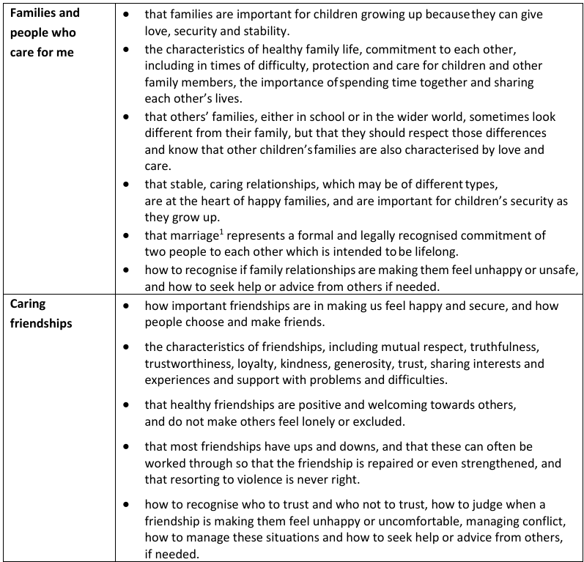
Appendix
By the end of Year 5, pupils should know:

Marriage in England and Wales is available to both opposite sex and same sex couples. The Marriage (Same Sex Couples) Act 2013 extended marriage to same sex couples in England and Wales. The ceremony through which a couple get married may be civil or religious.

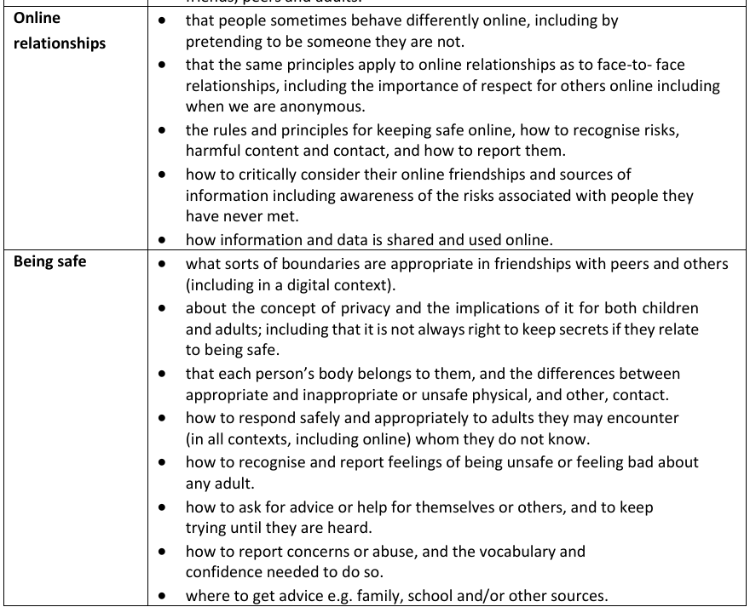
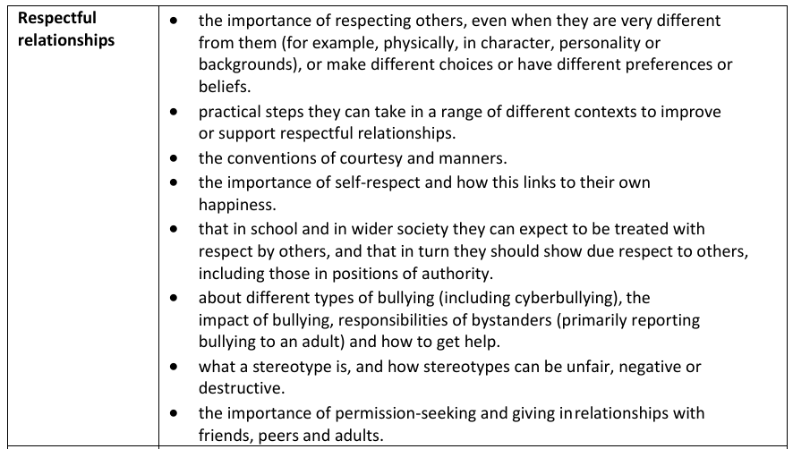
Health Education
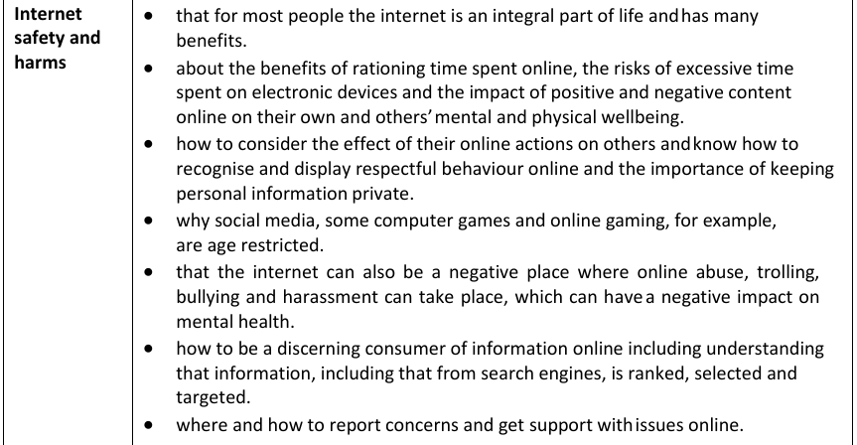
By the end of Year 5, pupils should know:


