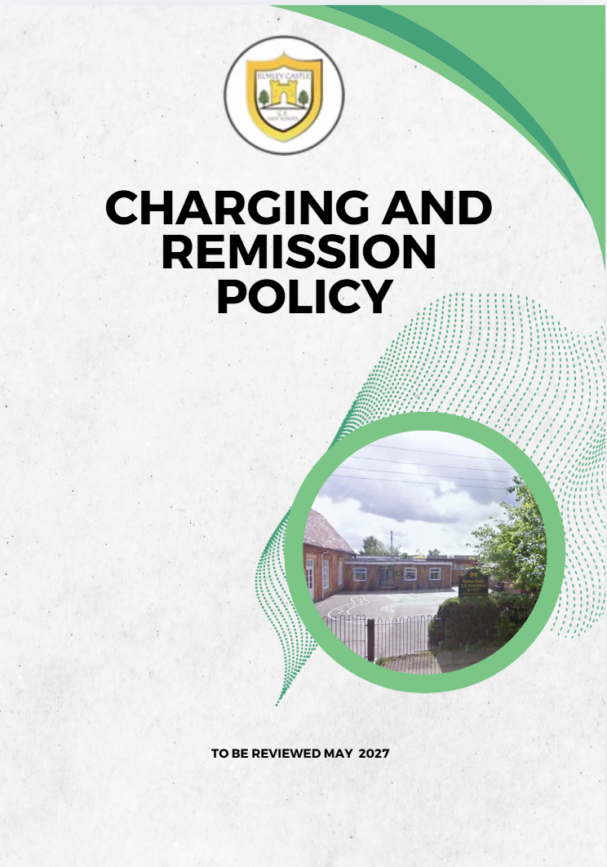

Elmley Castle C of E First School Vision

At Elmley Castle C of E First School, we believe that every child is a light in the world. We love
one another, inspire growth, and serve our community with kindness. We embrace resilience,
learning from our mistakes and growing stronger together. Each day, we strive to shine in all that
we do, creating a safe and welcoming space where everyone can grow in faith, knowledge, and
community. Together, we light the way for a brighter future, serving as beacons of hope and love
to all.

"You are the light of the world. A city set on a hill cannot be hidden." – Matthew 5:14

BLISS
Believe in yourself
Love one another
Inspire greatness
Shine with kindness
Serve with a heart of compassion
Let your Light Shine!

1. Aims
This policy aims to:
- Ensure there are clear, robust processes for charging and remissions
- Set out what the school can and cannot charge for in line with legislation
- Ensure that no pupil is disadvantaged due to financial circumstances
- Support equality of access to educational opportunities

2. Legislation and Guidance
This policy is based on:
- The Education Act 1996 (Sections 449–462)
- DfE guidance: Charging for school activities
- DfE statutory policies for maintained schools
- The Equality Act 2010

3. Definitions
- Charge: A fee payable for a specific activity
- Remission: The reduction or cancellation of a charge

4. Roles and Responsibilities

Governing Board
The governing board:
- Approves and reviews this policy annually
- Monitors the impact of charging and remissions to ensure fairness and compliance

Headteacher
The Headteacher is responsible for:
- Ensuring consistent application of this policy
- Making decisions on remissions and discretionary support
- Keeping appropriate records of decisions

Staff
Staff are responsible for:
- Applying this policy consistently
- Referring queries or uncertainties to the Headteacher

Parents/Carers
Parents are expected to:
- Engage with the school regarding any concerns about charges
- Notify the school if financial hardship may impact participation

5. Where Charges Cannot Be Made
The school will not charge for:

Education
- Education provided during school hours
- Materials, books or equipment required for lessons
- Education outside school hours if part of:
  - The National Curriculum
  - A prescribed public examination syllabus
  - Religious education

Examinations
- Entry for prescribed public examinations where the pupil has been prepared by the school
- Resits where preparation is provided

Transport
- Transport where the local authority has a statutory duty

Residential Visits
- Education provided on residential visits (charges may apply only to board and lodging)

6. Where Charges Can Be Made
The school may charge for:
- Optional extras (see below)
- Materials or equipment where parents wish their child to own them
- Music tuition requested by parents
- Early years provision beyond funded entitlement
- Community facilities

Optional Extras
Charges may be made for:
- Education outside school time not part of the National Curriculum
- Examination entries where the pupil has not been prepared by the school
- Transport not required by law
- Board and lodging on residential visits
- Extended services (e.g. breakfast club, after-school provision)

Charging Principles
- Charges will reflect the actual cost of provision
- No element of subsidy for other pupils will be included
- Parental agreement will be obtained in advance

Extended Provision
A late collection charge may apply where a child is collected after the agreed time. This charge will reflect the additional staffing and supervision costs incurred by the school.

Music Tuition
Charges may apply where:
- Tuition is requested by parents
- Tuition is not part of the National Curriculum
Charges will not apply where:
- The pupil is looked after
- The tuition forms part of statutory provision

Residential Visits
The school may charge for board and lodging only, not exceeding actual cost.

7. Voluntary Contributions
The school may request voluntary contributions for:
- Educational visits
- Enrichment activities
- External workshops or visitors
Key principles:
- Contributions are voluntary
- No child will be excluded if parents are unable or unwilling to contribute
- Activities may be cancelled if insufficient funds are raised

8. Activities Charged For
The school currently charges for:
- Breakfast and after-school provision
- Extra-curricular activities and clubs
- Nursery provision beyond funded hours
Charges are reviewed annually by the governing board.

9. Early Years Provision
The school operates in line with current government childcare funding entitlements.
- Funded hours are provided in accordance with national guidance
- Charges apply only to provision outside funded entitlement
- Full details are provided to parents annually

10. School Meals and Additional Provision
- Meals are charged at cost where applicable
- Universal Infant Free School Meals apply to eligible pupils
- Milk and fruit provision follow national schemes

11. Remissions
The school will provide support with charges in appropriate circumstances.

Eligibility for Remission
Families in receipt of the following may qualify:
- Universal Credit (eligible criteria)
- Income Support
- Income-based Jobseeker’s Allowance
- Child Tax Credit (below threshold, without Working Tax Credit)
- Support under the Immigration and Asylum Act
- Guarantee element of Pension Credit
- Income-related Employment and Support Allowance
- Free School Meals / Pupil Premium eligibility

Discretionary Remission
The Headteacher may agree additional support where:
- Financial hardship is evident
- Safeguarding or welfare concerns exist
- Participation is essential for inclusion
All decisions will be:
- Made on an individual basis
- Recorded appropriately
- Applied consistently and fairly

12. Equality and Inclusion
The school is committed to ensuring that no pupil is disadvantaged due to financial circumstances.
All decisions will take into account:
- Equality Act 2010 responsibilities
- Inclusion and safeguarding needs
- The best interests of the child

13. Damage or Loss of Property
The school may request a contribution towards the cost of replacing or repairing school property where loss or damage is the result of a pupil’s behaviour.

14. Complaints
Any concerns regarding charges or remissions should be raised with the school in the first instance.
Formal complaints will be handled in accordance with the school’s Complaints Policy.

15. Monitoring and Review
- The Headteacher will monitor the implementation of this policy
- The governing board will review annually to ensure compliance and fairness
- Charging practices will be reviewed to ensure they do not disadvantage any group

16. Publication
This policy will be published on the school website and made available to parents on request.

