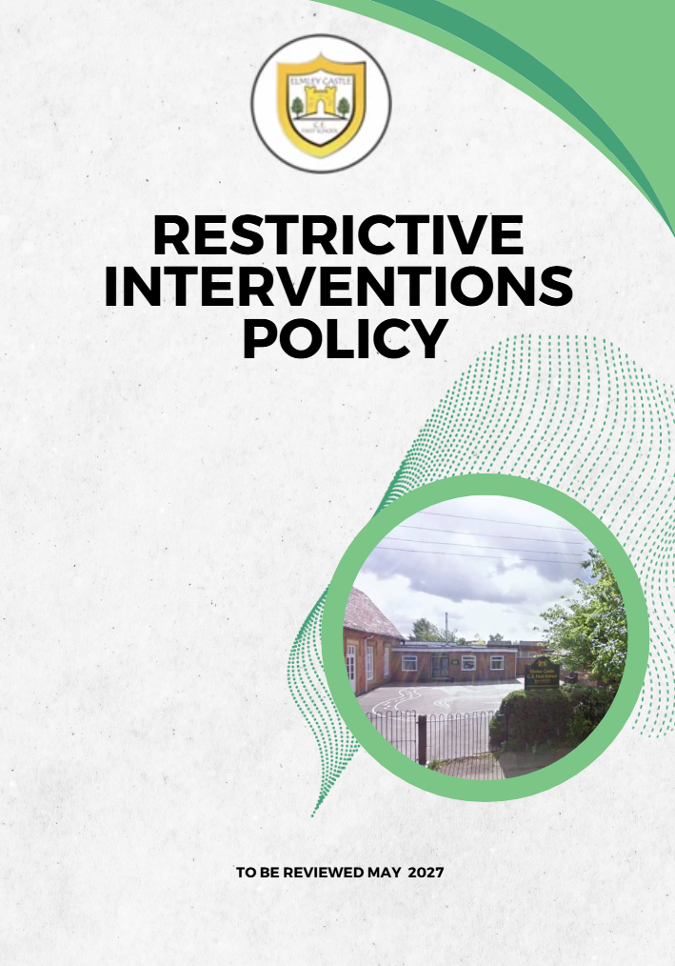

Elmley Castle C of E First School Vision

At Elmley Castle C of E First School, we believe that every child is a light in the world. We love
one another, inspire growth, and serve our community with kindness. We embrace resilience,
learning from our mistakes and growing stronger together. Each day, we strive to shine in all that
we do, creating a safe and welcoming space where everyone can grow in faith, knowledge, and
community. Together, we light the way for a brighter future, serving as beacons of hope and love
to all.

"You are the light of the world. A city set on a hill cannot be hidden." – Matthew 5:14

BLISS
Believe in yourself
Love one another
Inspire greatness
Shine with kindness
Serve with a heart of compassion
Let your Light Shine!

1. Statement of Intent
At Elmley Castle CE First School, in line with our Christian vision—“Let Your Light Shine”—we believe every child deserves to learn in a safe, nurturing environment. We are committed to minimising the use of restrictive interventions and ensuring any such measures are lawful, proportionate, and focused on preserving the dignity, welfare, and rights of every pupil.
2. Legal and Statutory Framework
This policy is based on:
- DfE: Restrictive interventions, including use of reasonable force, in schools (effective April 2026).
- Schools (Recording and Reporting of Seclusion and Restraint) (No. 2) (England) Regulations 2025.
3. Definitions
Restrictive Interventions: Any intervention that restricts a pupil's movement, liberty or freedom to act independently, including physical restraint, seclusion and other forms of restraint
Reasonable Force: The force used by a member of staff that is necessary, proportionate and reasonable in the circumstances to prevent injury, damage to property, the commission of a criminal offence, or serious disruption to the good order and discipline of the school.
Seclusion: Placement of a pupil alone in a safe environment against their will to prevent harm.
4. Principles and Preventative Approach
- Restrictive interventions must never be used as punishment.
- Emphasis on prevention, early support, and de-escalation.
- Staff promote positive relationships and emotional regulation.

4a. Unacceptable Restrictive Interventions
The school recognises that some restrictive practices carry an unacceptable risk of harm and must not be used.
Except in genuinely unforeseeable emergency situations where no safer alternative exists, staff must not:
- Use any intervention intended to cause pain, injury, fear or humiliation.
- Restrict a pupil's breathing or obstruct their airway.
- Apply pressure to the neck, throat, chest, abdomen or joints.
- Use prone (face-down) restraint except where its use is unavoidable in response to an immediate and unforeseeable risk of serious harm and no safer alternative is available.
- Use restrictive interventions as a punishment, sanction or means of securing compliance.
- Use interventions which intentionally degrade, intimidate or humiliate a pupil.
- Use mechanical restraint unless specifically authorised through an individual risk assessment and supported by professional advice.
Any intervention that places a pupil or member of staff at increased risk of injury must cease immediately where it is safe to do so.
5. Criteria for Use
Reasonable force must never be used as a punishment or solely to secure compliance.
Staff may use reasonable force only where it is necessary, reasonable and proportionate to:
- Prevent injury to any person.
- Prevent serious damage to property.
- Prevent the commission of a criminal offence.
- Prevent serious disruption to the good order and discipline of the school

6. SEND and Vulnerable Pupils
Adjustments must be made for pupils with SEND. Staff must consider triggers and support plans.

6a. Individual Planning for Pupils at Foreseeable Risk
Where a pupil's behaviour indicates that restrictive intervention may reasonably be foreseeable, the school will take proactive steps to reduce the likelihood of restrictive interventions becoming necessary.
This may include:
- Individual risk assessments.
- Positive Behaviour Support Plans.
- Behaviour Support Plans.
- SEND Support Plans.
- Individual Healthcare Plans where appropriate.
- Consultation with parents/carers and, where appropriate, external professionals.
Plans should identify:
- Known triggers and early warning signs.
- Effective de-escalation strategies.
- Preferred methods of communication.
- Sensory, emotional or environmental adjustments.
- Agreed responses to escalating risk.
- Any foreseeable restrictive interventions that may be necessary to prevent harm.
The school will review plans regularly and following any significant incident.

6b. Seclusion, Withdrawal and Time Out
The school recognises the distinction between supportive behaviour strategies and seclusion.
Withdrawal occurs when a pupil is encouraged or directed to spend time away from a situation in order to regulate emotions and can freely leave the area when ready.
Time out involves reducing stimulation or providing a calm environment to support emotional regulation, where the pupil remains free to leave.
Seclusion occurs when a pupil is prevented from leaving a room or area and is alone against their wishes.
Where seclusion is used to prevent an immediate risk of serious harm:
- It must be lawful, reasonable, proportionate and necessary.
- It must be used for the shortest possible time.
- The pupil must be continuously monitored.
- The pupil's physical and emotional wellbeing must be regularly assessed.
- The intervention must stop as soon as the risk has reduced.
- The incident must be recorded and reported in accordance with this policy.
7. Staff Training and Preparedness
The school will seek to ensure that an appropriate number of staff receive training in de-escalation, behaviour support and, where appropriate, restrictive intervention techniques. Training will be refreshed in accordance with the recommendations of the training provider and the needs of the school.
The Headteacher will maintain a register of trained staff and monitor refresher training requirements. Where training has expired or staffing changes reduce the number of trained personnel, a risk assessment will be undertaken and refresher training arranged as soon as reasonably practicable.
Where restrictive interventions may be foreseeable, suitably trained staff should be identified and available wherever possible.
Where a situation presents an immediate risk of harm and no trained member of staff is available, any member of staff may use reasonable force, in accordance with their legal powers, if it is necessary, reasonable and proportionate to prevent injury, serious damage to property, serious disorder, or the commission of a criminal offence.
In such circumstances:
- Staff should use the least restrictive intervention necessary.
- Any intervention should be for the shortest time possible.
- Assistance should be sought from trained colleagues where available.
- The incident must be recorded and reviewed by senior leaders.
- The need for additional training must be considered following the incident.
The absence of trained staff does not remove the school's duty to protect pupils, staff and others from foreseeable harm; however, the school recognises that maintaining appropriately trained staff is an important element of safe practice.
In the event that no currently trained member of staff is available on site, senior leaders will ensure that staffing arrangements, risk assessments and training needs are reviewed promptly to minimise future risk and maintain the safety of pupils and staff.
8. Recording and Reporting
All significant incidents involving restrictive interventions must be recorded as soon as practicable and no later than the end of the school day.
Records will include:
- Date, time and location of the incident.
- Names of pupils and staff involved.
- Description of events leading up to the incident.
- Known triggers or contributing factors.
- De-escalation strategies attempted.
- Nature of the risk presented.
- Type of restrictive intervention used.
- Duration of the intervention.
- Any injuries, distress or medical concerns.
- Immediate outcomes.
- Follow-up actions undertaken.
- Whether parents/carers were informed.
- Any reviews or amendments to support plans.
Parents/carers will normally be informed as soon as practicable and, wherever possible, on the same day as the incident. Where informing a parent may place a pupil at risk of serious harm, the school will follow statutory guidance and safeguarding procedures.
Records will be retained in accordance with the school's data retention procedures and reviewed regularly by senior leaders.
All records relating to restrictive interventions will be recorded on the school's Restrictive Intervention Incident Log and uploaded to the pupil's CPOMS record, linked to behaviour and safeguarding records where appropriate.

8a. Post-Incident Review and Support
Following any significant restrictive intervention, the school will ensure appropriate support is provided to all those involved.
This will normally include:

Support for the Pupil
- An opportunity to discuss the incident when calm.
- Restoration of positive relationships.
- Consideration of emotional wellbeing.
- Review of support strategies and plans.

Support for Staff
- Debriefing following the incident.
- Opportunity to discuss concerns.
- Access to wellbeing support where required.
- Review of future risk management strategies.

Learning and Improvement
Senior leaders will consider:
- Whether preventative strategies were effective.
- Whether additional support is required.
- Whether risk assessments or support plans should be amended.
- Any training implications for staff.

9. Monitoring and Governance
The Governing Body will receive anonymised information regarding restrictive interventions to enable effective oversight and assurance.
Monitoring will consider:
- Frequency and nature of incidents.
- Patterns relating to particular times, locations or activities.
- Disproportionate use affecting particular groups of pupils, including pupils with SEND.
- Effectiveness of preventative approaches.
- Staff training needs.
- Safeguarding concerns arising from incidents.
Where trends are identified, leaders and governors will take appropriate action to minimise future use of restrictive interventions.
10. Complaints and Allegations
Concerns will follow the school’s Complaints Procedure and safeguarding policies.

Related Policies
This policy should be read alongside:
- Behaviour Policy
- Safeguarding and Child Protection Policy
- SEND Policy
- Health and Safety Policy
- Staff Code of Conduct
- Complaints Procedure
- Medical Conditions Policy
- Supporting Pupils with Medical Needs Policy
- Equality Information and Objectives
This policy will be reviewed annually, or sooner in response to legislative change, updated guidance or identified need.

